**Course Introduction**

Save note

Do you want to learn how to use spreadsheets and start analyzing data using Excel?

This course from IBM is designed to help you work with Excel and gives you a good grounding

in the cleaning and analyzing of data which are important parts of the skill set required

to become a data analyst.

You will not only learn data analysis techniques using spreadsheets, but also practice using

multiple hands-on labs throughout the course.

In module one you will learn about the basics of spreadsheets, including spreadsheet terminology,

the interface and navigating around worksheets and workbooks.

In module two you will learn about selecting data, entering an editing data, copying and

auto filling data, formatting data, and using functions and formulas.

In module three you will learn about cleaning and wrangling data using a spreadsheet, including

the fundamentals of data quality and data privacy, removing duplicated and inaccurate

data, removing empty rows, removing data inconsistencies and white spaces, and using the flash fill

and text to columns features.

In module four you will learn about analyzing data using spreadsheets, including filtering

data, sorting data, using common data analysis functions, creating and using pivot tables,

and creating and using slicers and timelines.

At the end of this course in module five, you will complete a series of hands-on labs which

will guide you on how to create your first deliverable as a data analyst.

This will involve you understanding what the business scenario is, cleaning and preparing

your data, and analyzing your data.

You will follow two different business scenarios throughout the course, with each using their

own data set.

These different scenarios and data sets will be used in the lesson videos and in the hands-on

labs.

After completing this course, you will be able to understand how spreadsheets can be

used as a data analysis tool; understand when to use spreadsheets as a data analysis tool

and their limitations; create a spreadsheet and explain its basic functionality; perform

data wrangling and data cleaning tasks using Excel; analyze data using filter sort and

pivot table features within Excel spreadsheets.

You will also perform some intermediate level data wrangling and data analysis tasks to

address a business scenario.

The course team and other peers are available to help in the course discussion forums in

case you require any assistance.

Let's get started with your next video where you will get an introduction to spreadsheets.

**Introduction to Spreadsheets**

Save note

In this first video of the course, we will list some of the common spreadsheet applications

available, learn about the key capabilities of spreadsheets, and discuss why spreadsheets

might be a useful tool for a Data Analyst.

There are several spreadsheet applications available in the marketplace; some of them

are more widely known and used than others, and some are free, while others need to be

paid for.

By far the most commonly used spreadsheet application, and the most fully featured of

them all is Microsoft Excel.

The desktop version comes in a paid form as part of the Office suite and some Microsoft

365 subscriptions, but there is also a web-based cut-down version called Excel for the web,

also known as Excel Online.

The online version is free to users with a Microsoft account, but does not offer all

the advanced features that the desktop version provides.

The next most popular is Google Sheets, which offers a lot, though not all of the features

that Excel provides, and is free with a Google account.

This is a web-based application and it integrates nicely with other Google apps, such as Google

Forms, Google Analytics, and Google Data Studio.

Then there is LibreOffice Calc, a totally free and open source desktop spreadsheet application

that offers more basic functionality than Excel or Google Sheets, but still has a lot

of the tools you need for data analysis, such as charts, conditional formatting, and pivot

tables.

Other spreadsheet apps include Zoho Sheet (a fully-featured web-based application that

is comparable with Google Sheets), OpenOffice Calc, Quip from Salesforce, Smartsheet (which

is predominantly for project management), and Apple Numbers, (which is included with

Apple devices such as Mac computers and is also available on the App Store for other

Apple devices).

So, there are many spreadsheet application options open to you, from fully-featured to

basic, from cloud-based to desktop apps, from paid-for to free versions.

It’s up to you to decide which one best fits your needs and your budget.

Spreadsheets provide several advantages over manual calculation methods.

For example, once you have your formulas correctly written, you can be assured that your calculations

are accurate, and that the calculations will be performed automatically for you.

Spreadsheets also help keep your data organized and easily accessible.

Your data can be easily formatted, filtered, and sorted to suit your needs.

If you do make mistakes in your data entry or your calculations you can easily edit them,

undo them, or use error-checking tools to help remedy those mistakes.

And lastly, you can analyze data in spreadsheets, and create charts, graphs, and reports to

help visualize your data analysis.

Since spreadsheet software for personal computers first appeared on the market in the 1970s,

with VisiCalc on the Apple II PC, spreadsheets have come a long way in terms of the capabilities

and features they now offer businesses, from uncomplicated tables and relatively simple

computations to powerful tools for the analysis, management, and visualization of enormous

sets of data.

The most common business uses for spreadsheet applications include the following:

Data Entry and Storage, Comparing Large Datasets, Modelling and Planning, Charting, Identifying

Trends, Flowcharts for Business Processes, Tracking Business Sales, Financial Forecasting,

Statistical Analysis, Profit and Loss Accounting, Budgeting, Forensic Auditing, Payroll and

Tax Reporting, Invoicing, and Scheduling.

And away from the business side of things, other typical uses include Personal Expenses,

Household Budgeting, Recipe library, Fitness Tracking, Calorie Counting & Weight Monitoring,

Sports Leagues such as Fantasy Football, Cataloging Music Libraries, and even Contact Lists, Shopping

Lists and Christmas Card Lists.

As a Data Analyst, you can use spreadsheets as a tool for your data analysis tasks, including:

Collecting and harvesting data from one or more distributed and different sources.

Cleaning data to remove duplicates, inaccuracies, errors, and resolve missing values to improve

the quality of the data.

Analyzing data by filtering, sorting, and interpreting it to determine what useful information

can be gleaned from it.

And visualizing data, to help you tell a story about your data analysis findings to key business

stakeholders and any other interested parties within your organization.

In this video, we had an introduction to spreadsheets.

We learned about some common spreadsheet applications, what the main capabilities of spreadsheets

are, and why spreadsheets might be a useful tool for a Data Analyst.

In the next video, we will look at the basics of spreadsheets, including common spreadsheet

terminology.

**Spreadsheet Basics - Part 1**

Save note

Now that we have a basic understanding of what spreadsheet software is available, and

why spreadsheets might be a useful tool for a Data Analyst, let’s get started on looking

at some of the basics of using a spreadsheet application.

In these videos we will be using the full ‘desktop’ version of Excel, but the majority

of the tasks that we will perform can also be done using Excel ‘on the web’, also

known as Excel Online, and other spreadsheet applications such as Google Sheets.

Let’s first cover some basic spreadsheet terminology.

When you open Excel, you have the option of creating a new blank workbook or opening an

existing workbook.

We’re going to choose New, and then Blank workbook.

Workbooks are the highest-level component in Excel and are represented as a .XLSX file.

So, when you open an existing workbook or create a new workbook you are in fact working

with a .XLSX file.

The workbook contains all your data, calculations, and functions, and contains several other

underlying elements that make up a workbook.

A workbook consists of one or more worksheets, each of which is represented by a tab in Excel.

Each worksheet is given a name which is displayed on the corresponding tab for the worksheet.

By default, each tab is named Sheet1, then Sheet2, and so on.

To make these worksheet tabs more meaningful it is usual to rename them, so they make more

sense in relation to the worksheet’s purpose.

For example, you might call a worksheet January Sales, or perhaps the name of a region or

store, or even an office or department.

To do this, right-click the tab and choose Rename.

Instead of right-clicking to rename, you can also just double-click the name of a worksheet

tab to rename it.

Essentially, worksheet tabs can be named anything you want to fit your particular needs to make

it easier to understand what that worksheet represents.

Note that a worksheet that is highlighted, as the Tire Sales worksheet tab is here, is

referred to as the active worksheet.

If you want to order your worksheets in a different way, that is very simple to do.

Either drag a worksheet tab to the left or right and drop it in the place you want, which

is represented by the little black arrow, or if you are not comfortable with dragging

and dropping, then the longer way of doing that is to right-click the worksheet tab,

select Move or Copy, and then in the list titled Before sheet, select where you want

your worksheet tab to be placed, and click OK.

Every worksheet is made up of a lot of rectangular boxes called cells.

These cells will contain your data, which may be text, numbers, formulas, or calculation

results.

Cells are organized in columns, which run vertically down the screen and use a letter

system; this is column B for instance.

And rows, which run horizontally across the screen and use a numeric system; this is row

7 for example.

Each cell is represented by a cell reference which is essentially just its column letter

and row number.

For example, if we click somewhere near the center of this worksheet, we now have the

cell M20 selected.

This is usually referred to as the ‘active cell’.

This is not only indicated by the highlighted edges of the cell but also if you look in

the top left corner of the worksheet, you will see its cell reference is noted in the

little box.

Here you can see it says M20.

One important thing to note here is that cells are always referenced by their column letter

first then their row number; so, column M, and row 20.

The last element of a workbook I want to mention is a cell range.

This identifies a collection of several cells selected together; that could mean a few cells

in the same row or the same column, or it could mean several rows and columns together.

This can either be done using the mouse by selecting the first cell then ‘dragging’

down or across to include other cells; or you can use SHIFT+ arrow keys.

This range of cells is often referred to as an array, and it’s most commonly used as

a reference in calculations and formulas.

For example, if you wanted to add up all the values in a column between cells D9 and D19

you would specify this cell range within a formula.

Note that cell ranges are notated using a full colon (:) between the cell references;

so, in this example it would be D9:D19, or to specify a few cells in the same row it

might be D9:H9, or to select several rows and columns it might be D9:H19.

We will see this notation in use later in this course when we start looking at calculations

and formulas.

These cell ranges could even be a reference point to cells contained on another worksheet;

this is usually referred to as a 3D reference.

We can now close this workbook and we don’t need to save it.

In this video, we learned about some of the basic terminology of spreadsheet elements.

In the next video, we will discuss how to navigate around a spreadsheet, how to use

the ribbon and menus, and how to select data.

# Spreadsheet Basics - Part 2

Now that we have a basic understanding of the main elements that make up a worksheet,

let’s see how to move around a spreadsheet, get familiar with the ribbon and menus, and

learn how to select data in a worksheet.

To open a sample file, we click File.

This opens Backstage View.

Here you can create a new workbook, or open, save or print a workbook.

You can also access Excel Options.

Now, we want to open our sample file.

So, we click Open, and either select it from my Recent list, or click Browse to find the

data file we want.

The first thing we should do is get acquainted with the ribbon and menus.

Notice that on the ribbon at the top we have several tabs.

Some of these tabs may be familiar to you from other Office products, such as the Home,

Insert, and View tabs, while others might be new to you, such as Formulas, Data, and

Power Pivot.

To make a little more workspace for ourselves we can hide this ribbon by double-clicking

any tab, and to unhide it, we do the same.

The other option is to use the shortcut key CTRL+F1.

The ribbon is organized into groups of buttons to make them easier to find.

So, on the Home tab we have groups for Font, Alignment, Number, Styles, and so on.

Some of these groups contain all the available buttons on the ribbon when viewing in full

screen, such as Styles and Cells, but other ribbon groups have more options, which we

access by clicking the little arrow icon in the bottom right corner of the group, as can

be seen here on the Number group for example.

The next item I want to point out is the Quick Access Toolbar at the top of the screen above

the ribbon.

As the name suggests this is where you can quickly access the tools you use most often.

You can see we already have some tools in this toolbar such as Save, Undo, Redo, New,

and Open.

But we can add other tools to the toolbar if we wish.

So if we click the drop-down arrow in the toolbar and then select a tool we will use

a lot, such as Sort Ascending, that will be added, and we will also add the Sort Descending

button too.

Now we need to be comfortable with moving around a worksheet.

You can simply use the arrow keys to move left, right, up, and down 1 cell at a time.

But you can also use Page Down and Page Up to move around a bit faster, which is especially

useful if you have lots of rows of data.

And to move even quicker up or down a large datasheet use the vertical scroll bar, and

to move left or right use the horizontal scroll bar.

Again, these can be very useful when you have a large data set.

There are also some useful shortcuts you can use.

CTRL+Home key for example takes you back to the start of the worksheet (i.e. cell A1).

CTRL+End takes you to the cell at the end of your data in the worksheet.

CTRL+Down arrow takes you to the end of the column you’re in, while CTRL+Up arrow takes

you back to the top of that column.

So a quick way to find out how many rows of data you have in your worksheet is to go to

the first cell in your data and press CTRL+Down arrow to see the last row of data.

So here you can see we have 160 rows.

Now how do we go back to the top again?

CTRL+Home will do it.

So far, we have seen how to navigate around our worksheet and its data, now we need to

look at how we select data.

This is very important because you often need to select data to move it, copy it, or select

it in a formula.

The simplest selection is a single cell, usually done with a mouse or maybe a directional arrow

key.

The next step up is to select multiple cells together, and this can be done either with

a mouse by dragging from one cell to additional adjoining cells, or you can use the SHIFT

key with directional arrow keys.

Next up is selecting a single column or row which is done simply by selecting the letter

at the top of a column, or the number on the left of a row.

Then we can progress to selecting multiple columns and rows, by clicking the mouse button,

holding it down and dragging across more columns.

Or if you are not comfortable with dragging you can also select the column first, then

hold SHIFT+Arrow keys to select multiple columns.

The same applies to rows too.

However, if you have data in non-contiguous rows or columns (i.e. not next to each other)

you can select the first column, then use the CTRL key to select another unconnected

column, such as columns C and F here.

The largest thing you might want to select is the whole worksheet which you can do by

clicking in the top left corner of the cells.

However, this selects the entire worksheet including all the empty rows and columns;

so if you only want the data in your worksheet, you can use the shortcut CTRL+A. A word of

warning when selecting data in cells, rows, and columns; there are 3 types of cross symbols

that you might see when working with selected cells.

The first one is the large white cross that you see when you select a cell as can be seen

here in cell A4, this is the Select cross that we have been using already in this video

to select cells.

The second type you might see is when you hover over the bottom edge of a cell and see

a thin black cross-type symbol with arrows on each point…. this is the Move symbol

and would move the cell data to another location.

The last type is the small thin black cross that is seen when you hover over the bottom

right corner of a cell; this is the Fill Handle or Copy symbol and it fills (or copies) the

cell data to another location.

In this video, we learned how to move around a spreadsheet, became familiar with the ribbon

and menus, and learned how to select data in a worksheet.

In the next video, we will discuss how to enter data, how to copy and paste data, and

how to format data in a spreadsheet.

# Reading: Excel Keyboard Shortcuts

**Estimated time needed:** 30 minutes

The table below lists keyboard shortcuts for some of the most common Excel tasks.

| **Task** | **Shortcut** |
| --- | --- |
| Close a workbook | Ctrl+W |
| Open a workbook | Ctrl+O |
| Save a workbook | Ctrl+S |
| Copy | Ctrl+C |
| Cut | Ctrl+X |
| Paste | Ctrl+V |
| Undo | Ctrl+Z |
| Remove cell contents | Delete |
| Bold | Ctrl+B |
| Open context menu | Shift+F10 |
| Expand or collapse the ribbon | Ctrl+F1 |
| Move up one cell in the worksheet | Up arrow key |
| Move down one cell in the worksheet | Down arrow key |
| Move one cell left in the worksheet | Left arrow key |
| Move one cell right in the worksheet | Right arrow key |
| Move to the edge of the current data region in the worksheet (e.g. end of column) | Ctrl+Arrow key (e.g. Ctrl+Down arrow) |
| Move to the last cell on a worksheet | Ctrl+End |
| Move to the beginning of a worksheet | Ctrl+Home |
| Extend the selection of cells to the last used cell on a worksheet (lower right corner) | Ctrl+Shift+End |
| Move to the cell in the upper-left corner of the window (when Scroll Lock is On) | Home+Scroll Lock |
| Move one screen down in a worksheet | Page Down |
| Move one screen up in a worksheet | Page Up |
| Move one screen to the right in a worksheet | Alt+Page Down |
| Move one screen to the left in a worksheet | Alt+Page Up |
| Move to the next sheet in a workbook | Ctrl+Page Down |
| Move to the previous sheet in a workbook | Ctrl+Page Up |
| Edit the active cell and put the cursor at the end of the cell’s contents | F2 |
| Enter the current time | Ctrl+Shift+colon (:) |
| Enter the current date | Ctrl+semi-colon (;) |

## Author(s)



# Hands-on Lab 1: Introduction to Excel for the web

**Estimated time needed:** 20 minutes

Microsoft Excel is the most widely used spreadsheet software even three decades after its initial release. For all these years it has been available as a standard application that needed to be installed on your desktop; but it is not just a desktop app anymore. Now, you can even use Excel when you’re online by using ‘Excel for the web’ - and run it right in your web browser without installing anything on your desktop!

‘Excel for the web’ (sometimes referred to as Excel Online) can be used at no charge as part of a free Microsoft account. Although it does not have all of the capabilities of the desktop and paid online versions, the free web version provides many of the key features.

# Software Used in this Lab

The instruction videos in this course use the full Excel Desktop version as this has all the available product features, but for the hands-on labs we will be using the free ‘Excel for the web’ version as this is available to everyone.

Although you can use the Excel Desktop software if you have access to this version, it is recommended that you use Excel for the web for the hands-on labs as the lab instructions specifically refer to this version, and there are some small differences in the interface and available features.

# Dataset Used in this Lab

The dataset used in this lab comes from the following source: <https://www.kaggle.com/sudalairajkumar/indian-startup-funding> under a [**CC0: Public Domain license**](https://creativecommons.org/publicdomain/zero/1.0/).  
Acknowledgement and thanks also goes to [https://trak.in](https://trak.in/) who were generous enough to share the data publicly for free.

We are using a modified subset of that dataset for the lab, so to follow the lab instructions successfully please use the dataset provided with the lab, rather than the dataset from the original source.

# Objectives

After completing this lab, you will be able to:

* Sign up for a Microsoft Account to use Excel for the web
* Sign in, upload and open a workbook in Excel for the web

# Exercise 1: Sign-up for a Microsoft Account to Use Excel for the web

In this exercise, you will sign up for a Microsoft Account to use Excel for the web.

* If you already have a Microsoft account, you can skip Exercise 1 and proceed to Exercise 2 directly.

1. Go to [www.office.com](https://www.office.com/). Click **Sign in**

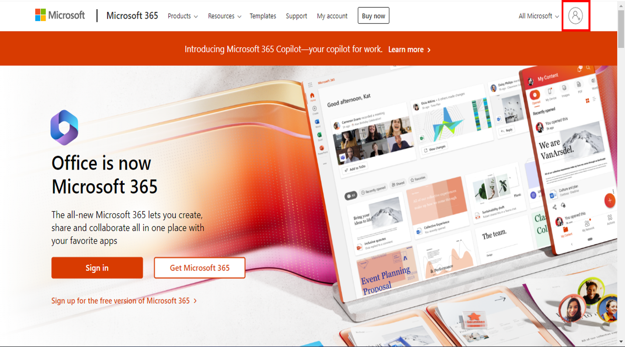

1. Click **Create one!**

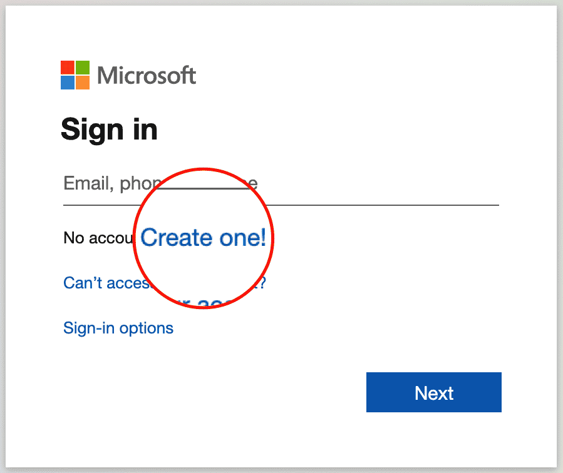

1. Enter your existing email id with which you want to create a Microsoft account. Click **Next**.

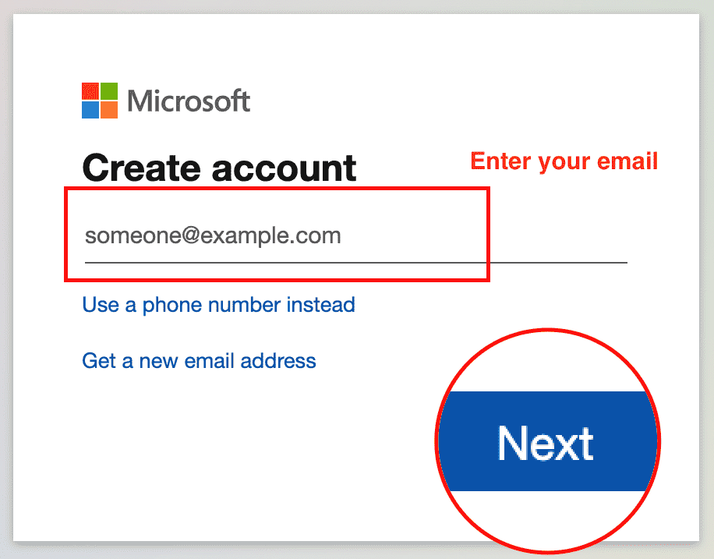

1. Enter your password and click **Next**.

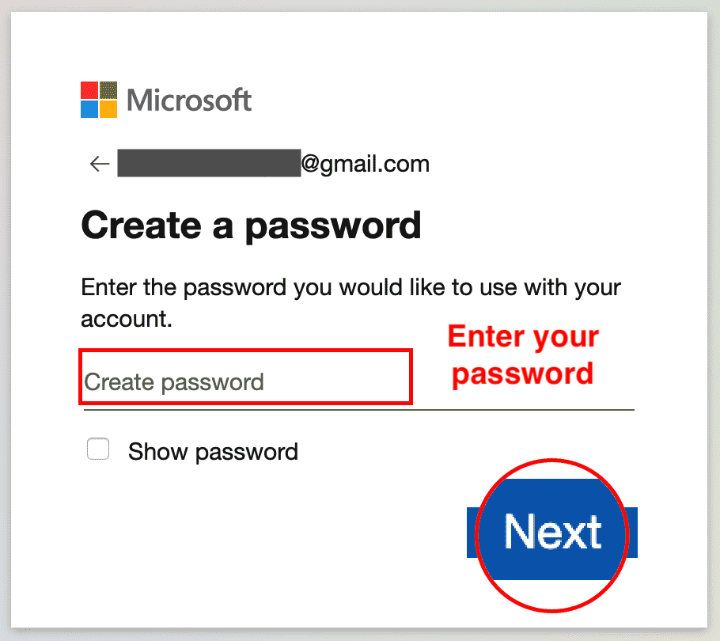

1. Enter the code you received by email. Click **Next**.

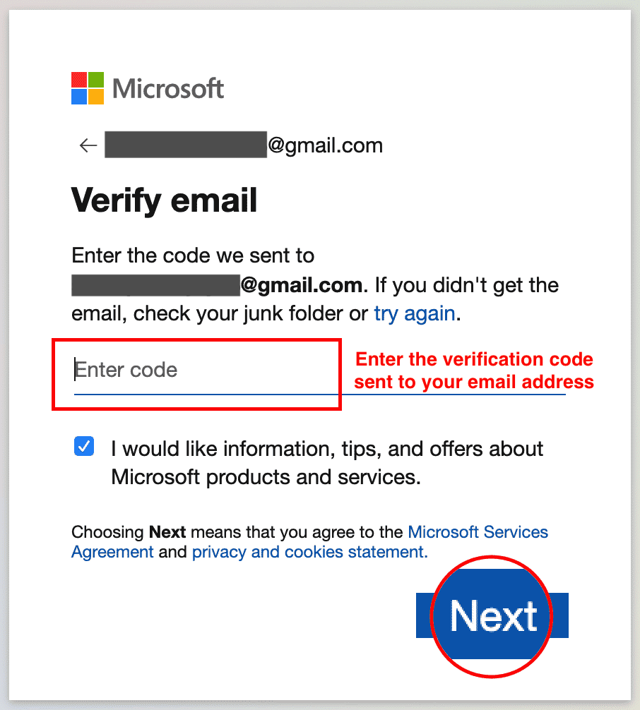

1. Enter your phone number and click **Send Code**.

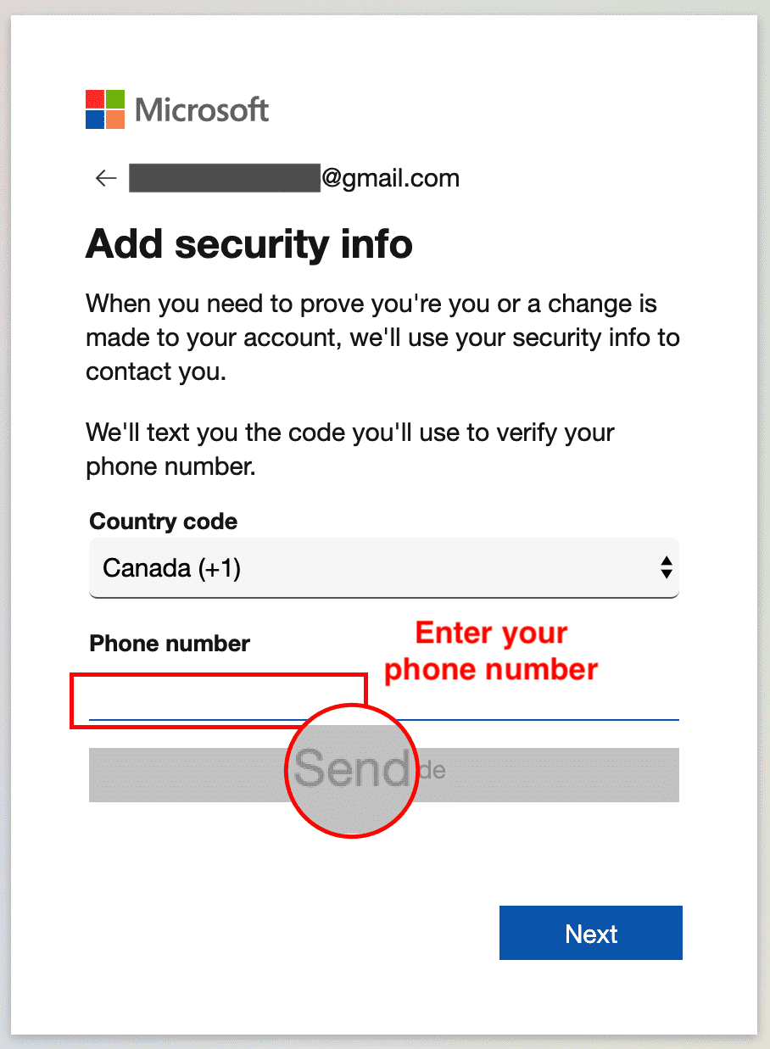

1. Enter the access code you received as a text on your phone, then click **Next**.

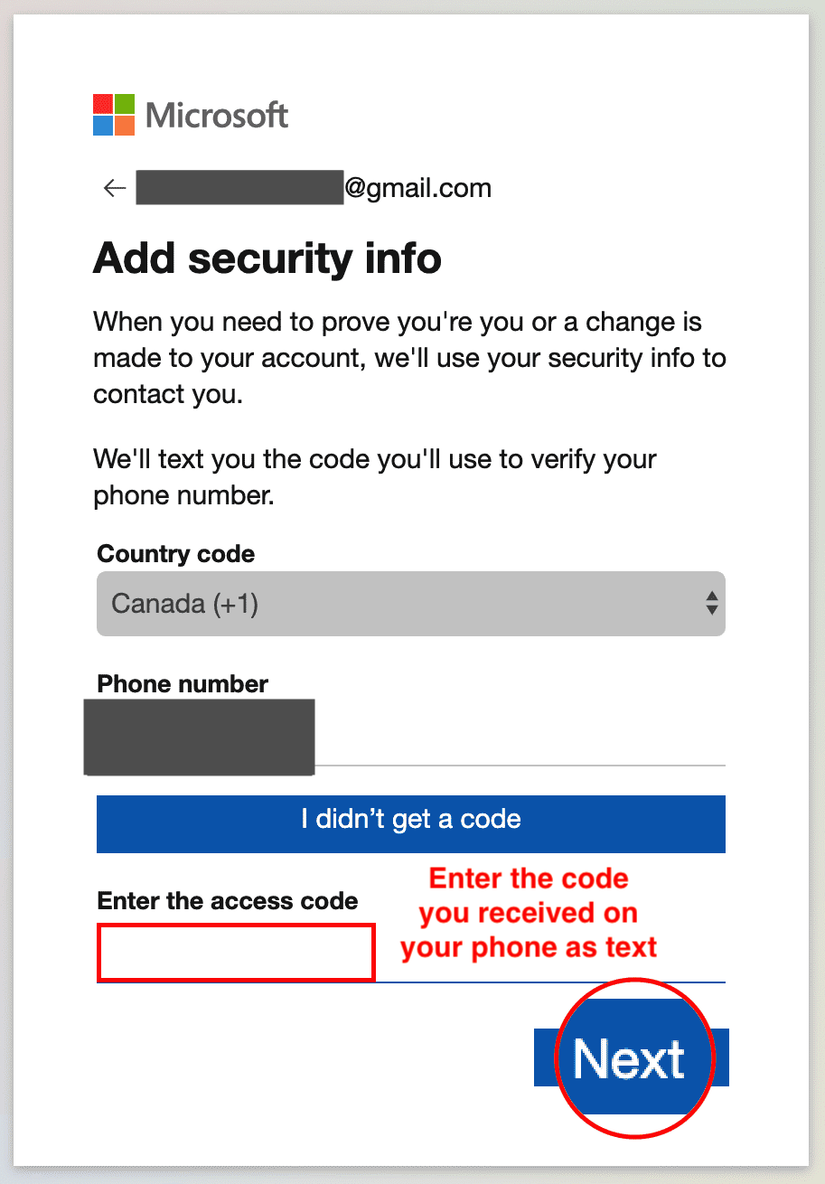

1. You are now done with the sign up procedure. Now since you are signed in after sign up at this stage, you can proceed directly to **Task B** of **Exercise 2**.

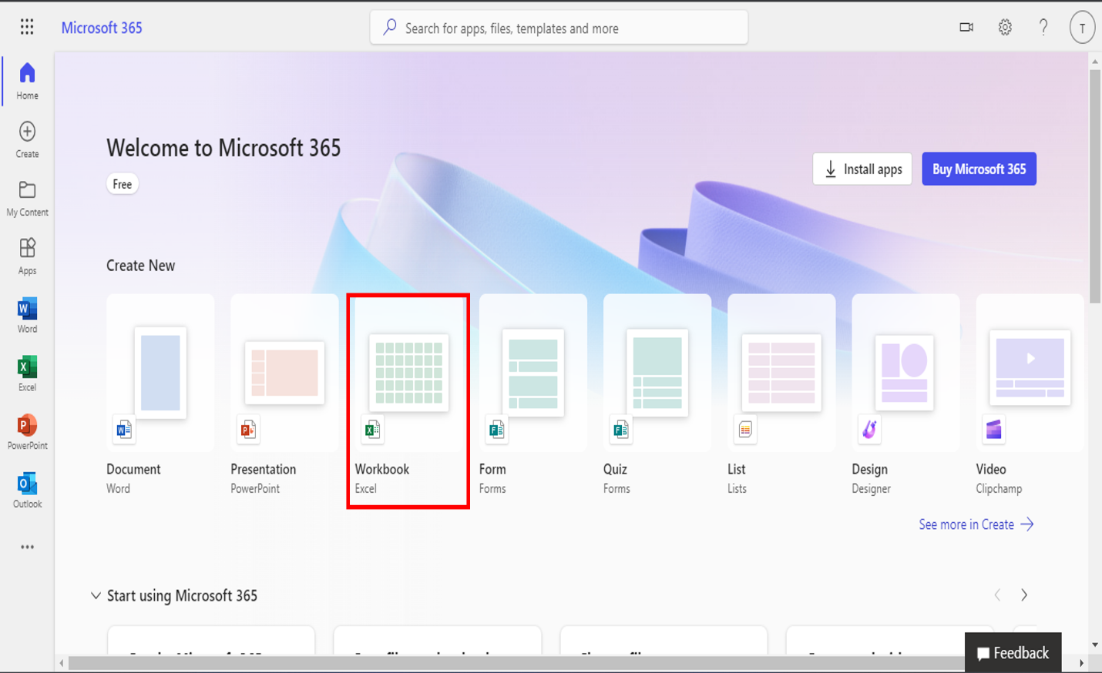

# Exercise 2: Sign-in, Upload and Open a Workbook in Excel for the web

In this exercise, you will sign in to Excel for the web, open a new workbook and then upload and open a workbook.

## Task A: Sign in to Excel for the web

1. Go to [www.office.com](https://www.office.com/). Click **Sign in**.



1. Enter your sign in email.

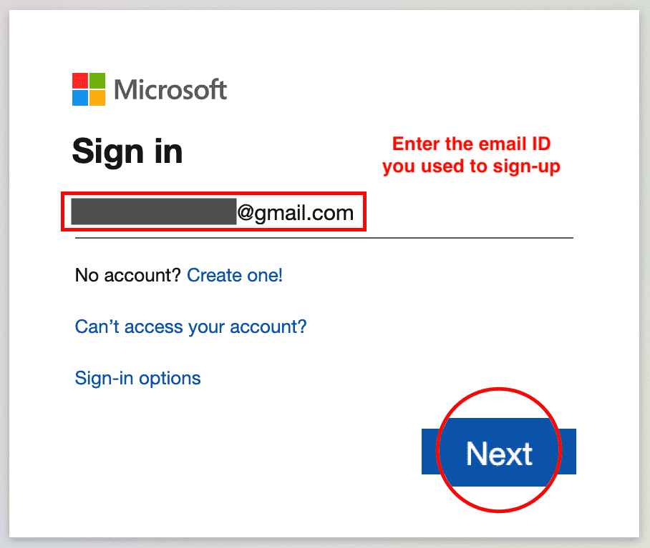

1. Enter your password.

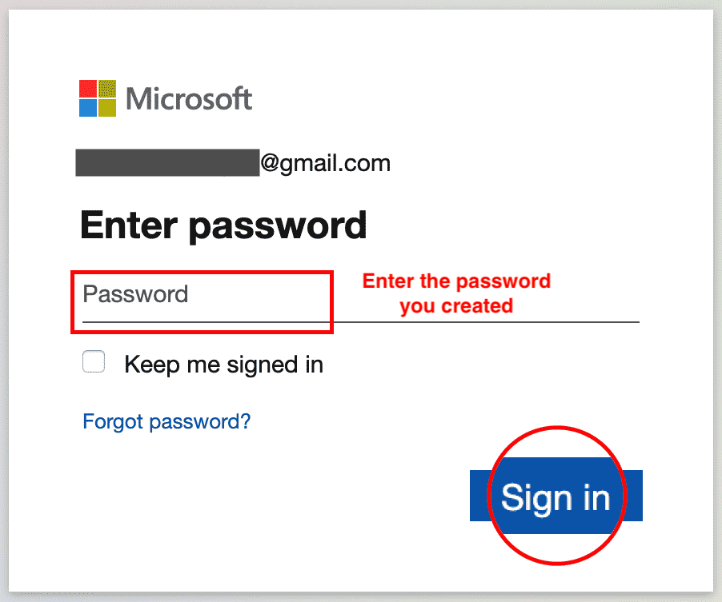

1. You are now signed in.



## Task B: Open a new workbook in Excel for the web

1. Click on the **Excel** icon.
2. Click **New blank workbook**.

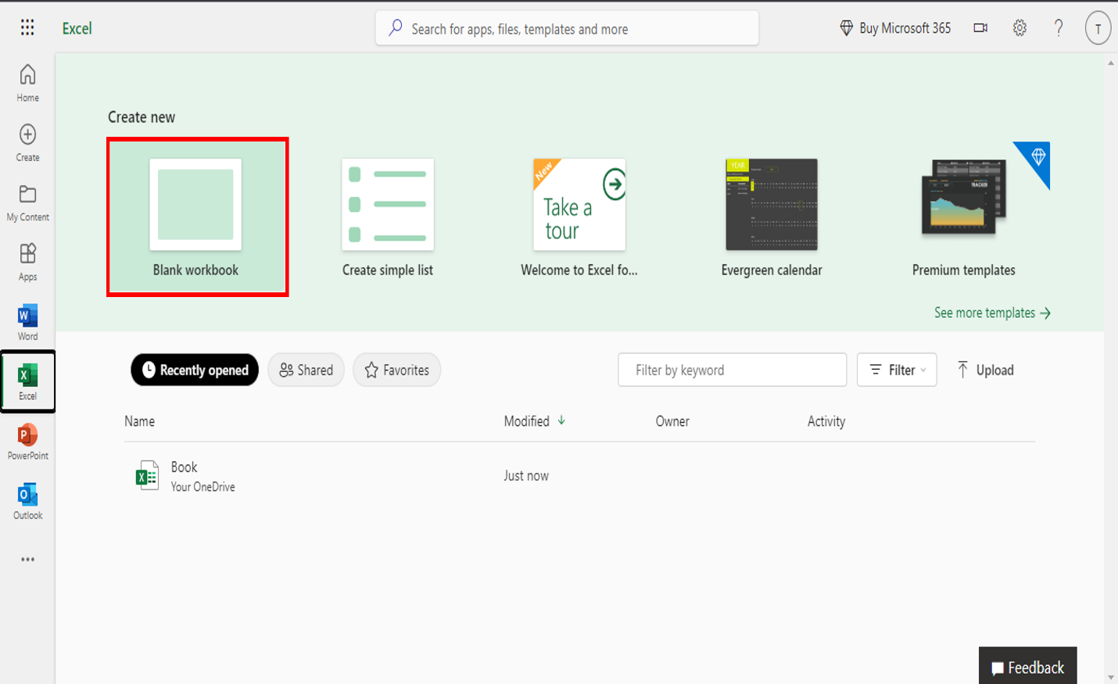

1. You have successfully opened a new workbook in Excel for the web.

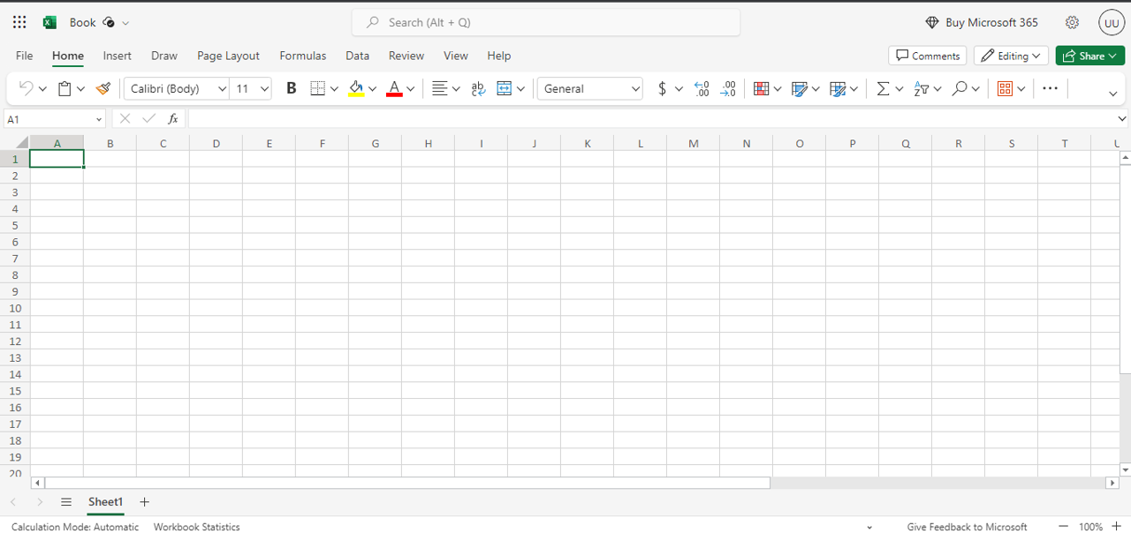

## Task C: Upload and Open a workbook in Excel for the web

1. Download the file [**indian_startup_funding_Lab1.xlsx**](https://cf-courses-data.s3.us.cloud-object-storage.appdomain.cloud/IBMDeveloperSkillsNetwork-DA0130EN-SkillsNetwork/Hands-on%20Labs/Lab%201%20-%20Access%20to%20the%20environment%20-%20Excel%20for%20the%20web/indian_startup_funding_Lab1.xlsx).
2. To upload and open a workbook in Excel for the web, click the **App Launcher** (cube of dots) in the top left corner. Click **Excel** icon. Then click **Upload and open…** and select the **indian_startup_funding_Lab1.xlsx** file.

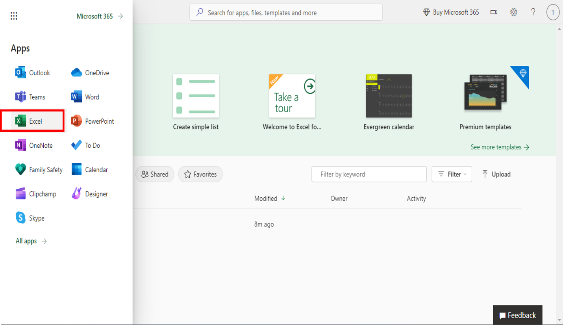 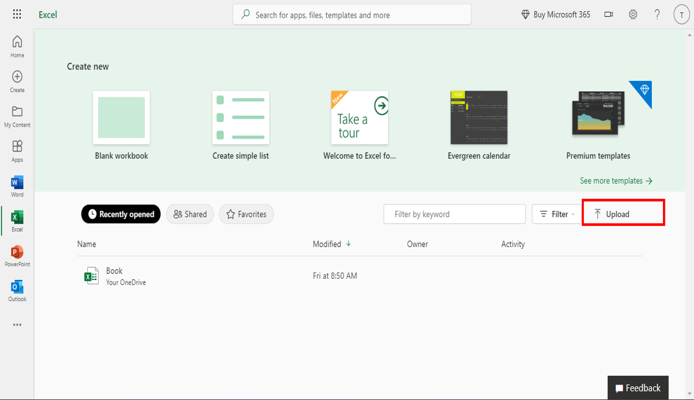

1. The file will be uploaded to your OneDrive of the Microsoft Account you signed up and used to open Excel for the web.

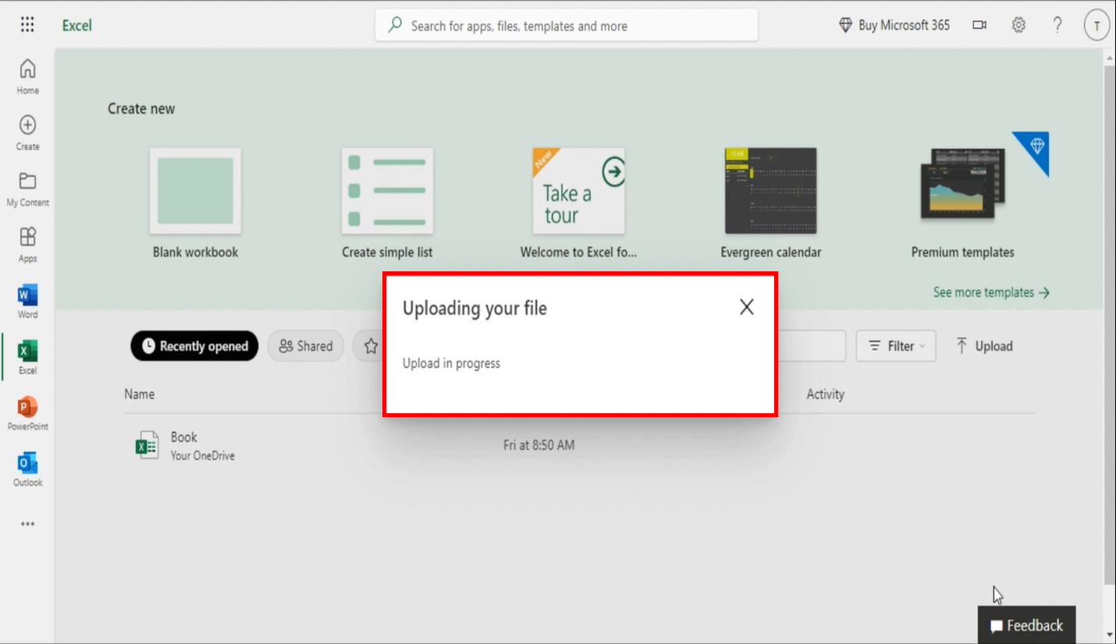

1. You have successfully uploaded and opened a workbook in Excel for the web.

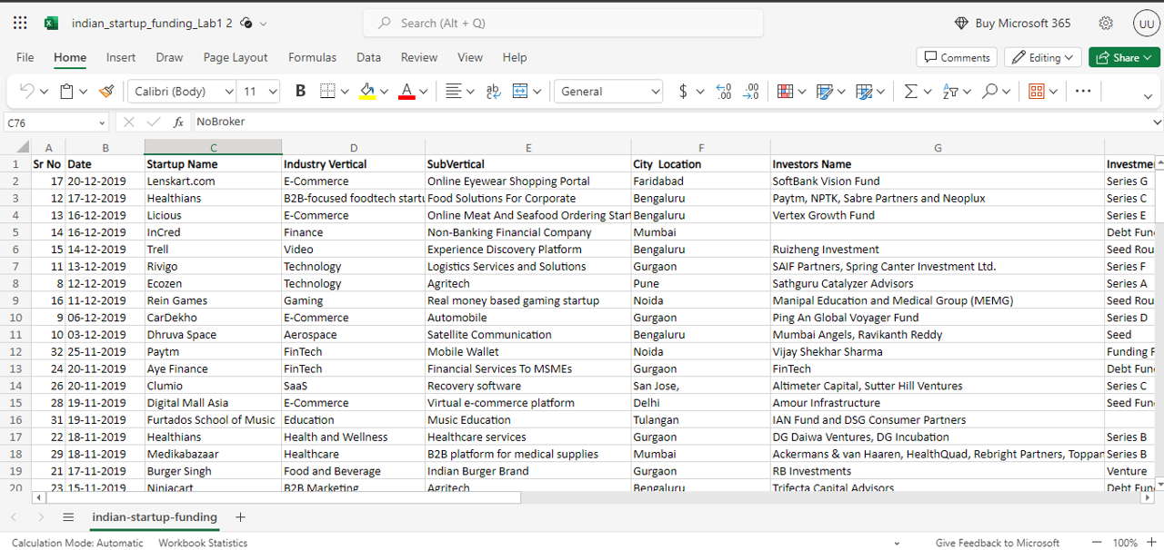

### Congratulations! You have completed Lab 1, and you are ready for the next topic.

# Viewpoints: Using Spreadsheets as a Data Analysis Tool

n this video, we will listen to several data professionals discuss the advantages and limitations

of using spreadsheets as a tool for data analysis.

Let us start with, “What are the benefits and advantages of using spreadsheets as a

tool for data analysis?”

My experience using spreadsheets as a tool for data analysis is somewhat mixed.

I think they can be really, really useful in the right context, but using spreadsheets

definitely has its limitations, so the big pro of using spreadsheets is you can see all

the data cleanly laid out in front of you in a table.

So, I think it's very clear to anyone looking at a spreadsheet exactly what the data is,

what format it comes in, all of that.

You can just easily, visually inspect it.

As a CPA, I use Microsoft Excel on a daily basis and I have done so for the duration

of my career.

The functionalities, the pivot, the pivot tables, the charts, etc.

But also, being able to use formulas.

My personal favorite is Index Match for using a pretty simple way to take just thousands

of lines of information and sift through all of that to find specifically what you're looking

for.

Excel is really that one-stop-shop where you can perform calculations, analyze financial

ratios, and even export reports out of the ERP that I spoke of earlier to customize it

as you need.

My experiences using spreadsheets is that they're great for simple analysis.

I will say spreadsheets, over the years, the process itself has just improved as systems

improve, as technology improves, spreadsheets are the way to go.

Spreadsheets overall, when you do have probably anywhere from zero to twenty-thousand lines

of data, it's a good way to go, you can really pull out the data.

Whether I'm trying to see how much a client’s making per month, but they may have, you know,

a thousand transactions.

All of that's helpful.

I can use this spreadsheet to whittle down what is actually going on per month or if

I want to do a Sum If, or you know if this happens, give me this number.

It it's really helpful to be able to dig in and wrap your hands around it and take something

that seems, on the surface, twenty-thousand lines seems almost unmanageable, but if I

take it and I massage it, put it in a spreadsheet and then sort it filter it, make it pretty,

put in a pivot table, I can get what I need.

It’s just all about not looking at it as being this intimidating thing but making it

more manageable and breaking it down into bite size chunks.

Spreadsheets are the easiest way to analyze data and present data.

We don't need any fancy tools or additional software for spreadsheets.

It's like the commonly utilized language to communicate.

Thank you for that insight, but let's move on to look at the other side of the coin.

What are the drawbacks and limitations of using spreadsheets as a tool for data analysis?

I think one of the big cons in terms of analyzing data within spreadsheets is it's really hard

to reproduce state.

So, in other words, if you load in some data and you filter out some bad values, or you

impute some missing values, there's no way to tell your colleagues or your future self

exactly the different steps you took to create that data set.

Or to modify that data set.

It's almost a dilemma because of the plethora of options available within Excel and all

of the functions that are there, supposedly to make your life easier, but it's nearly

impossible to know everything.

And you can find yourself in what we accountants call analysis paralysis when you're looking

at something for too long or you're not well versed in a particular Excel function.

So, you may spend a lot more time, energy, and effort trying to figure that one thing

out.

And had you done it a different way?

Or maybe a manual way?

You probably could have gotten to the solution a lot easier.

And the downside of using spreadsheets is that if you have complex formulas, v-lookups,

if-statements at times they just stopped working and you have to rebuild them.

So, I have found that it's better to use Excel just for simple analysis and for a download

of information.

I love a good spreadsheet.

I love using Excel and pivot tables to get to the data, but I find that I if I start

to get over ten, twenty- thousand lines of data, it gets a little tricky.

And sometimes the spreadsheets will crash.

So that's when we might move to Access and some of the other tools that we use.

Is very difficult to handle the extremely large data set in spreadsheets.

Besides spreadsheets have less flexibility for complicated analysis and presentation.

# Summary and Highlights

In this lesson, you have learned:

* There are several spreadsheet applications available in the marketplace; the most commonly used and fully-featured spreadsheet application is Microsoft Excel.
* Spreadsheets provide several advantages over manual calculation methods and they help you keep data organized and easily accessible.
* As a Data Analyst, you can use spreadsheets as a tool for your data analysis tasks.
* There are several elements that make up a workbook in a spreadsheet application.
* The ribbon provides access to all the features and tools required to view, enter, edit, manipulate, clean, and analyze data in Excel.
* There are several ways to navigate around a worksheet and workbook in Excel.

### .

Question 1

Of the following, which one would be considered a core capability of spreadsheets?

1 / 1 point



Converting documents



Statistical analysis



Selling stocks



Storage

Correct

Statistical analysis is a core capability of spreadsheets.

### 2.

Question 2

When you open an Excel workbook or spreadsheet, what kind of file is it?

1 / 1 point



.docx



.gsheet



.pdf



.xlsx

Correct

Of these file types, only .xlsx files can be opened in Excel.

### 3.

Question 3

According to the video, on the Excel Home tab what groups are listed?

1 / 1 point



Table, Illustrations, Add-ins, Charts



Tools, Pens, Convert, Replay



Font, Paragraph, Styles, Editing



Font, Alignment, Number, Styles

Correct

The Font, Alignment, Number and Styles groups are located on the Home tab in the Excel ribbon.

### 1.

Question 1

Which of the following key Data Analyst tasks is typically done last?

1 / 1 point



Cleaning data



Collecting data



Analyzing data



Visualizing data

Correct

Visualizing data is the key task that a Data Analyst typically does last

### 2.

Question 2

How are Excel worksheet cells referenced?

1 / 1 point



Column letter first then row number



Row number first then column letter



Column number first then row letter



Cell number first then row number

Correct

Excel worksheet cells are referenced by column letter first then row number, for example: B2 or H12

### 3.

Question 3

Which of the following Excel keyboard shortcuts could be used to find how many rows of data you have in a worksheet, assuming you have no empty rows in your data? **Select all that apply.**

1 / 1 point



CTRL+Up



CTRL+Home



CTRL+End

Correct

You can use this shortcut to find how many rows of data you have in a worksheet. Assuming you have no empty rows in your data, CTRL+End takes you to the very last data cell in a worksheet



CTRL+Down

Correct

You can use this shortcut to find how many rows of data you have in a worksheet. Assuming you have no empty rows in your data, CTRL+Down takes you to the bottom of the current column in a worksheet

Week2

# Viewing, Entering, and Editing Data

Now that you have learned basic spreadsheet terminology and learned how to navigate your

way around worksheets and select data in Excel, it’s now time to start entering some data.

First, we will look at some of the handy viewing features provided in Excel, and then we’ll

enter some data, and then edit that data.

When you have a lot of data in your worksheet it can be useful to zoom in closer to a specific

area of the data.

The Zoom Slider at the bottom right corner of the worksheet allows you to do just that.

You can either click on the plus and minus buttons or drag the slider to select your

preferred zoom value.

You also have some zoom controls in the ribbon on the View tab.

Zoom lets you pick a predefined zoom level or a custom one, the 100% button zooms the

worksheet back to its original size, and Zoom to Selection enables you to select an area

of data and then zoom into that specific selection only.

If you want to see several areas of your data at the same time while zoomed in, you can

use the Split button.

This splits the screen into multiple sections; and you can scroll each section separately.

If you only want two sections, you can remove either the horizontal or the vertical split

by double-clicking on it.

If you have headings in your columns like a header row, then you might want those to

remain on screen while you move down the sheet.

To do that you need to use Freeze Panes.

You can freeze only the top row if you wish, or if that doesn’t suit, as is the case

here, then you can select the row (or even just a cell in the row) below the row or rows

you want to freeze, and then select Freeze Panes.

You can do a similar thing for columns you want to freeze too.

And you can even freeze both rows and columns at the same time.

The trick here is to first select the cell that is both one row below where you want

to freeze, and one column to the right of where you want to freeze.

In this case, that is cell C4.

Now we can scroll down the worksheet and across the worksheet and we can still see the header

row and the Manufacturer and Model columns.

Now, if you have multiple workbooks open (notice I said workbooks and not worksheets) then

you can switch between them by using View, Switch Windows, or the faster method is to

use the CTRL+F6 shortcut.

Now let’s enter some data into a blank worksheet.

The easiest way to open a new worksheet from within Excel is to click the New button in

the Quick Access Toolbar (or CTRL+N if you prefer keyboard shortcuts).

So let’s enter some headings across the top of the worksheet; this is typically referred

to as a ‘header row’.

Note, that if you press Enter after typing data into a cell the next active cell is the

one directly below, which is not what we want in this case.

But, if we press Tab after we enter data in a cell, it selects the next cell along in

the row as the active cell.

Now we’ll enter some headings and press Tab after each entry.

Notice that the text is slightly longer in some of the cells and it either gets partly

hidden by the next cell or overlaps it.

If you click and hold the divider line between two columns, you can drag it left and right

to resize it manually.

If you want to do that automatically, you can double-click the divider line between

two columns.

As these are going to be headings for our columns, let’s make them bold.

Now let’s add another column between the parts and accessories columns.

Simply select the right-hand of those two columns, then right-click and choose Insert

to put another column to the left of the selected column.

Let’s call it Servicing Sales.

To tidy up all our column widths simultaneously, we select all the columns from A to E, then

double-click any of the divider lines between columns; this automatically reduces or increases

each column’s width to fit the data in that column.

OK, now we have some headings, let’s enter some month data in column A.

So, if we type Jan in cell A2 and press Enter then it takes us to the cell below, which

is what we want in this case and we can type Feb in cell A3 and so on until

we get to Dec in A13.

Now, let’s suppose you need to change a couple of your headings.

You have several ways of editing existing data in a cell;

You can either select the cell and then just start over typing.

Or you can select the cell and press F2 on your keyboard to put the cursor at the end

of the cell and make your changes.

Or you can simply double-click somewhere on the cell to put the cursor at that position

in the cell and make your changes.

And you can even select the cell and then click in the formula bar to edit your cell

data.

Now let’s do the same for the parts and accessories column headings.

In this video, we learned about some of the viewing options in Excel, and we learned how

to enter and edit data in cells.

In the next video, we will learn how to copy and fill data, and how to format the cells

and data in a worksheet.

# Copying, Filling, and Formatting Cells and Data

Now that we have learned about some of the handy viewing features provided in Excel,

and entered and edited some data, let’s discuss how to move, copy, and fill data,

and how to format cells and data to suit our needs.

The first thing we are going to discuss is how to move data, so if you select a range

of cells, in this case the headings in A1 to E1, and then hover over the top or bottom

edge of a selected cell, and you will see the Move pointer, then you can drag the selection

to another place on the worksheet.

Alternatively, if you want to copy the data instead, you do the same thing but this time

you also hold CTRL key as you select and drag the selection to another location and you

will see the Copy pointer.

If you are not comfortable with dragging, you can also use Copy and Paste menu commands

or keyboard shortcuts.

So if you select some data in column A and copy it to the clipboard.

Then you simply select the new location and paste the copied data.

You can also move or copy between worksheets, so let’s create a new worksheet.

Then select some data from Sheet1, and this time let’s use the CTRL+C keyboard shortcut

to copy it to the clipboard.

Then choose the other worksheet and use the CTRL+V shortcut to paste the data.

However, notice that the column widths are not the same as the original source data,

so let’s undo that and try another paste option.

By default, when you paste the copied data, it uses the column width settings of the destination

cells.

So, to paste it and retain the column widths of the source data, you chose the special

option under the Paste command, called Keep Source Column Widths.

As an alternative to having to enter data manually in a worksheet, you can use an Excel

feature that automatically fill cells with data when it follows a sequential series or

pattern.

The feature is called AutoFill, and it can be especially useful when you need to enter

lots of repetitive data into Excel, such as date information.

For example, if you enter a month in a cell, even using a shortened version of the name,

you can use what’s called the Fill Handle to select down to the end of the series, and

AutoFill will work out what the series is, based on the selected data.

Let’s try the same thing with days of the week.

If you enter Mon in a cell, then drag the fill handle to use AutoFill, it will determine

that you want to enter the days of the week sequentially.

However, if you also enter Wed (for Wednesday) in the next cell down, and select both cells

in the series, i.e.

A16 and A17, and then drag the fill handle down, AutoFill determines that the sequence

has changed to every other day, and fills in the data series for you.

It’s important to select all cells that define the pattern when using AutoFill so

that it can best determine what the pattern is, in this case cells A16 and A17.

A similar thing applies to numerical patterns; if you enter 5 in a cell, and then use the

fill handle to fill the data down the column.

Because the data is not the name of a day or month for example, AutoFill can’t determine

what the pattern is yet.

So, In this case, it just copies the value 5 into every selected cell.

However, if you enter the value 10 in B3, and then use the fill handle to fill the data

down the column, AutoFlll determines that the pattern is incrementing by 5 each time

and it fills in the remainder of the data pattern for you.

We are now going to look at formatting our data, and there are essentially two distinct

parts to this.

First, there’s formatting of the cells themselves (with a fill color and a bold border for example

and bold text within it).

And then there’s formatting the data in the cells (for example, making it text format,

number format, or a specific currency or accounting format).

Let’s open the car sales worksheet we used previously.

Then select the headings in cells A3 to P3 either using the mouse, or you could use the

shortcut keys CTRL+SHIFT+Right Arrow.

On the Home tab, click the Styles drop-down arrow, and select a style color for your cells.

Then you can make the selected cells bold.

Then you select the data in the Manufacturer column either using the mouse, or the shortcut

keys CTRL+SHIFT+Down Arrow.

In the Styles drop-down arrow, select another style color for the selected cells.

Again you can make the cells bold.

Then you select the data in the Model column again either using the mouse, or the shortcut

keys CTRL+SHIFT+Down Arrow.

In the Styles drop-down arrow, select another style color for the selected cells.

This time you could make the selected cells italic.

And you can also change the font size and style.

Lastly, you can select all the other cells in the data by using the mouse or the CTRL+SHIFT+Right

Arrow then Down Arrow, and apply borders to the data cells.

Now it’s time to format the cell data.

The sales figures in columns C and D can be formatted to display only two decimal places;

just select the data and click the Decrease Decimal button.

We also have an issue with a couple of the car models.

If you look in cells B129 and B130, where the model name is supposed to be displayed,

you can see there are actually two dates listed instead.

And if you look in the Number Format box, the format type is Custom.

This has happened because the model numbers are supposed to be the Saab 9-5 and the Saab

9-3 but when the files were imported from CSV files these two cells must have been incorrectly

determined to be date values and not just numbers.

You can fix this by formatting these two cells as Text, and then enter the correct values

of 9-5 and 9-3.

The last thing we shall do is format some data as currency.

If you look at the heading in column F it says it is Price in thousands of dollars,

and cell F4 is using the General format.

So, let’s change the format of this column to American currency format.

We select the column, F in this case, then select More Number Formats from the drop-down

list, then we choose the Currency option, and the correct currency symbol and format.

And we’re done.

In this video, we learned how to move, copy, and fill data, and how to format cells and

cell data to suit our needs.

In the next video, we will look at the basics of formulas, learn how to perform simple calculations,

and learn how to select ranges and copy formulas.

# Software Used in this Lab

The instruction videos in this course use the full Excel Desktop version as this has all the available product features, but for the hands-on labs we will be using the free ‘Excel for the web’ version as this is available to everyone.

Although you can use the Excel Desktop software if you have access to this version, it is recommended that you use Excel for the web for the hands-on labs as the lab instructions specifically refer to this version, and there are some small differences in the interface and available features.

# Dataset Used in this Lab

The first dataset used in this lab comes from the following source: <https://www.kaggle.com/sudalairajkumar/indian-startup-funding> under a [**CC0: Public Domain license**](https://creativecommons.org/publicdomain/zero/1.0/). Acknowledgement and thanks also goes to [https://trak.in](https://trak.in/) who were generous enough to share the data publicly for free.

We are using a modified subset of that dataset for the lab, so to follow the lab instructions successfully please use the dataset provided with the lab, rather than the dataset from the original source.

The second dataset used in this lab is an internal dataset.

# Objectives

After completing this lab, you will be able to:

* Use viewing options, and enter and edit data
* Copy and fill data, and format cells and data

# Exercise 1: Viewing, Entering and Editing Data

In this exercise, you will learn some of the viewing options in Excel, how to enter and edit data in cells.

## Task A: Viewing Data

1. Download the file [**indian_startup_funding_Lab3.xlsx**](https://cf-courses-data.s3.us.cloud-object-storage.appdomain.cloud/IBMDeveloperSkillsNetwork-DA0130EN-SkillsNetwork/Hands-on%20Labs/Lab%203%20-%20Entering%20and%20Formatting%20Data/indian_startup_funding_Lab3.xlsx). Upload and open it using Excel for the web.
2. Select **F20:H26** (if required, use the vertical and horizontal scroll bars to bring the selected cell range area to the center of the screen). Hold **CTRL and +** to zoom in closer to the specific area of the data. Then hold **CTRL and -** to zoom the worksheet back out to its original size. (**Note:** **Zoom to Selection** which is found under the **View** tab of Excel Desktop, is not available for Excel for the web)
3. On the ribbon, click **View, Freeze Panes, Freeze Top Row**. Now you have headings in your columns like a header row, which will remain static on screen while you move down the worksheet. Next, click **Unfreeze Panes**, and click **Freeze First Column**. The Sr No column will remain static on the screen while you move right across the worksheet. Lastly, click **Unfreeze Panes** to end this step.

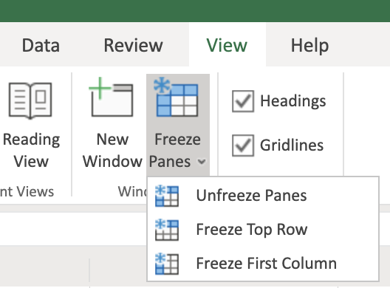

1. To freeze both the top row and the first column at the same time, select cell **B2** and click **View, Freeze Panes, Freeze Panes**.



1. You can open multiple workbooks in multiple browser tabs in Excel for the web, and to switch between them, you just click each browser tab. (In Excel Desktop you have to click the **View** tab, then click **Switch Windows**)

## Task B: Entering Data

1. Download the file [**Personal_Monthly_Expenditure_Lab3.xlsx**](https://cf-courses-data.s3.us.cloud-object-storage.appdomain.cloud/IBMDeveloperSkillsNetwork-DA0130EN-SkillsNetwork/Hands-on%20Labs/Lab%203%20-%20Entering%20and%20Formatting%20Data/Personal_Monthly_Expenditure_Lab3.xlsx). Upload and open it using Excel for the web. Go to the **Expense - 2018** worksheet.
2. In cell **A1**, type **Month** and press **Tab**. Then type **Housing** and press **Tab**, type **Food & Dining**, and press **Tab**, type **Personal**, and press **Tab**, type **Auto & Transport**, then press **Tab**, type **Health & Fitness**, then press **Tab**. You are now done with the header row.
3. To enter some data as rows in column **A**, in **A2**, type **Jan** and press **Enter**. Then type **Feb**, and press **Enter**, type **Mar**, and press **Enter**, type **Apr**, and press **Enter**.
4. To add another column between the **Housing** and **Food & Dining**, select column **C**, then right-click column **C**, and choose **Insert Columns**. In the top row header cell **C1**, type **Bills & Utilities**.

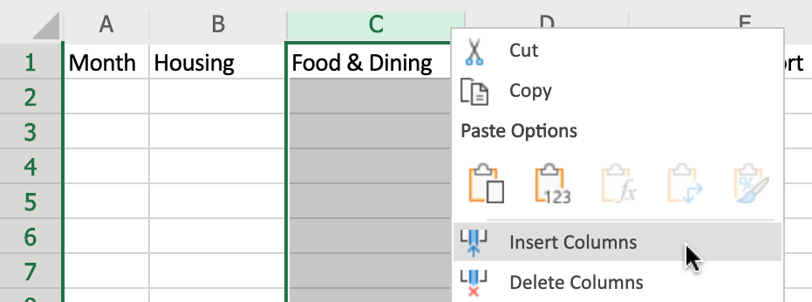

1. Select columns **A to G**, then double-click the divider between **A** and **B** to adjust the column widths.



## Task C: Editing Data

1. Select cell **C1** and press **Backspace** to clear the contents. Then type **Bills**.
2. Click **Undo** to undo the change.

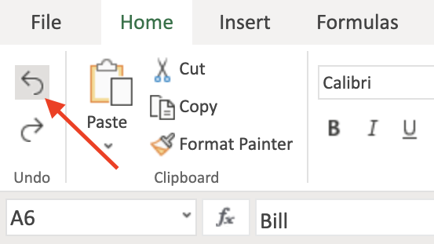

# Exercise 2: Copying, Filling, and Formatting Cells and Data

In this exercise, you will learn how to move, copy, paste, and fill data, and how to format cells and cell data in a worksheet.

## Task A: Copying and Filling Data

1. Select **A2:A5**. Hover over the edge of the selected cells to get the **Move** pointer and then drag the selection to move the selected cells to **B6**. Click **Undo**.

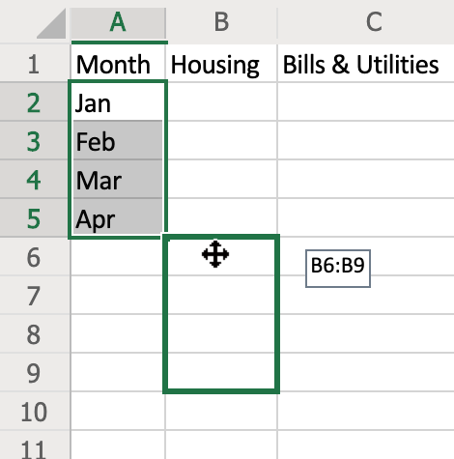

1. Select cell **A5**. Hover over the bottom right corner of cell **A5** to get the **+ (Fill Handle)** symbol, then drag to **A13**.



1. On the **Expense - 2018** sheet, select **A1:G13** and press **CTRL+C**. Then on the **Expense - 2019** sheet, select cell **A1** and press **CTRL+V**.
2. Select cell **A1** and press **CTRL+A** to select the whole datasheet. On the **Home** tab, in the **Cells** group, click the drop-down arrow under **Format**, and click **Auto-Fit Column Width**.

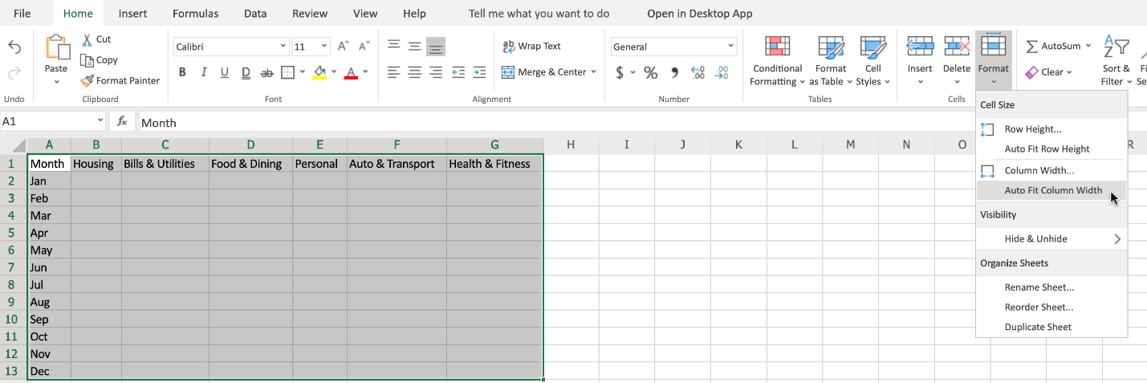

## Task B: Formatting Cells and Data

1. Formatting Cells:
   * a. Select **A1:G13**. On the **Home**, in the **Tables** group, click **Format as Table**, and choose a table style from the list. In the pop-up dialog box, ensure that the option **My table has headers**, is checked and then click **OK**.

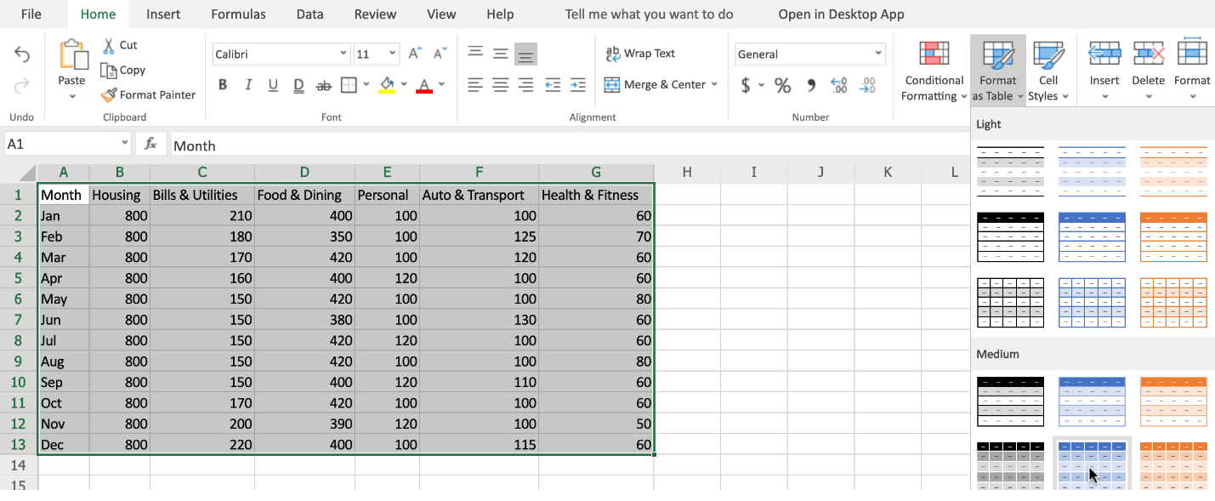

* + b. Select **A2:A13**. In the **Font** group click **Italic**. In the font size box, select **10**. In the font style drop-down box, select **Arial**.

1. Formatting Cell Data:
   * a. Select column **B**, and use **SHIFT+right arrow** to select across to include column **G**. On the **Home** tab, in the **Number** group, click the **Number Format** drop-down list and choose **Currency**.
   * b. Select columns **B** to **G** again. On the **Home** tab, in the **Number** group, click **Decrease Decimal** once.
   * c. Select columns **B** to **G** again. On the **Home** tab, in the **Number** group, click the **Accounting Number Format ($)** drop-down list, and select **£ English (United Kingdom)**.

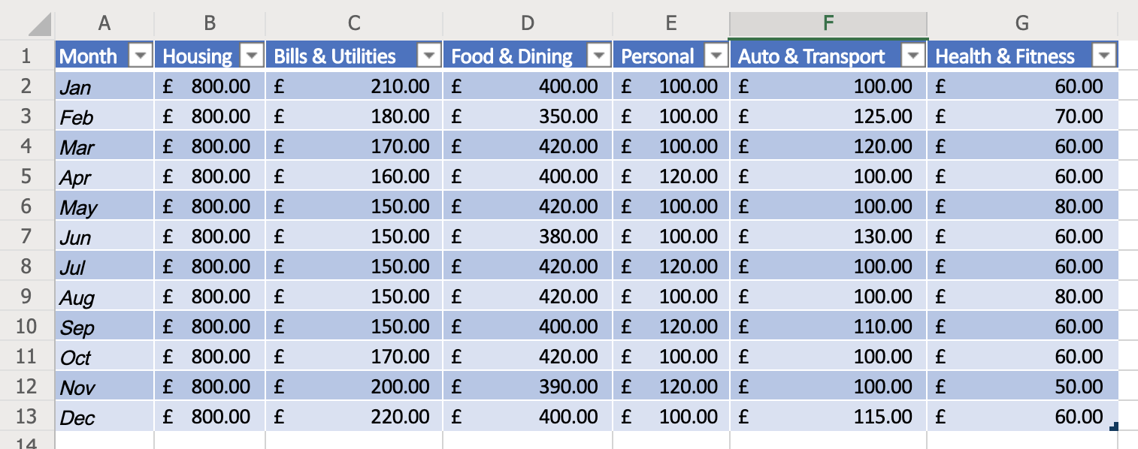

# The Basics of Formulas

Now that we have learned how to move, copy, and fill data, and how to format cells and

data, next we will take a look at the basics of formulas, including some basic calculations,

selecting ranges in formulas, and how to copy formulas.

A typical formula is made of several key components.

The equal sign starts the formula off and lets Excel know you are creating a formula

in this cell.

The next part is the function, which performs the calculation.

For example, the SUM function adds up the values in referenced cells or cell ranges.

Then comes the reference, which is the cell or range of cells you want to include in your

calculation, and these need to be enclosed in parentheses.

You also have operators, which specify what type of calculation to perform.

Common arithmetic operators include: addition, subtraction, multiplication and division.

And these are represented by symbols.

The plus symbol for addition, the minus symbol for subtraction, the asterisk for multiplication,

and the forward slash for division.

There are other types of operators too.

Namely comparison, text concatenation, and reference.

You may also use constants in your formulas, which as the name suggests are numbers or

values which you can enter directly into a formula, and which don’t change.

This might be a whole number such as 5, it might be a percentage such as 10%, or it might

even be a date.

So, a typical formula might be =SUM(B5*20), which would take the value in cell B5 and

multiply it by 20.

Let’s start with a few basic calculations.

Suppose you want to add up January and February sales of accessories.

You would start by typing an equal sign, which lets Excel know you are entering a formula.

Then you type in the function you wish to use, in this case the SUM function.

Note the description.

Next you type an open parenthesis, then you select your cell range, which in this case

would be E2 to E3, so you could enter that as ‘E2,E3’ then a close paranthesis and

press Enter.

And if you wanted to add March sales as well, then you would have to extend the cell range

to include E4.

So you could type E2,E3,E4 as your range and it will work.

Remember, to edit a cell, you select the cell, and either edit it directly in the formula

bar, or press F2, or double-click the cell.

However, it’s very cumbersome and not very flexible to do it this way, because if you

wanted to add up the entire column then you’d have to type every cell reference, one after

the other.

So thankfully, there’s a better way.

Instead of typing each cell to include in the reference, you just put a colon between

the first and last values in our range, so E2:E4, in this case.

And if you wanted the whole column, then you would enter E2:E13 in your formula.

But there’s another way of doing it, and that’s by using your mouse to select the

range, so you still type =sum then open parenthesis, but select the range with your mouse (or SHIFT

+ arrow keys) and just press Enter.

Excel will add the close parenthesis for you.

To total these columns up, and add some tax, you’d add some headings first for Subtotals,

and Tax at 20%.

Then your formula will need to multiply the value in Subtotals by 20%.

If you want to add up all the column subtotals and calculate the taxes, then you could repeat

the previous process for each column, but that’s very time consuming, and you don’t

need to, because Excel has some neat tricks to do this for you.

Just select the fill handle in the bottom right corner of the cell, and drag across

to the other cells to copy the formula; this is called AutoFill.

Notice how the formula is copied, but the row references change in relation to the cells’

position on the worksheet.

So what was E2:E13 has become B2:B13.

These are known as relative references, but more on that later in the course.

And you can do the same thing for the tax values in row 16.

Now, you need a row for showing the totals.

The calculation here is simply the subtotal value in cell B15, added to the tax in B16.

And again, you can use the fill handle to copy the formula across.

If you want to total the sales of all products by month, you’d add a column heading; notice

how the cell style is copied to the new heading automatically.

Remember, to widen a column, either drag the divider manually, or double-click the divider.

Then enter the formula in cell F2 as you’ve done before.

However, Excel has another trick up its sleeve.

It’s called AutoSum and is found on the Home tab, in the Editing group.

This is a great little shortcut for some simple common functions like Sum, Average, Count,

Max, and Min, but you can choose other functions too.

You want ‘Sum’ for this particular calculation.

Notice that it also has a keyboard shortcut of ‘Alt plus equals’, and then press Enter,

and it’s done.

Now you can use the fill handle to copy down the remaining values.

But hold on, there is one more Excel trick to show and it’s a good one!

Suppose your column of data was very long; you might have to drag the fill handle down

over several pages, which isn’t easy to do and can easily lead to errors when selecting

large lists of data values.

Rather than needing to drag down to the rest of the column, you can just double-click the

fill handle, and it will automatically copy the formula to all the remaining cells in

that column.

This one is a real time-saver.

Finally, let’s format all these values to use the US dollar currency format.

In this video, we learned about the basics of formulas, how to perform simple calculations,

how to select ranges in formulas, and how to copy formulas.

In the next video, we will look at how to use some of the common functions used by Data

Analysts and discover some more advanced functions.

# Intro to Functions

Save note

Now that you have learned about the basics of formulas, learned how to perform some basic

calculations, and how to select ranges and copy formulas, next we will have an introduction

to functions, including using some common statistical functions.

And then we will learn about some more advanced functions that a Data Analyst might also use.

First, let’s look at some common functions used for statistical calculations.

So, we’ll add some row headings for average, minimum, maximum, count, and median.

Then in cell B20, let’s work out the average of the car sales for the year, from the table

above.

On the Home tab, in the Editing group, we click the AutoSum drop-down list and choose

Average.

Now, because AutoSum tries to add up the values directly above it in the column, we need to

modify the cell range here to B2 to B13.

Then we can use the Fill Handle as we’ve seen before to copy the formula across to

column E.

For the minimum calculation in B21, we select Min from the AutoSum list.

And again, we need to modify the cell range.

So this calculates the lowest value in our range.

And fill across to column E. And for the maximum calculation, we select

Max from the list.

And then modify the range.

And once again, copy the formula across.

This calculates the highest value in our range.

In B23 we will calculate the Count, which basically just means the number of values

that exist in the selected range.

So, we select Count Numbers from the list.

Then modify the range.

For the median calculation, we can select ‘More Functions’ from the AutoSum list,then

select ‘Statistical’ as the category, and scroll down to find the MEDIAN function.

The ‘median’ returns the exact middle of a range of selected values.

Note that if you’re selecting an odd number of values it will return the figure that is

the middle value in your selected range, but if you have selected an even number of values

in your range, it will return the middle figure between the two middle values in your range.

Once again, we need to change the cell range to B2 to B13.

And we can then copy this formula across to column E.

You’ve seen AutoSum and some of the common statistical functions in Excel, but there

are another 400-plus other functions available, so let’s explore just a few of those now.

On the Formulas tab, in the Function Library group, there are drop-down lists for several

function categories.

The first is a list of ‘Recently Used’ functions, which updates automatically as

you use them.

Then you have functions related to ‘Financial’ calculations.

If you hover over the name of a function, you see a short description for each one;

so here we have the accrued interest function, and here is the interest rate function.

The ‘Logical’ list has BOOLEAN operator functions such as AND, IF, and OR.

There are several functions related to Text, such as CONCAT, which is an updated version

of a previous function called CONCATENATE (which is still supported by the way for backwards

compatibility), FIND, and SEARCH.

There are also several functions related to dates and times, such as NETWORKDAYS, WEEKDAY,

and WEEKNUM.

In the ‘Lookup & Reference’ list there are functions such as AREAS, HLOOKUP, SORTBY,

and VLOOKUP.

In the ‘Math & Trig’ list you’ll find lots of useful mathematical functions, such

as POWER, SUMIF, and SUMPRODUCT, alongside many functions for trigonometric purposes,

such as cosine, sine and tangent.

There is also a ‘More Functions’ list which provides several more function categories,

such as Statistical, Engineering, and Information.

In the ‘Statistical’ list you’ll find functions such as Average, Count, Max, Median,

and Min; we saw some of these used earlier in this video.

If you’re struggling to find the function you want in these lists, you can also search

for a function; just click the ‘Insert Function’ button on the Formulas tab, and then either

browse the category lists available, or choose ‘All’ and look down the alphabetical list

for the function you want.

Alternatively, type the name of a function you want to find, and click ‘Go’ to search

for it, then select the one you want from the returned search.

In this video, we learned about the basics of functions, how to use some of the more

common functions that a Data Analyst might employ, and looked at some of the more advanced

functions available in Excel.

In the next video, we will look at referencing data in formulas; specifically differentiating

between relative and absolute references, and error handling in formulas.

# Referencing Data in Formulas

Save note

Now that you've had an introduction to functions,

seeing the use of some common statistical functions and

learned about some of the more advanced functions that a data

analyst might use, in this video will look at the difference

between relative, absolute, and mixed references in formulas as

well as how to use them. And we'll learn about formula errors

in Excel. It's important to understand the difference

between relative and absolute references when creating your

formulas. By default, in Excel, cell references are always

relative references. The term relative is the key here,

because it means that when you reference a cell, you are in

fact referencing the cells position in relation to the cell

that the formula is in.

That is why when we have been copying formulas from one cell

to another so far in this course, using either copy and paste or

the fill handle, we haven't needed to modify the cell

references because Excel assumes you are using relative

references. When the formulas are copied, the cell references

are changed to match the relative positions of the cells

that are being copied to.

So now we know that relative references are the default in

Excel, but how do we make it so that the cell references don't

change when we copy them? For that you need to use absolute

references in contrast to relative references. Absolute

references to cells stayed the same. When you copy a formula

containing such references.

Lastly, there may also be some instances where you only want

one of the cell reference identifiers to be absolute and

the other one to be relative. For example, you might want the

row identifier to be absolute, but the column Identifier to be

relative, or vice versa. These are called mixed references and.

An example of this would be equal sign a dollar sign one

plus A3 where a dollar one.

Has a relative column and an absolute row or dollar 8. Three

has an absolute column. Ando

relative RO. In contrast to relative and absolute

references, when you copy a formula containing mixed cell

references, any relative cell references will change, whereas

any absolute cell references will stay the same in the copied

formula. First, let's look at an example of using relative

references in a formula. For example, if we enter the formula

equals A1 plus a 3IN cell, four note the blue an red highlighted

cells in a one, and a three. These denote the cells being

relatively referenced in the formula. If we copy the formula

to the cell directly below using the fill handle, we can see that

the result changes, and if we look at the copied formula.

You can see that the blue and red cell references have changed

relative to their position on the worksheet. The formula has

been changed to equals A2 plus a four in the copied formula. That

is, each cell reference has moved one cell down and if we

copy and paste the formula to see seven, you can see that the

results also changes and again we can see that the blue and red

cell references in the copied formula have changed now.

Let's look at an example of how to use absolute references in a

formula. All you need to do to make a cell reference absolute

is put a dollar sign in front of the column and or row

identifiers in the formula. For example, if we enter the formula

equals dollar sign a one plus sign a dollar 3IN cell E4. Note

the blue and red highlighted cells in a one and a three.

These denote the cells being.

Absolutely referenced in the formula. When we copy the

formula using the fill handle, you can see that the result

stays the same this time and if we look at the copied formula

you can see that the blue and red cell references haven't

changed. The formula is still equal sign dollar a dollar one

plus a dollar three in the copied formula. That is, the

cell references haven't changed.

Similarly, if we then copy and paste the formula to E7, you can

again see that the result stays the same this time and we can

see that the blue and red cell references haven't changed. The

formula is still equal sign dollar a dollar one plus dollar

a dollar three in the copied formula. That is, the cell

references haven't changed. Lastly, will look at an example

of how to use mixed references in a formula so.

If we enter the formula equals a dollar one plus dollar 8, three

in cell G4. Note the blue and red highlighted cells in A1A

three. These denote the cells being referenced in the formula.

If we copy the formula to the cell below using the fill

handle, you can see that the result changes, but it's a

different result from the previous examples. And if we

look at the copied formula, you can see that the first blue cell

reference has stayed the same.

But the second red cell reference has changed. If we

copy and paste the formula to G7, you can see that the same

thing happens. The result changes and again we can see

that the first blue cell reference has stayed the same in

the copied formula, while only the red cell reference has

changed. Now we'll have a quick introduction to dealing with

formula errors in Excel.

Because of the complexity of writing formulas, especially the

more complicated ones, there are bound to be occasions when you

make a mistake in the syntax or in the data selection which will

lead to a formula error. Errors are typically denoted by

displaying in the cell that is supposed to be displaying the

result. One of the error codes in this list when you see

multiple hash symbols in a cell, it's not really an error, it

just means the column either isn't wide enough to display the

whole word or value.

Or it contains a negative date or time value?

So if we type control plus semi colon, then space then control

plus shift plus semi colon, it enters today's date and the

current time. But the cell is too narrow to display it. So

what we see is multiple hash symbols. If we adjust the column

width we can now see the cell contents. So as I said, this

really shouldn't be considered as an error. However if we enter

the formula seen in Cell I7.

When we press enter, we see a hash name error. This error was

caused by trying to use an X as a multiplication operator when

in fact it should be an asterisk. Note the small green

triangle in the top left corner of the cell.

Also note that when you select the cell and exclamation mark

appears, providing you with a hint about what caused the

error. In this case it says the formula contains unrecognized

text. When you click the dropdown error next to the

exclamation mark for an error, you see several options. The

first line also gives you a clue on the nature of the error. This

one says invalid name error, so it was probably a mistyped cell

reference value or function

name. If you click help on this error, uh, help pane opens with

specific information related to this error. If you click show

calculation steps, a dialog box opens displaying the current

syntax with the error underlined. And you can try to

evaluate the error if you are certain the error is incorrect,

you can choose ignore error, and if you want to edit the

formula, click edit in Formula Bar and the cursor will be

focused in the formula bar so that you can try and correct

the formula error.

Play video starting at :8:34 and follow transcript8:34

If you click error checking options, the Excel Options

Dialog Box is opened at the section related to error

checking rules and you can modify these options to suit

your needs. Each of the errors you make which generate one of

the error codes listed at the start of this video will have a

different reason and a different solution For more information on

each of these errors and typical solutions visit the link

provided. In this video we learned about referencing data

in formulas, specifically differentiating between

relative, absolute, and mixed references, and how to use them.

And we learned about formula errors in Excel.

**Software Used in this Lab**

The instruction videos in this course use the full Excel Desktop version as this has all the available product features, but for the hands-on labs we will be using the free ‘Excel for the web’ version as this is available to everyone.

Although you can use the Excel Desktop software if you have access to this version, it is recommended that you use Excel for the web for the hands-on labs as the lab instructions specifically refer to this version, and there are some small differences in the interface and available features.

**Dataset Used in this Lab**

The dataset used in this lab is an internal dataset.

**Objectives**

After completing this lab, you will be able to:

* Understand the basics of formulas
* Perform simple calculations
* Select ranges in formulas and copy formulas
* Understand the basics of functions
* Use common functions
* Understand the more advanced functions available
* Reference data in formulas
* Differentiate between relative and absolute references
* Understand how to handle formula errors

**Exercise 1: Basics of Formulas**

In this exercise, you will learn the basics of formulas, how to perform simple calculations, how to select ranges in formulas, and how to copy formulas.

1. Download the file [**Personal_Monthly_Expenditure_Lab4.xlsx**](https://cf-courses-data.s3.us.cloud-object-storage.appdomain.cloud/IBMDeveloperSkillsNetwork-DA0130EN-SkillsNetwork/Hands-on%20Labs/Lab%204%20-%20Simple%20use%20of%20functions/Personal_Monthly_Expenditure_Lab4.xlsx). Upload and open it using Excel for the web. Go to the **Expense - 2018** worksheet.



1. In **A14**, type **Totals** and in **B14**, type **=SUM(** then select cells **B2 to B13** with the mouse, and press **Enter**.
2. Select the **fill handle** on cell **B14** and drag to **G14** to copy the formula.



1. In cell **H1**, type **Monthly Total** and double-click the divider between **H and I**.
2. In **H2**, type **=SUM(** then select cells **B2 to G2** with the mouse, and press **Enter**. If necessary, select the **fill handle** on cell **H2** and drag to **H14** to copy the formula.
3. Select columns **B to H**. On the **Home** tab, in the **Number** group, click the **Accounting Number Format ($)** drop-down list, and select **$ English (United States)**.

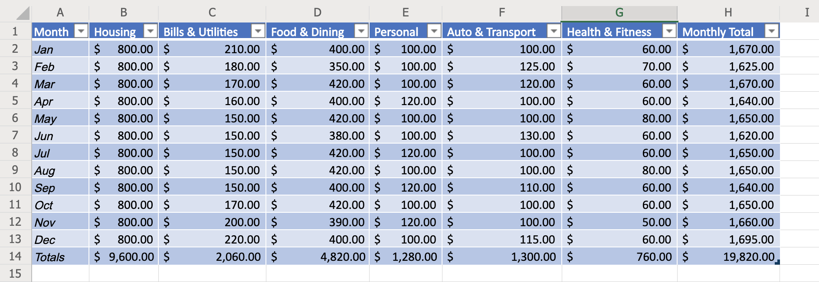

**Exercise 2: Basics of Functions**

In this exercise, you will have an introduction to functions, including using some common statistical functions, and then you will learn about some more advanced functions that a Data Analyst might also use.

1. In cells **A16-A20**, type the following:
   * **Avg**
   * **Min**
   * **Max**
   * **Count**
   * **Median**
2. In **B16**, type **=AVERAGE(** then select cells **B2 to B13** with the mouse, and press **Enter**. Select the **fill handle** on cell **B16** and drag to **G16** to copy the formula.
3. In **B17**, type **=MIN(** then select cells **B2 to B13** with the mouse, and press **Enter**. Select the **fill handle** on cell **B17** and drag to **G17** to copy the formula.
4. In **B18**, type **=MAX(** then select cells **B2 to B13** with the mouse, and press **Enter**. Select the **fill handle** on cell **B18** and drag to **G18** to copy the formula.
5. In **B19**, type **=COUNT(** then select cells **B2 to B13** with the mouse, and press **Enter**. Select the **fill handle** on cell **B19** and drag to **G19** to copy the formula. Select row **19**. On the **Home** tab, click the **Number Format** drop-down list, and select **Number**.
6. In **B20**, type **=MEDIAN(** then select cells **B2 to B13** with the mouse, and press **Enter**. Select the **fill handle** on cell **B20** and drag to **G20** to copy the formula.

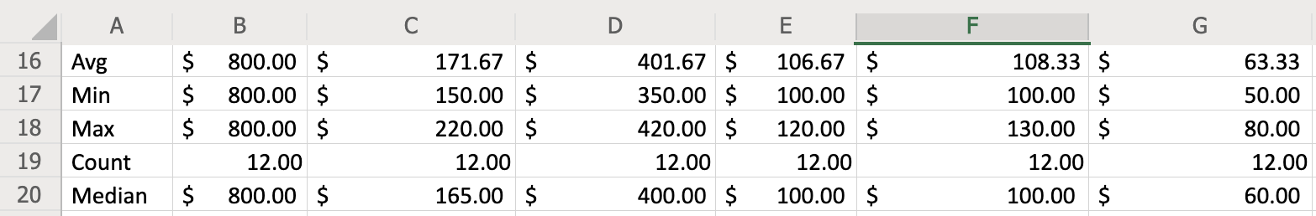

1. Explore some more commonly used functions of a data analyst by clicking the arrow under **AutoSum**, then select **More Functions** and look at some of the functions in various categories to see what actions they perform:
   * Financial : **ACCRINT, INTRATE**
   * Logical : **AND, IF, OR, NOT**
   * Text : **CONCAT, FIND, SEARCH**
   * Date & Time : **NETWORKDAYS, WEEKDAY**
   * Lookup & Reference : **AREAS, SORTBY, VLOOKUP, HLOOKUP**
   * Math & Trig : **POWER, SUMIF, SUMPRODUCT**
   * Statistical : **AVERAGE, COUNTIF, MAX, MEDIAN, MIN**

**Exercise 3: Referencing Data in Formulas (relative vs absolute) & Formula Errors**

In this exercise, you will learn how to reference data in formulas; specifically differentiating between relative and absolute references, and you will also learn about error handling in formulas.

1. In cells **A31-A40**, type **1-10**. Select row **31 to 40**. On the **Home** tab, click the **Number Format** drop-down list, and select **General**.
2. Relative References : In cell **B33**, type **=A31+A32** and press **Enter**. Select the **fill handle** on cell **B33** and drag to **B40** to copy the formula. Here, both first and second cell reference will move 1 cell down. For example, on cell **B34** formula will be changed to **=A32+A33**, on cell **B35** formula will be changed to **=A33+A34** and so on.
3. Absolute References : In cell **C33**, type **=$A$31+$A$32** and press **Enter**. Select the **fill handle** on cell **C33** and drag to **C40** to copy the formula. Here, both first and second cell references will not change. For example, on cell **C34** formula will remain **=$A$31+$A$32**, on cell **C35** formula will remain **=$A$31+$A$32** and so on.
4. Mixed References : In cell **D33**, type **=$A$31+$A32** and press **Enter**. Select the **fill handle** on cell **D33** and drag to **D40** to copy the formula. Here, first cell reference will stay the same, but the second reference will change. For example, on cell **D34** formula will be changed to **=$A$31+$A33**, on cell **D35** formula will be changed to **=$A$31+$A34** and so on.

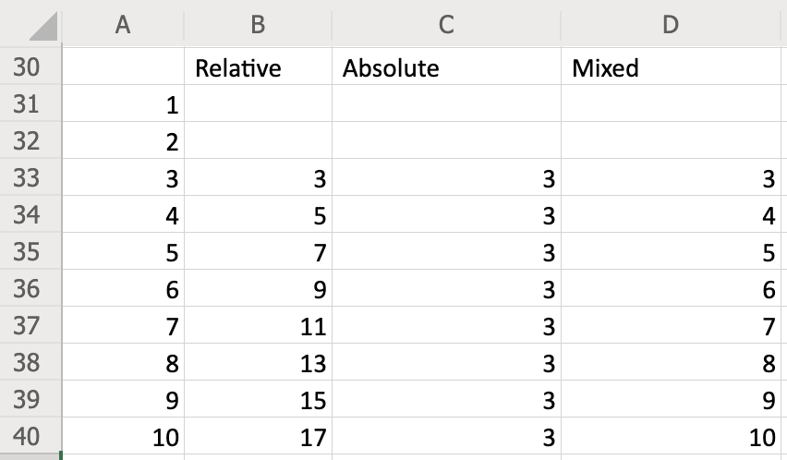

1. In cell **B31**, type **=A16+A17**. Now this will lead to a formula error **#VALUE!** since cells **A16** and **A17** do not contain any number.

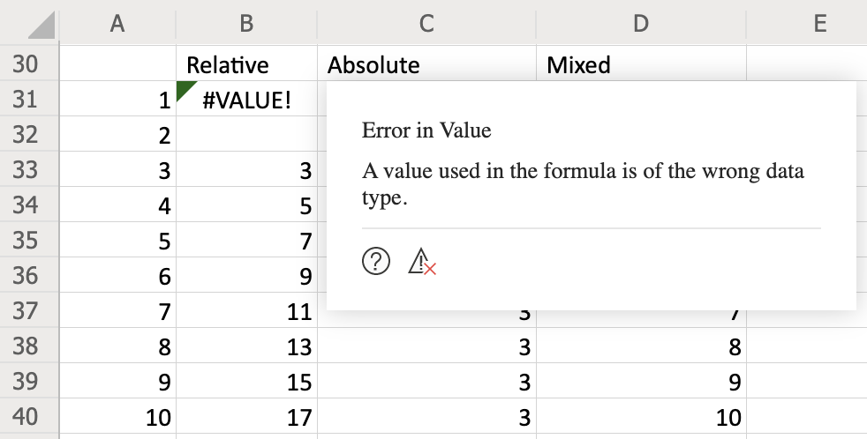

1. Click the **question mark icon** in the error message box. This will open the **Help** for this topic. Read through this help file for more information about **#VALUE!** errors in formulas.

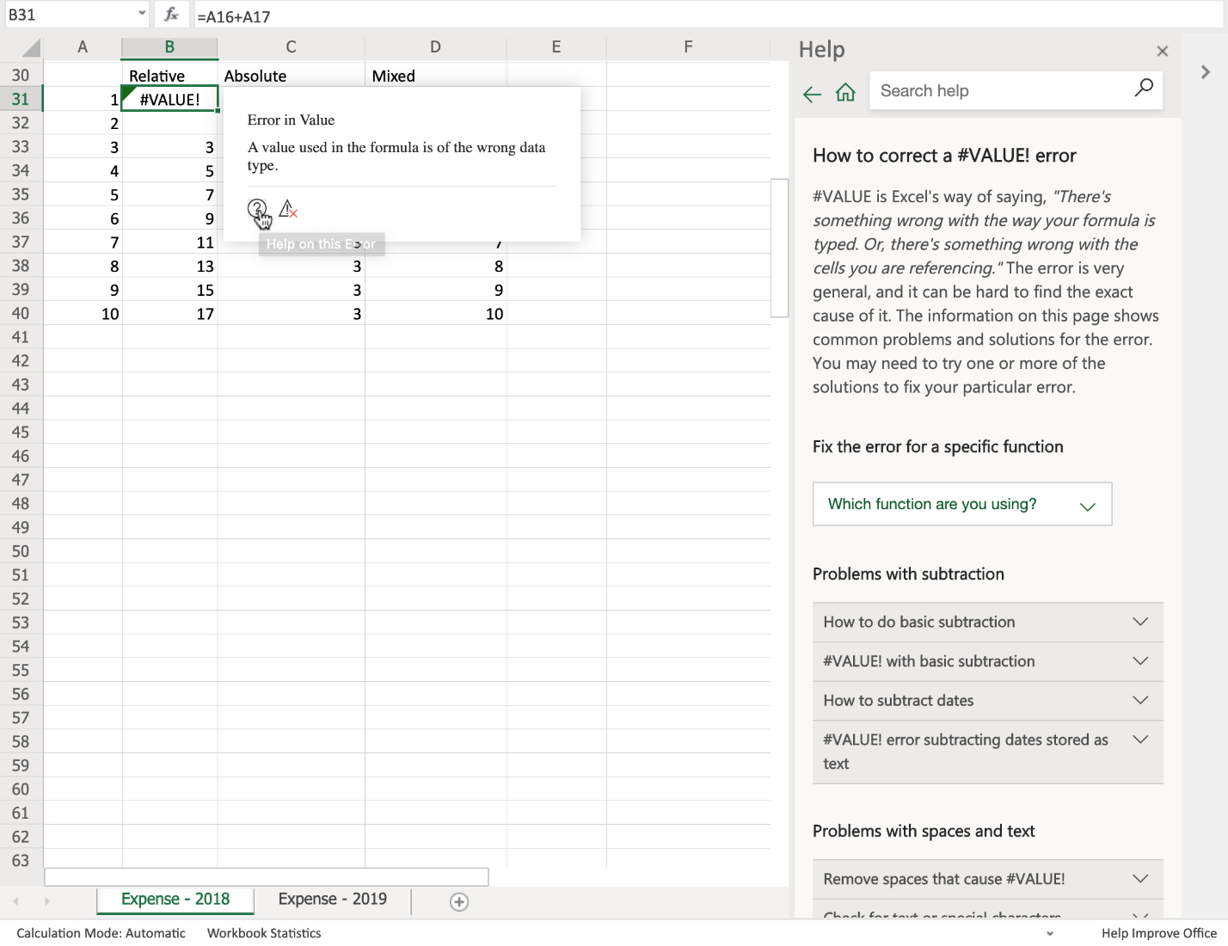

# Summary and Highlights

this lesson, you have learned:

* There are several features to modify views in Excel, and it is very straightforward to enter and edit data in a spreadsheet.
* You can move or copy data within a worksheet or between worksheets, and you can use AutoFill to automatically enter data that is in a series or that fits a pattern.
* You can format both cells and data in Excel.
* A formula is made up of several component parts, and formulas can perform calculations using numbers directly or by using references to data in the worksheet.
* You can use the Fill Handle in Excel to quickly copy formulas to other cells.
* There are several different categories of function you can use for different purposes, and you can search for a function by name, or by category.
* You can reference cells in the worksheet in your formulas by using relative, absolute, or mixed references.
* You can make a formula absolute by adding a dollar symbol ($) to a cell reference.
* If you get errors in your formulas, you can use the error-checking capabilities of Excel to resolve them.
* Question 1
* How can you zoom to a specific area of data in an Excel spreadsheet?
* 1 / 1 point
* 
* Use the Freeze Frames option
* 
* Use the Zoom button
* 
* Use the 100% button
* 
* Use the Zoom to Selection button
* Correct
* Of these options, only the Zoom to Selection button will zoom in to a specific area of your data.

### 2.

* Question 2
* What do you use the AutoFill feature for?
* 1 / 1 point
* 
* Automatically fill cells with data in a sequential series or pattern
* 
* Drag selected data to another place
* 
* Move or copy data between spreadsheets
* 
* Paste data in a cell with the same column width settings
* Correct
* AutoFill is used to fill cells automatically for you, when the data is identified to be in a sequential series or pattern

### 3.

* Question 3
* What is one of the key components of a typical formula?
* 1 / 1 point
* 
* Reference
* 
* Division
* 
* Percentage
* 
* Calculation
* Correct
* While you can use division and percentages in your calculations in a formula, of these options, only Reference is a key component of a typical formula

### 4.

* Question 4
* What happens when you use the median calculation but select an even number of values in a range?
* 1 / 1 point
* 
* Returns one of the middle value of the selected range
* 
* Returns both of the middle values of the selected range
* 
* Returns middle figure between the two middle values in the selected range
* 
* Divides the selected range in half
* Correct
* The median is a midway point between a range of values, so if you select an odd number of values, it uses the middle value, but when you select an even number of values, the median is the midway point between the two middle values

### 5.

* Question 5
* What are Excel cell references by default?
* 1 / 1 point
* 
* Cell references must be assigned
* 
* Mixed references
* 
* Relative references
* 
* Absolute references
* Correct
* By default in Excel, cell references are always relative, and you must manually configure a cell reference to be absolute or mixed

### 6.

* Question 6
* When creating formulas, what is a mixed reference?
* 1 / 1 point
* 
* Both cell references are manually assigned
* 
* One cell reference is absolute, the other one is relative
* 
* Both cell references are either absolute, or relative
* 
* One cell reference is absolute, the other must be manually assigned
* Correct
* A mixed reference has at least one relative cell reference and at least one absolute cell reference
* Question 1
* Which of the following is a valid way of editing existing data in a cell? **Select all that apply**
* 1 / 1 point
* 
* Press F2
* Correct
* This is a valid way of editing the existing data in a cell
* 
* Select the cell you want to edit and then click in the formula bar
* Correct
* This is a valid way of editing the existing data in a cell
* 
* Select the cell you want to edit and press Enter
* 
* Press CTRL+N

### 2.

* Question 2
* In Excel for the web, how can you format data in cells to use a currency? **Select all that apply**
* 1 / 1 point
* 
* Right-click on a cell and select Number Format
* Correct
* 
* Select "More Number Formats" from the Number Format drop-down list in the Number group
* Correct
* This will enable you to format your data as a currency.
* 
* Select the data and click the Decrease Decimal button
* 
* Select "Format cells" from the Format drop-down list in the Cells group

### 3.

* Question 3
* What character do you type first when you want to start writing a formula?
* 1 / 1 point
* 
* Equal sign '='
* 
* Percentage sign '%'
* 
* Plus sign '+'
* 
* Division sign '/'
* Correct
* You type the '=' character first when you want to start writing a formula

### 4.

* Question 4
* What is one of the functions found in the AutoSum drop-down list?
* 1 / 1 point
* 
* Count Numbers
* 
* General
* 
* Accounting
* 
* Number
* Correct
* Count Numbers is one of the functions found in the AutoSum drop-down list, The other options are Sum, Average, Max and Min

### 5.

* Question 5
* In Excel Desktop, what is one of the function categories on the Formulas tab, in the Function Library group?
* 1 / 1 point
* 
* Lookup & Reference
* 
* Functional
* 
* Medical
* 
* Analytical
* Correct
* Lookup & Reference is one of the function categories on the Formulas tab, in the Function Library group

### 6.

* Question 6
* How do you make a cell reference absolute in a formula?
* 1 / 1 point
* 
* Put a plus sign (+) between the column and row identifiers in the formula
* 
* Put a dollar sign ($) in front of the column and/or row identifiers in the formula
* 
* Put an asterisk (*) in front of the column or behind the row identifiers in the formula
* 
* Put a percentage sign (%) behind the column or row identifiers in the formula
* Correct
* Putting a dollar sign ($) in front of the column and/or row identifiers is how you make a cell reference absolute in a formula

### 7.

* Question 7
* Formula errors in Excel are preceded by a hash symbol (#). What does it mean when multiple hash symbols exist in a cell?
* 1 / 1 point
* 
* Formula is missing a cell reference
* 
* Column isn't wide enough or it contains negative date or time values
* 
* Formula contains unrecognized text
* 
* Formula contains multiple errors
* Correct
* When you see multiple hash symbols in a cell it means that either the column isn't wide enough to display the full data, or it contains negative date or time values

# Introduction to Data Quality

Save note

Data analysis can play a pivotal role in business decisions and processes.

In order to use the data to make confident decisions, we must have the right information

for the project and the data must be free from errors.

In this video we will learn how to profile data to discover inconsistencies.

Whether we are working with small sets of data or analyzing a spreadsheet with thousands

of rows, one of the most difficult parts of the data analysis is finding and keeping clean data.

Play video starting at ::41 and follow transcript0:41

To help with this process and qualify the data, look for these five traits: Accuracy,

Completeness, Reliability, Relevance and Timeliness.

Accuracy is the first and most significant aspect to data quality.

A data analyst must clean the data set by removing duplicates, correcting formatting

errors, and removing blank rows.

Another important aspect of data quality is determining if the information required to

complete the data set is readily available.

Why does this matter as a trait for quality data?

Let’s say we are given the task to calculate the revenues of all sales per region.

After collecting the data, we discover that no regions were specified.

This data would then be considered incomplete and other sources would have to be considered

to obtain the data required.

Reliability is another vital factor in determining the quality of the data.

For instance, let’s say we are given the task to determine the agent revenue by customer.

When gathering the data, we find the agents keep their own records and do not always update

the information in the shared company database.

With those factors in mind, we would then determine that the data in the shared company

database was unreliable and new processes would need to be established to ensure reliable data.

Play video starting at :2:7 and follow transcript2:07

Relevance is another trait of quality data.

When collecting information, a data analyst must consider if the data being assembled

is really necessary for the project.

For example, when reviewing the data related to the sales revenue per customer, information

such as customer birthdays and other personal information is also included.

By making the determination early to exclude the personal information from the data set,

the analyst would save themselves from having to review unnecessary information.

The last factor in determining the quality of the data is timeliness.

This trait refers to the availability and accessibility of the selected data.

Let’s say our sales report is going to be used for weekly employee reviews, but our

report is only refreshed once a month.

This error in refreshing the data would cause our report to become outdated, and would have

serious consequences for employee reviews.

In this video we learned the important role of a data analyst in qualifying data.

By considering the five traits of good quality data, an analyst can save time, avoid serious

issues, and have data that is free from errors.

In the next video we will take the collected data and learn how to import it to our spreadsheet.

# Importing File Data

Save note

Now that you have learned about the importance of data quality, in this video you will learn

how to import data from a text file using the Text Import Wizard, learn how to adjust

column widths, and learn how to add and remove columns and rows.

As you know, by default Excel works with .xlsx or .xls files and opens them as workbooks.

But Excel can also use data that is in other formats, such as plain text, or data that

has been comma-separated and tab-separated.

Sometimes, these source files will be saved with a .txt extension and referred to as ‘text’

files, but others might be saved with a .CSV file extension, and are typically referred

to as CSV files.

Here in Notepad, I have opened a text file that contains data about car sales, and it

uses comma separated values (or CSVs) to separate each bit of data in a record.

Notice that the top line holds headings, such as Manufacturer, Model, Engine_size, and so

on, and each one is separated by a comma.

We want these to become our headers when we import the file into Excel.

The line below these headings is the first line of real data, and again you can see that

each piece of data is also separated by a comma.

There are 16 headings and there are also 16 pieces of data on each of the lines below

the headings.

If we scroll to the bottom, we can see that last data record is for the Volvo S80.

Now, to open the file in Excel, we choose File, Open, and then either select the file

from the recently used list, or click Browse to find the file we want to import.

When we open the file, the Text Import Wizard launches automatically, and it will start

to try and determine what your file is.

Note that it has been detected as being a delimited file; that is, one that has its

data fields separated by a character such as a comma or a tab.

As we want the headings to become headers in Excel, we need to ensure that we select

the option ‘My data has headers’.

We can see a mini preview of the data in the preview box below.

Then we click Next to proceed in the wizard.

In step 2 of the wizard, we need to select our delimiter; that is, which character is

separating our pieces of data; so we select Comma, and deselect any others.

Note the data preview now starts to show us what the imported data will look like.

You can scroll down and across this preview window to ensure that the data is going to

look as you want and expect.

It all looks OK, so we’ll continue with the wizard.

In step 3 of the wizard, we can set the data format for each column.

For example, you might want to change a column to Text or Date format.

In this case we can just accept the default General format, and finish the import wizard.

In Excel we can see that the headings in the text file have been imported as a header row.

But also notice that some of the columns are not showing all the data; some of the headings

are not showing in full and some of the data is not shown either; all you can see are a

number of hashes in the cells.

This is because the column widths are too narrow in some cases.

If you remember, we can manually adjust a column’s width by dragging the divider across.

But to change them all in one go, we select all the columns first, then double-click one

of the selected column dividers.

We can do a similar thing with rows by dragging to make them bigger or smaller, or double-clicking

a row divider to autosize it.

There are some columns that we have decided we don’t really need; namely Vehicle_type

and Latest_Launch, so let’s remove those.

This can either be done using the Delete drop-down menu in the Cells group on the Home tab, and

select Delete Sheet Columns, or by selecting and right-clicking a column and deleting it

that way.

To add another column, you simply select the column to right of where you want your new

column to be, then right-click the column and choose Insert.

And let’s give the header a name, such as Year.

To delete a row you don’t need, select the row, right-click it, and choose Delete.

And to add a row, select the row below the place you want to add your new row, right-click

the row, and choose Insert.

If you want to save the file as an Excel file, you can either choose File, Save As, or you

can click Save As in the yellow tooltip that appeared at the top of the worksheet when

we imported the file, and then you would choose ‘Excel Workbook (*.xlsx)’ in the ‘Save

as type’ box.

In this video, we learned how to import data using the Text Import Wizard, we learned how

to adjust column widths, and we learned how to add and remove columns and rows.

In the next video, we will discuss the importance of data privacy, including sensitive information,

and personally identifiable data.

# Basics of Data Privacy

Save note

In this video, we will learn about data privacy and the regulations that govern the collected

data. When collecting customer data, specific regulations

apply to how that data can used. By understanding data privacy regulations and getting familiar

with the following three fundamentals, you can eliminate the risk of financial penalties

and keep the trust of your customers. Confidentiality, Collection and Use, and Compliance.

Confidentiality is an important element in data privacy and it acknowledges that the

customer’s personal information belongs to them. The types of information that can

be accessed by a data analyst can range from sales forecasts, to employee information,

or even patient records. When accessing these types of records the analyst must be able

to recognize the different types of personal data.

Personal Information or PI is any type of information that can be traced back to a specific

individual. This type of information can include anything from emails to images.

Personally Identifiable Information or PII is specific information that could be used

to identify an individual. This type of information could include a social security number or

a driver’s license number. And lastly , Sensitive Personal Information

or SPI, may not necessarily identify a specific individual, but contains private information

that needs to be protected because if made public it could possibly be use to harm the

individual . The type of information can include data about race, sexual orientation, biometric

or genetic information. By understanding personal data and the associated

regulations, we can efficiently anonymize our data by removing unnecessary information.

This type of action can help build consumer confidence and continue to develop the free

flow of information. When searching through data, the analyst must

know the location of the company collecting the data and the location of the respondent.

Knowing where the data was collected is an essential element of data privacy and what

regulations must be applied.The General Data Protection Regulation or

GDPR is a regulation specific to the European Union, and only applies to the jurisdiction

of the individual. A new law created in Brazil, the LGPD, will

take effect in August 2020. These new data policy regulations apply to individuals within

Brazil, and ignores the location of the data processor.

While the United States does not have one country-wide principle law for data privacy.

Because of this individual states began to make their own regulations. For instance,

California created the California Consumer Privacy Act (CCPA) to better protect customer

data. There are also industry specific regulations

that govern the collection and use of sensitive and personal data. For example, in Healthcare,

HIPAA privacy rules govern the collection and disclosure of protected health information.

In retail, the PCI standards govern credit card data, and failure to safeguard cardholder

information can result in hefty fines. With a basic understanding of these policies,

we are able to remain compliant when handling any sensitive information.

Unfortunately, breeches in customer data is an all too common occurrence and understanding

how to remain compliant is essential. Understanding the data privacy regulations of the European

Union, the United States, and other countries as well as industries is key to keeping data

safe. Companies must comply with these privacy regulations at all times and also make sure

policies are readily accessible to employees. For example, let’s say a data analyst downloads

a spreadsheet of sensitive information. In order to complete the report by Monday morning,

the analyst decided to take their work laptop home for the weekend. After driving home,

the analyst accidently left the laptop in their car. The next morning, they found their

car had been stolen along with the laptop. Because it is the responsibility of the company

to keep customer data safe, this was a breach of privacy when the data left company property.

This type of action could not only cost the company large amounts of money in fines and

penalties, but could also reduce consumer confidence causing a significant impact to

revenue. While data privacy applies to most data that

is collected, there are some instances where these regulations do not apply. In order for

these laws and regulations not to apply, the particular collection of data must be completely

anonymous. To make data anonymous means to exclude all data which ties it back to a particular

individual. While this approach might not be practical in all circumstances, collecting

data with privacy in mind could remove privacy limitations and make data collections more

accessible. In this video we learned about the importance

of data privacy and the challenges that a data analyst can face when collecting and

sorting through data. In the videos in the next lesson, we will learn about different

methods for cleaning data in a spreadsheet.

# Viewpoints: Data Quality and Privacy

Save note

In this video, we will listen to several data professionals discuss the importance of data

quality and data privacy as they relate to data analysis.

Let us start with, “What is the importance of data quality as it relates to data analysis?”

Data quality is of the utmost importance in terms of data and analytics, but the reason

behind this is because as soon as what you're presenting does not align with what someone

expects, that's the first thing that they tend to go after.

Where did you get the data?

What's happened to the data?

How's it been transformed?

Because people like to think that they know and understand their, their business.

And when you start to challenge that if you don't have the ground to stand on of the data

that it's quality that it's clean and then it is from a trusted source, that's when you

start to get into a lot of discussions.

A lot of debate.

And ultimately, the plot of what you're trying to present gets lost.

The backbone of any successful data analysis project is good quality data.

There is a common term in computer science called garbage in garbage out, which is essentially

if you read in bad quality data, you can expect to get bad quality results.

So, there's really nothing more important when doing a data analysis than making sure

that you're working with good quality data, and it's really important to sense-check the

data yourself and really feel comfortable that the data you're using is of a really

high quality.

Data accuracy is above all: garbage in garbage out.

It's a waste of time to analyze data of poor quality, and it might mislead the business

direction.

The integrity of the data that you're using or providing for someone else to use is of

the utmost importance.

Data is used determine, when or where to launch a product, if a division is profitable or

not and it's easy to get things confused if you're not paying attention to the details.

Using inventory as an example, if you're looking at inventory at a SKU level and you accidentally

pick the wrong SKU to analyze and then you draw these conclusions that this particular

item isn't profitable when in fact it is.

So, that's a major, major decision for a company to make obviously, so the expectation is that

there will be lots of due diligence, but in the beginning if you start off with that data

and then you build on that only to later realized that it wasn't a good idea, you've lost time,

energy, effort, and in some cases, trust.

Thank you for those viewpoints.

What about the importance of data privacy as it relates to data analysis?

Data privacy is incredibly important, especially when you're working in industries like pharmaceuticals

or healthcare, but that's not where it stops.

We have to have the ability to make sure that the users are getting the appropriate level

of data based on their roles and their permissions.

Now we can do this through a number of cuts of the data specific to each geography or

each function, or in some tools such as Cognos Analytics, we can start to build out that

as part of our model.

Within there you can say who has access to what, whether it's at a granular level of

this person can see data in Canada or the US or whether it's simply this person can

see this report in its entirely or not.

There's lots of different ways to handle this, but data privacy is of the utmost important

across all industries.

In today's world, data privacy is a huge thing on the tax side, especially of our business

we have what we have what we call PII: personal, identifiable information.

We have to protect that and so we can't just send things through email.

We don't send tax returns or even actually in our business.

We don't send things through email.

They have sensitive PII data in it.

We encrypt it.

We make sure the email is encrypted or we use software.

Some certain softwares that will allow us to not show the social security numbers or

the names or the date of birth and what will happen is it has a certain sequence, and we share

that with the client by calling them.

We don't put that in an email and we certainly don't put that in the same email with the

encrypted information because we want to make sure that you are always safe.

So, we have to make sure we're protecting it.

At all costs.

# Summary and Highlights

In this lesson, you have learned the following information:

The Five Traits of Data Quality:

* Accuracy
* Completeness
* Reliability
* Relevance
* Timeliness

Importing Text:

* You can use the ‘Text Import Wizard’ to import data from other formats, such as plain text, or comma-separated value files.

The Three Fundamentals of Data Privacy:

* Confidentiality
* Collection and Use
* Compliance

### 1.

Question 1

What is the first and most significant part of data quality?

1 / 1 point



Relevance



Reliability



Accuracy



Completeness

Correct

While all the options are traits of data quality, accuracy is the first and most significant aspect to data quality

### 2.

Question 2

Which data quality trait refers to the availability and accessibility of the data?

1 / 1 point



Reliability



Timeliness



Completeness



Accuracy

Correct

Timeliness refers to the availability and accessibility of the selected data

### 3.

Question 3

What is a delimited file?

1 / 1 point



file with text qualifiers between data fields



file with data fields separated by characters like commas or tabs



file with no spaces between data fields



file with data fields separated by fixed-widths

Correct

A delimited file is a file that has data fields separated by characters, the most common of which are comma and tab

Question 1

Which data quality trait can be summarized by asking if the data is really necessary?

1 / 1 point



Reliability



Timeliness



Relevance



Completeness

Correct

The Relevance data quality trait can be summarized by asking if the data is really necessary

### 2.

Question 2

Which data quality trait refers to the availability and accessibility of the data?

1 / 1 point



Completeness



Reliability



Accuracy



Timeliness

Correct

The Timeliness data quality trait refers to the availability and accessibility of the data

### 3.

Question 3

After importing a text file into Excel, you find some columns aren't showing all data. How can you fix all column widths at the same time?

1 / 1 point



select all columns and double-click one of the selected column dividers



click the Format button



drag a divider across



shorten the text so it fits

Correct

This will fix all column widths at the same time

# Removing Duplicated or Inaccurate Data and Empty Rows

Save note

Now that we have learned about the importance of data quality and data privacy, in this

video we will learn how to deal with inaccurate data, how to remove empty rows, and how to

remove duplicated data.

It’s very common when collecting or importing data - whether through manual or automated

processes - to get errors and inconsistencies in your data.

This can be as simple as spelling mistakes, extra white space, or the wrong case used

in text, to empty rows or missing values in your data, to inaccurate or duplicated data.

Having these errors and inconsistencies in your data can lead to issues with formulas

not working, with unsuccessful sorting and filtering operations and therefore inadequately

visualized and presented data findings.

These data errors and inconsistencies require you to carry out some form of data-cleaning

routine to improve the quality and usability of the data.

Let’s start off with one of the easier of those tasks, which is spell checking.

In Excel, this works in pretty much the same way as you may have already encountered in

applications such as Microsoft Word or other common word processing applications.

I have some data here relating to the sales of toy vehicles, and the first thing we need

to do is select what data we wish to check for spelling; in this case we will try column

K which contains the product line data.

Then we click Spelling which is on the Review tab.

Well that seems to be OK, so let’s try the Country information in column T.

So, we do have an error here, where a country name has been misspelt, or more likely, mistyped.

We just click Change if we are happy with the spelling suggestion, or we could choose

another suggestion from the list, or even ignore this error if we know the data is correct,

but in this case we will change it.

Here’s another typo for a country name

and here’s one more.

So, that seems to be all the errors in this column, let’s try the final column now which

is the deal size in column X.

Here is a misspelling of the word small and another for medium.

And that seems to be all for this column.

The next inconsistency we will look for is empty rows.

Empty rows in your data can cause lots of issues relating to moving around your data,

working with formulas, and sorting and filtering.

Therefore, it’s very important to remove them from your data.

If you remember from an earlier lesson, when we click CTRL+DOWN ARROW, it should take us

to the end of that column of data, but notice if we do that in this dataset, the cursor

keeps stopping when it gets to an empty row meaning that the dataset if essentially being

split into multiple sections, separated by these empty rows.

That’s not good, so let’s resolve that now.

We have a couple of options; one option is to just manually scroll down the sheet looking

for empty rows and deleting each one, which is easy enough, and fine to do if you only

have a small amount of data, but imagine if you were dealing with hundreds, or thousands,

or even tens of thousands of rows?

That would be a very laborious and time-consuming process.

There is a much better way - which involves selecting all our data first, either using

the mouse, or the CTRL+SHIFT+END keyboard shortcut.

Then we select the Filter icon on the Data tab.

We can now see that each column has a filter icon next to the column header.

If we then select the Customer Name column-filter in column M

then uncheck Select All

then scroll down to the bottom of the list, we can check the item called Blanks, and then

click OK.

This will now show only the empty rows at the top of our sheet; this can be quite hard

to see, but if you look in the row numbers, you can see that rows 28,29,65,73,74,75 and

117 are listed at the top and are highlighted in blue text.

We can now select these rows, either using the mouse or going to the first cell in the

first data row, which is A28, and then using the CTRL+SHIFT+END keyboard shortcut

then delete the offending empty rows.

We then need to clear the filter and turn it off, so we can view our data again.

Now, if we go back to the first row in the top of the datasheet and try the CTRL+DOWN

shortcut again, to go to the end of the data column, it will work.

The next inconsistency we’ll look for is duplicated rows of data; it’s quite common

for duplicate data rows to exist in your imported data, caused either by human input error,

or an error in the import process.

There are two ways of doing this in Excel; the first way includes reviewing the data

you plan to remove first, before deleting it, to ensure you are deleting the right data.

This is our preferred method as it provides an additional level of data security.

The second method, which we will also show you, is simpler, as you don’t review the

data to be removed first, but it lacks the security of the first method.

It’s important to select a column of data that you would NOT expect to have duplicate

values in.

For example, if we consider the Price Each column, which is C, we would expect lots of

these values to be repeated, because the unit price of some products is the same, so this

is a bad example of a column to use to find duplicates.

Instead, let’s use the Sales column in column E, because it is far less likely that these

values will be duplicated in the normal process of things, as they are the total sales for

each order.

So, we select the column…and choose Conditional Formatting, then Highlight Cells Rules, and

then Duplicate Values.

When we click OK, and scroll down the sheet, we can see that only a few values have been

identified as being duplicates.

There seem to be duplicate values in rows 36 to 40

and in rows 74 to 78

Let’s zoom out so we can see both duplicate sections together.

It seems like these are in fact exact duplicate entries, and are likely to be an input error.

Let’s delete the second section of duplicate rows as they are out of sequence; as they

relate to Motorcycles sales and are in the Ships section of the sheet.

So that was the first, and recommended method of removing duplicate rows of data, which

previews the data to be removed first.

Now, let’s try the second, simpler, but less secure method.

Let’s go back to 100% zoom, and go back to the top of the worksheet.

This time, we select the whole datasheet, and on the Data tab, we use the Remove Duplicates

button.

We then unselect all the columns, then only select the Sales column.

And the duplicate rows are deleted.

The last cleaning process we’ll look at in this video is using the Find & Replace

feature to repair some misspelt surnames in the customer contacts column.

Find and Replace tools are under Find & Select on the Home tab in Excel, and if you have

used other Office products such as Word, it should be familiar to you already.

We’ve had an email from a Swedish customer, informing us that we have his surname spelt

incorrectly on his order sheets.

So, we type the misspelt surname in to the ‘Find what’ box and click Find Next, then

click it again to see there are multiple incorrect entries.

If we click Find All, all instances are listed,

and we can open the Replace tab to enter a name to replace the incorrect spellings.

His surname should be Larsson with a double ‘s’, so we’ll replace all instances

with that corrected spelling.

That looks better, and we are finished.

In this video, we learned how to deal with inaccurate data, how to remove empty rows,

and how to remove duplicated data.

In the next video, we will look at changing the case of text, fixing date formatting errors,

and trimming whitespace from data.

# More Excel Features for Cleaning Data

Save note

Now that we’ve learned how to change the case of text, how to change date formatting,

and how to trim whitespace from data, in this video we’ll discuss how to use the Flash

Fill and Text to Columns features in Excel to help clean data.

We used Flash Fill briefly earlier in the course as a quick method of entering data

that fits a specific pattern, such as the names of months or days of the week, but it

can also be useful as a data cleaning tool.

It can split a column of full names into two separate columns for the forename and surname,

and it can also help to modify the naming convention used in a column of names.

For example, in the vehicle toy sales worksheet there is a column containing the last names

of contacts, and another containing their first names.

If you want to use the Flash Fill feature to combine these names into one name column,

you first insert a helper column; let’s call it ‘Contactname’.

Then, in the first row in the new column you enter the full name of the first contact in

the format of your choice; for example you might want surname, then a comma, then the

forename, or you might want surname, and just an initial, and so on; in this case let’s

just enter the name in the standard format of forename then surname with a space between

them, and then we press Enter.

Next you start typing the second contact’s name in, and you’ll see that Flash Fill

displays a preview of the remaining names for you.

If you’re happy with what’s in the preview, all you have to do is press Enter, and it

fills in the remaining names for you right down the column.

It even works when there are two names in one of the columns such as Wing C here …

and Da Cunha here.

Now you can remove the original columns if you no longer need them.

So, in the previous task we saw how to combine two columns of data into one column using

Flash Fill; now let’s see how to use it to modify the naming convention in a column.

Let’s switch to the customer contacts worksheet.

Then in the first data row of the next column, that is B2, we type the name of the first

contact using whatever naming convention we want.

We’ll use surname, then comma, then a space, then the forename, and press Enter.

Again, when we start typing the second contact’s name in the next row down, that is B3, Flash

Fill detects the pattern and fills in the remaining names in column B when we press

Enter.

You could then copy and paste the column header, and delete the original column A.

What we couldn’t do with Flash Fill was take a single column with two names in and

split that into two separate columns.

We need to use the ‘Text to Columns’ feature to do that.

So, we’ll close this worksheet and we won’t save the changes.

Now, let’s see how the ‘Text to Columns’ feature can help with data cleaning too.

As the name suggests, and unlike Flash Fill, the ‘Text to Columns’ feature can take

a column containing multi-part text and split that text into one or more other columns.

This can be useful for splitting any multi-part text, such as names or addresses, into separate

component parts.

Let’s open the customer contacts worksheet again.

Then we’ll add column headings for the next two columns, and copy the cell format used

in the first column header.

Then we’ll widen the columns.

If we then select the data in column A from A2 to A23, and on the Data tab, click Text

to Columns, a wizard is launched.

On the first page of the wizard, ensure that ‘Delimited’ is selected.

On the second page, ensure that only ‘Space’ is selected as the delimiter.

On the third page of the wizard, click the little arrow next to ‘Destination’…

and select cell B2 on the worksheet, then click the little arrow again to return to

the wizard.

We’re now finished with this wizard.

You can see that the full customer contact names in column A have now been successfully

split into two new columns in B and C, and you could now remove column A if you no longer

need it.

We’ll close this worksheet, and again we won’t save the changes.

You can also achieve the same result using functions.

This would be required if you were using ‘Excel for the web’, the online version of Excel,

as this doesn’t have the ‘Text to Columns’ feature.

There’s also a bit more flexibility with functions, which can be especially useful

if you have names that are complex and mixed, such as having hyphenated names or some names

with a middle initial, some with two middle initials, and some with no middle initial.

So, we open the customer contacts worksheet again.

Then we’ll add column headings for the next two columns, and copy the cell format used

in the first column header.

Then we’ll widen the columns.

Next, we enter the formula in B2 to extract the forename part of the name.

This formula extracts five characters from cell A2, starting from the left and including

the space.

Then, in cell C2 we enter the formula to extract the surname part of the name.

This formula extracts seven characters from cell A2, starting from the right.

Then we double-click the Fill Handle in cell B2 to use AutoFill to complete the column.

And we do the same to the Fill Handle in cell C2 to use AutoFill to complete that column

also.

In this video, we learned how to use the Flash Fill and Text to Columns features in Excel

to help clean data.

In this exercise, you will learn how to change the case of text, how to change date formatting, and how to trim whitespace from data.

## Task A: Use the PROPER function to change text from upper case to proper case

1. Select row **2**, then right-click it and choose **Insert Rows**.
2. In cell **A2**, type **=PROPER(A1)** and press **Enter**.
3. Hover over the bottom-right corner of cell **A2**, and drag the **Fill Handle** across to the last column.
   * If dragging across is too difficult with the mouse, then select the cells in the row 2 using **SHIFT+RIGHT ARROW**, then press **F2** to put the cursor focus back in cell **A2**, then hold **CTRL** while you press **Enter**.
4. Select row **2**, then press **CTRL+C**.
5. Select row **1**, Right-click and choose **Paste Options>Values**.
6. Select row **2**, right-click it and choose **Delete Rows**.

## Task B: Use the UPPER function to change text from proper case to upper case

1. Select column **AG (Generation)**. Then right-click and choose **Insert Columns**. In cell **AG1**, type **Generation**.
2. In cell **AG2**, type **=UPPER(AH2)** and press **Enter**.
3. Hover over the bottom-right corner of cell **AG2** and double-click the **Fill Handle**.
4. Select column **AG**, then press **CTRL+C**.
5. Select column **AH**, right-click and choose **Paste Options>Values**.
6. Select column **AG**, right-click it and choose **Delete Columns**.

## Task C: Use the LOWER function to change text from proper case to lower case

1. Select column **AC (T_Type)**. Then right-click and choose **Insert Columns**. In cell **AC1**, type **T_Type**.
2. In cell **AC2**, type **=LOWER(AD2)** and press **Enter**.
3. Hover over the bottom-right corner of cell **AC2** and double-click the **Fill Handle**.
4. Select column **AC**, then press **CTRL+C**.
5. Select column **AD**, right-click and choose **Paste Options>Values**.
6. Select column **AC**, right-click it and choose **Delete Columns**.

## Task D: Change date formatting

1. Select column **Z (Order_Ship_Date)**.
2. On the **Home** tab, in the **Number** group click **Number Format> More Number Formats**.
3. In the Category list, select **Date**.
4. In the **Format Cells** box, under **Locale**, select **English (United States)**.
5. Under **Type**, select **Wednesday, March 14, 2012** and click **OK**.

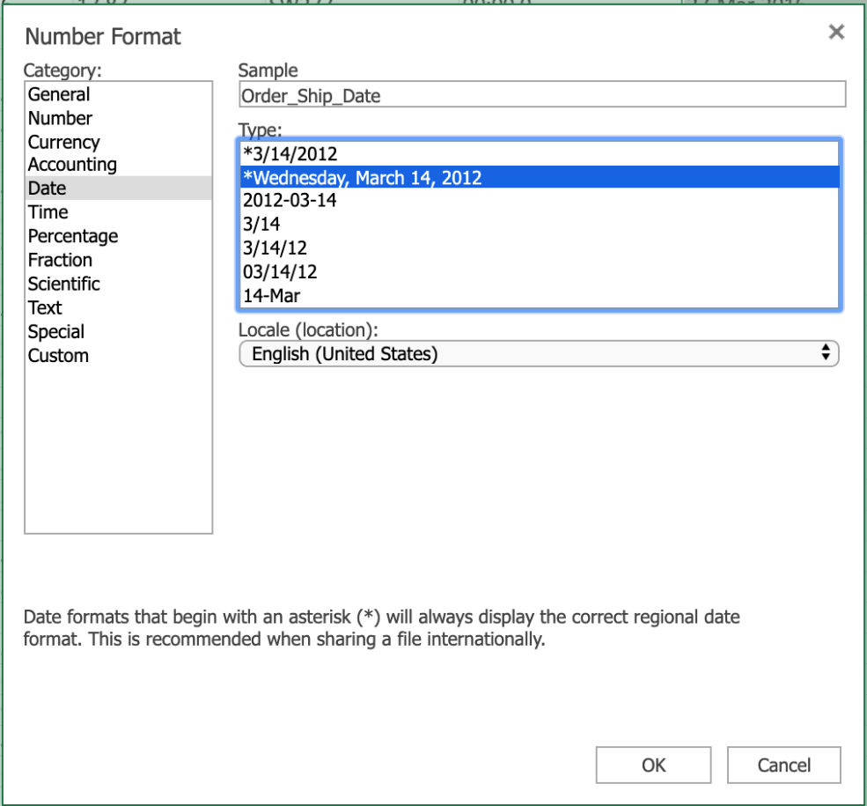

## Task E: Use Find & Replace to trim whitespace

1. Click **CTRL+HOME**.
2. Select all the data using **CTRL+SHIFT+END**.
3. On the **Home** tab, click **Find & Select**, then **Replace**.
4. In Find what, type **2 spaces**. In Replace with, type **1 space**.
5. Click **Find All**, then click **Replace All**.
6. Click the **Close** icon.

# Exercise 3: More Excel Features for Cleaning Data

In this exercise, you will learn how to use the Flash Fill feature and functions in Excel to help clean data.

## Task A: Use the Flash Fill feature to clean data:

1. Select column **A (Cust_Name)**, right-click and choose **Insert Columns**.
2. In cell **A1** type **Customer_Name** and press **Enter**.
3. In cell **A2**, type **Mr. Allen Perl** and press **Enter**.
4. Select column **A (Customer_Name)**, on the **Data** tab, click **Flash Fill**.
5. Click **Undo** to undo this step.

**If you are using the desktop version of Excel, you could use the ‘Text to Columns’ feature to perform this next task (see the corresponding topic video for instructions).**

**If you are using ‘Excel for the web’ (the online version of Excel), the ‘Text to Columns’ feature is not available, but you can achieve the same results using functions, as shown in the steps below.**

## Task B: Use LEFT, RIGHT, LEN, and SEARCH functions to clean data:

1. Select column **A (Cust_Name)**, right-click and choose **Insert Columns**.
2. Select column **A** again, right-click and choose **Insert Columns**.
3. In cell **A1**, type **Customer_Firstname** and in cell **B1**, type **Customer_Lastname**.
4. Click **C1**, then on the **Home** tab, click **Format Painter**, then drag **across to A1 and B1**.
5. Double-click the **divider between columns A and B**.
6. In cell **A2** type **=LEFT(C2, SEARCH(“ “,C2,1))** and press **Enter**.
7. In cell **B2** type **=RIGHT(C2,LEN(C2)-SEARCH(“ “,C2,1))** and press **Enter**.
8. Double-click the **Fill Handle** on cell **A2**.
9. Double-click the **Fill Handle** on cell **B2**.

# Summary and Highlights

In this lesson, you have learned the following information:

* It’s important to remove any duplicated or inaccurate data, and it’s important to remove any empty rows in your dataset.
* There are several other types of data inconsistency that you may need to resolve, in order to properly clean your data:

1. Change the case of text
2. Fix date formatting errors
3. Trim whitepace from your data

* You can use the Flash Fill and Text to Columns features in Excel to manipulate and standardize your data, and functions can also be used to help manipulate and standardize your data.

### 1.

Question 1

According to the video, what's one of the easiest common errors or inconsistencies to fix when importing data?

1 / 1 point



Empty rows



Extra white space



Spelling mistakes



Duplicated data

Correct

All of these are issues that can be fixed after importing data, but fixing spelling mistakes by using the in-built spell checker is the easiest of them to fix

### 2.

Question 2

What is the first thing you should do when checking spelling errors in Excel?

1 / 1 point



Click the Spelling button



Select the data you want to check for spelling



Find the misspelled data



Use a dictionary

Correct

The first thing you should do when checking spelling errors in Excel is select the data you want to spell-check

### 3.

Question 3

What feature can you use to fix text that appears in mixed case?

1 / 1 point



AutoSum



Functions



Audits



Filter

Correct

You can use the Functions feature to fix text that appears in mixed case

### 4.

Question 4

What is one of the functions you can use to change the text case in your data?

1 / 1 point



CASE



STRUCTURE



LOWER



CAP

Correct

You can use the LOWER function to change the text case in your data

### 5.

Question 5

What does the Flash Fill feature have in common with the UPPER, LOWER, and PROPER functions?

1 / 1 point



Lookup & Reference



Keeps cell formatting



Repairs a REF error



Requires a helper column or row

Correct

Both the Flash Fill feature and the UPPER, LOWER, and PROPER functions require a helper row or column

### 6.

Question 6

Which of the following tasks can Flash Fill do? Select all that apply.

1 / 1 point



Set column width



Split one column of data into two

Correct

Flash Fill can split one column of data into two



Combine two columns of data into one

Correct

Flash Fill can combine two columns of data into one



Remove empty rows

### 1.

Question 1

What is one of the issues that empty rows cause in your spreadsheet?

0 / 1 point



Indexing function error



Data will be hidden



Formula errors



Spell-check will fail

Incorrect

This is not one of the issues that empty rows cause in your spreadsheet

### 2.

Question 2

How can you remove all empty rows at the same time in your imported spreadsheet?

1 / 1 point



Use Remove Duplicates to remove empty rows



Use Search & Replace to look for empty rows and delete



Select all rows and then filter for Blanks, select these and then delete



You must delete the empty rows one at a time

Correct

To remove all empty rows at the same time in your imported spreadsheet, select all rows, filter for Blanks, then select these and delete

### 3.

Question 3

There are two methods to locate and remove duplicated rows in Excel, what is the easiest way?

1 / 1 point



Search for the first character in rows



Select a column and choose Conditional Formatting > Highlight Cells Rules > Duplicate Values



Use the HLOOKUP function



Select all data and click the Remove Duplicates button

Correct

This is the easiest of the two methods to locate and remove duplicated rows in Excel

### 4.

Question 4

What does the PROPER function do?

0 / 1 point



Changes text to sentence case



Repairs a REF error



Converts lower case text to upper case



Converts upper case text to lower case

Incorrect

This is not what the PROPER function does

### 5.

Question 5

Why do you need to use the Paste Values option when you paste contents from a helper row to the original row?

1 / 1 point



Keeps cell formatting the same



Validates the copied function



Makes sure formulas aren’t also copied



Ensures consistency

Correct

To ensure that formulas aren't also copied when you paste contents from a helper row to the original row, you use the Paste Values option

### 6.

Question 6

What is one of the ways to apply new data formats to the rest of a column?

1 / 1 point



Format button



Format Painter tool



Paste Special tool



Text Import wizard

Correct

You use the Format Painter tool to apply new data formats to the rest of a column

### 7.

Question 7

What tools or features can we use to split a single column with two names in, into two separate columns with a name in each? **Select all that apply**

1 / 1 point



Format Painter tool



Text to Columns feature

Correct

You can use the Flash Fill feature to split a single column with two names in, into two separate columns with a name in each



Paste Special



Flash Fill feature

Correct

You can use the Flash Fill feature to split a single column with two names in, into two separate columns with a name in each

# Intro to Analyzing Data Using Spreadsheets

Now that we have learned how to collect and clean our data, it is time to decide the best

method for analysis.

In this video, we will discuss the importance of filtering, sorting, performing calculations,

and shaping our data to provide meaningful information.

Deciding how to manipulate our data can sometimes be difficult.

Before we make any changes or adjustments, we will need to visualize the final output.

Below are some questions to ask before beginning the task.

How big is the dataset?

What type of filtering is required to find the necessary information?

How should the data be sorted?

What type of calculations are needed?

Now that we have visualized the final output, we must decide the best approach to shape

our data.

The most basic step would be to filter and sort the data.

By sorting the data, we are able to organize it based on conditions such as alphabetically

or numerically.

For example, if we wanted to check for duplicate order numbers, we could sort the data and

quickly see any duplicates.

After sorting and removing the duplicate row, we find that the view needs to be more specific

to meet our requirements.

We now decide that we only want to see the data for the month of November.

By adding a filter, we can now choose to only see items with a ‘MONTH_ID” that is equal

to “11”.

By filtering our data, we are now able to only see the rows that meet the filter criteria

and it allows us to better analyze our information.

Becoming familiar with all of the tools to analyze data can seem daunting, but one key

benefit of using a spreadsheet is the ability to use functions.

Functions in Excel are organized by several categories, including mathematical, statistical,

logical, financial, and date and time-based.

Let’s say we wanted to get an average of company revenue for the month of June.

We realize there are over 100 items that would need to be calculated.

In normal circumstances, to get an average, we would have to create a formula to add each

row and divide by the total number of rows.

This type of calculation would not only be very long, but can expose the analyst to possibly

making a mistake.

=B1+B2+B3…../160

With the use of a function, we would be able to simplify our calculation in one easy step.

=AVERAGE(B1:B160)

While sorting and filtering data on our spreadsheet can be useful on its own, first converting

your data to a table has many benefits.

When we convert our data into a table, we are able to filter and calculate the data

more efficiently.

One example is the ability to easily calculate columns.

For the column ‘MSRP’, we choose ‘Sum’ and we’re able to quickly calculate the

sum of the column.

If we then look at the data, and only want to calculate the ‘MSRP’ total based on

Japan, we would filter the ‘Country’ column to only display Japan, and the column would

then only add the values in the rows that were associated with Japan.

While all data may not work in a table, there are quite a few advantages to formatting your

data as a table:

Automatic calculations even when filtering

Column headings never disappear

Banded rows to make reading easier

Tables will automatically expand when adding new rows

Sometimes data needs to be more organized then what a basic tabular format can give

us, and creating pivot tables with charts can be a better way to analyze and display

the required information.

In Excel we have the option of creating a pivot table to display and analyze our data,

and optionally, an associated pivot chart.

For example, let’s say we want to know what company ordered products in the month of October.

From the original table of data, we create a pivot table to organize and analyze the

required data, along with a pivot chart to display the information.

By then adding the month filter to the newly created pivot table, we can see the results

for the month of October not only in the table, but the changes are automatically updated

in the pivot chart.

When trying to single out specific information in a large dataset, a pivot table is a nice

way to show only the information that is required.

This allows us to quickly and easily scan the essential information.

Pivot charts are a nice accessory to pivot tables, as they allow us to visually process

data, and in most cases, will let the audience grasp the information quicker.

The advantages of selecting a pivot table and chart are:

Manipulate data without using formulas

Quickly summarize large data sets

Ability to display engaging charts and graphs

In this video, we learned about the importance of filtering, sorting, performing calculations,

and shaping our data to provide meaningful information, and we learned about some of

the tools to begin analyzing our data.

In the next video, we will learn more about filtering and sorting our data.

# Filtering and Sorting Data in Excel

Save note

TranscriptNotesDownloadsDiscuss

In the previous video we learned how to use the Flash Fill and Text to Columns features

in Excel to help clean data.

In this video we will discuss how to filter and sort our data to enable us to control

what information is displayed, and how it’s displayed in our worksheets.

Filtering your data enables you to gain more control over which parts of your data are

displayed at any given time in Excel.

This can help with the visibility of data by narrowing down the data to within specified

criteria and parameters, and it can also help when searching for specific pieces of data.

To filter your data, the first thing you need to do is turn filtering on, which is very

simple.

On the Data tab, click Filter, and that’s it.

You will now see a small filter icon next to each of the column headers.

As a sidenote; if you want to only filter on one or more columns, select those columns

first, then click Filter.

As another sidenote; if you format your data as a table, the columns automatically have

filter controls added to them.

So now, each column has a filter that can be applied to the data in that column.

In the Orderdate column you can filter on the years, in Productline you can filter on

the different product types, and in Customername you can filter on each customer by name.

Let’s first filter on the year.

We’ll select orders from 2004 only, by deselecting the other year.

And if we wanted to, we could expand the year and filter by months also, but we won’t

do that for now.

If you look in the status bar at the bottom of the worksheet, you can see that there are

only 50 out of 114 records now displayed.

If you want to clear a filter, you can either click the ‘Clear Filter From…’ option,

or click the Select All item in the filter list.

Now let’s filter on the productline column, to display only the rows that hold data for

sales of classic cars.

And again, we’ll clear the filter.

Lastly, we’ll filter on the customername column, and only display sales to Mini Gifts

Distributors Ltd.

And then clear that filter.

So far, we’ve only applied one filter at a time, but suppose you want to filter down

to a greater degree?

We can do that too by just enabling all those filters together

and now we are only displaying sales of classic cars, to Mini Gifts Distributors Ltd, in 2004.

Remember, if you only want to clear one filter, then click its filter button in the column

header, and click the ‘Clear filter from’ option

but if you want to quickly clear ALL filters, you can use the Clear button in the Sort & Filter

group on the Data tab.

So far, we’ve used what are commonly referred to as AutoFilters, but you can also use custom

filters to specify other criteria, to apply a filter to text or numbers.

For example, if you wanted to see sales orders that are over or under a certain value, you

can do that with custom filters.

For the sales column, let’s add a number filter that only displays sales that are over

$2,000.

If you look in the status bar, you can see that we are now showing 111 out of 114 records.

Then let’s clear that filter

and filter it the other way to display the sales orders that are BELOW $2000.

We can see that there are only 3 orders that are below $2000.

It’s important to note that the data rows that we don’t see have not been removed

they are still there they have just been hidden from view by the

filters.

And this is indicated by the row numbers you see on the left in blue.

The row numbers start at 69, and jump in large increments, indicating that there are many

more rows of data in our dataset, than are currently being displayed.

Let’s clear those filters.

If we look at a column filter for a column that contains text, you will see that the

menu item changes to ‘Text Filters’ instead of ‘Number Filters’, and you can see there

are several text filter options.

(And if you want to turn off filtering altogether for a worksheet, just click the Filter button

on the Data tab.

Now, let’s take a look at the basic sorting capabilities in Excel.

Sorting is a very important part of the role of a typical Data Analyst.

You might need to organize your text-based data alphabetically, your number-based data

numerically, or your date-based data chronologically.

When you sort data using these logical parameters, it makes it easier for you to conceptualize

and visualize your data in a more meaningful way.

When sorting data, the first thing you need to do is select which data to sort.

For example, if you want to sort your customers alphabetically, select a cell in the Customername

column first

and then either sort by A to Z

or by Z to A.

And if you want to sort your sales figures numerically, select a cell in the Sales column

first…

and then either sort from smallest to largest

or from largest to smallest.

And lastly, if you want to sort your customer’s order dates chronologically, select a cell

in the Orderdate column first…

then sort from oldest to newest

or from newest to oldest.

But you can also sort your data by more than one column at a time.

Simply select a cell in your data, then on the Data tab, click Sort.

Then either use the Sort by column suggested, or use the drop-down list to select a different

column; in this case we’ll choose the ‘Orderdate’ column as our first sorting criteria, and

we’ll choose ‘Oldest to Newest’ in the Order drop-down list.

To add a further sorting level, you click ‘Add Level’.

Then you choose another sort column in the ‘Then by’ drop-down list, in our case

we’ll choose Sales, and for this sort level we’ll choose ‘Largest to Smallest’ in

the Order list.

If you have a header row in your data – as we do here – then ensure you select the

‘My data has headers’ checkbox, then click OK to sort.

So, the data is now sorted to list the oldest orders by order date first, then within each

order date, if there are multiple instances with the same order date…

then the next sorting level lists data by the largest order values first, down to the

smallest order values.

In this video, we learned how to use the Filter and Sort tools in Excel to filter and sort

our data to enable us to control what information is displayed, and how it is displayed in our

worksheets.

# Viewpoints: Filtering and Sorting

Save note

In this video, we will listen to several data professionals discuss the importance of

filtering and sorting your data.

Why is it important to filter and sort your data?

Filtering and sorting are very important as part of your analysis and visualization experience,

because this allows you to create one single view of the data, but then provide a function

for people to be able to do their own analysis on it.

Now, just to clarify what we mean by this is sorting tends to be highest to lowest,

alphabetical, or in some cases, you may want to create some custom sorting where you put

your particular product or offering at the start and then have the rest falling behind

it.

Or you may want to group a few at the start to show your direct competitors versus others.

I love, love, love the filter sort feature in Microsoft Excel.

What it allows me to do is get to the heart of the data I can drill down and see, for

example, how much revenue a client had for a specific time frame, or how much money they

made in a specific timeframe without looking through a lot of rows and a whole lot of information.

So, filtering and sorting really allows you to narrow it down and they get very specific

and get the answers that you're looking for and not just get loads of data that you don't

necessarily need.

When we talk about filtering, we talk about this, to mean that I have a particular value

on which I want to see the data specified path.

So, for example, if we had a bar chart showing our sales over months and I want to see it

in a particular geography or for a particular product line, I could have that available

and allow me to filter down so that my sales would be specific just to one geography or

one product line.

TranscriptNotesDownloadsDiscuss

### **Interactive Transcript - Enable basic transcript mode by pressing the escape key**

You may navigate through the transcript using tab. To save a note for a section of text press CTRL + S. To expand your selection you may use CTRL + arrow key. You may contract your selection using shift + CTRL + arrow key. For screen readers that are incompatible with using arrow keys for shortcuts, you can replace them with the H J K L keys. Some screen readers may require using CTRL in conjunction with the alt key

Play video starting at ::8 and follow transcript0:08

In this video, we will listen to several data professionals

# Useful Functions for Data Analysis

Now that we’ve learned how to use the Filter and Sort tools in Excel to filter and sort

our data to enable us to control what information is displayed, and how it is displayed in our

worksheets, in this video we’ll discuss how to use some of the most common functions

a Data Analyst might use; namely IF, IFS, COUNTIF, and SUMIF.

First up, let’s look at how to use the IF function.

The IF function is one of the most used logical functions in Excel.

The IF function enables you to logically compare a value against criteria you set in the function,

and then return a result based on whether the result of the logical comparison is true

or false.

And these values can be text values or numeric values.

An IF function essentially says; “if something is true, then return a value or do something,

but if it’s not true, then return a different value or do something else”.

For example, in our vehicle toy sales worksheet, if we wanted to have a column that recorded

whether the order had been shipped or not, you could add a new column to the right of

the existing column – let’s call it shipped?

and then enter the formula seen in cell H2

This formula is saying – if the text in G2 says ‘shipped’ then return ‘Yes’,

and if it doesn’t then return ‘No’.

You can then use the Fill Handle to copy this formula down the column.

You can see that most of the cells do say ‘Yes’, but some don’t, as the order

hasn’t been shipped for one reason or another.

We could also use the IF function to emphasize the size of an order.

So, if we add a new column to the right of ‘Sales’, and name it ‘3K plus or minus’

Then enter the formula seen in cell F2

This formula is saying – if the order is over three thousand, then return the text

“Over 3k”, but if it isn’t, then return the text “Under 3k”.

And we can copy the formula down the column.

In an ideal world, you would only use the IF function to apply one or two conditions,

but there may be scenarios where you want to apply multiple conditions.

In these cases, you can use the ‘nesting’ capabilities of functions to bring together

several IF statements in one formula; these are called ‘nested IF functions’.

For example, if we add another column here for the order size.

And then enter the formula seen in cell F2.

You can see that this formula, contains multiple IF functions; one is needed for each condition

one for Large, one for Medium, and one for Small

and it requires three sets of parentheses.

So, it’s a relatively long and complex formula, but it does work.

Again, we can copy the formula down the column.

Even though Excel technically supports the nesting of up to 64 different IF functions

in a formula, it is not a recommended best practice.

Having multiple IF functions in a single formula can become extremely challenging to manage.

For example, suppose you come across a formula like this that you haven’t used for some

time, or even worse, was created by someone else; it could be quite difficult to work

out how and why it is being used.

Also, if your conditions increase, then you need to add more conditions to an already

quite complex and long formula, which will only complicate matters more.

To resolve this issue, a new function was developed called IFS.

The IFS function is only supported on Excel 2019, Excel for Microsoft 365, and Excel for

the web.

As the name suggests, this function can replace multiple nested IF functions being used in

a single formula, to simplify matters.

(So, if we add a further column for order size

but this time we’ll use the IFS function instead.

As you can see in cell G2, this formula only has one set of parentheses instead of three,

and only uses one function instead of three.

Let’s copy that formula down the column too.

Now let’s have a look at another example of using the IF function, but we’ll combine

it with Conditional Formatting too.

If we switch to the car sales worksheet…

and add a new column to the right of the Year Resale Value column

and call it ‘Retention %’.

Then, we enter the formula seen in cell G2, which will divide the ‘Year Resale Value’,

by the original ‘Retail Price’.

We need to format this as a percentage.

And then we can copy it down the column.

Next, we’ll add a column to highlight the retention value for each car.

The formula we add here in cell H2 uses the IF function to state that if the percentage

in the previous column is greater than 69%, then mark it as ‘Good’, but if it isn’t,

then mark it as ‘Poor’.

Once again, we’ll copy the formula down the column.

We could also use Conditional Formatting to highlight the retention value percentages

even more.

We select H2, and on the Home tab, click Conditional Formatting, and make a new rule.

The condition in our rule will only format cells that contain a specific text value…

and that value is the word ‘GOOD’.

And if it does match that condition, then format it with a dark green font and fill

the cell in pale green.

Let’s copy that conditional formatting down the rest of the column.

You can see that the cells that contain the word ’good’ are now formatted as we defined,

but the cells containing the word ‘poor’ are not.

Let’s add another conditional format rule.

This time, we’ll select Manage Rules, because we are going to add another rule to our existing

rule.

he new rule will be the same as the previous one, with the exception of looking for a match

with the word ‘poor’ instead, and formatting those matching cells with red text and a pink

background fill.

And once again, we copy that down the column.

Now all the cells that contain the word ‘poor’ are formatted as red text with a pink cell

fill.

Let’s now have a quick look at how to use the COUNTIF function.

COUNTIF is one of the statistical functions provided in Excel.

You can use it to count the number of cells that meet a certain criterion; such as the

number of instances where an employee’s name appears in a list of sales invoices,

or the number of occasions a particular part number appears in a list of purchase orders.

Let’s switch to the vehicle toy sales worksheet.

Suppose you want to find out how many of the sales orders in the list went to customers

based in the United Kingdom.

We enter the formula you see in cell AD7.

Note that when we are using text as a criterion, we have to enclose the text in quotation marks.

So there were 6 sales orders in the UK.

And if you wanted to discover the same thing for French customers, then you would just

edit the existing formula, or copy it and then edit it.

You can see there were 14 orders for French customers.

Notice that this time the text entered was in lowercase, and it still works; so names

in this function are not case-sensitive.

And let’s do the same for United States customers; there are 41 orders to customers

based in the states.

There is also a newer function called COUNTIFS which applies criteria to cells across multiple

ranges to count the number of occasions where all criteria have been met.

This removes the need to use multiple COUNTIF functions in a long and complex single formula.

The COUNTIFS function is only supported on Excel 2019, Excel for Microsoft 365, and Excel

for the web.

Now let’s take a quick look at how to use the SUMIF function, which is a very commonly

used mathematical function in Excel.

You use the SUMIF function to sum the values within a specified range that meet specified

criteria.

For example, you might want to add up only the salaries that are over a specified salary

level, or you might want to find the total of all sales of a particular product category.

We’ll enter the formula seen in cell AD10

This formula will add up each of the sales orders that have a total of more than 3,000

dollars.

Again, notice that because we have used an arithmetic operator, that is the ‘greater

than’ operator, we must enclose the criterion in quotes.

If we specify a criterion that is only a number, we don’t enclose it in quotes.

So, the total sum of all orders that were over 3,000 dollars is almost 470,000 dollars.

You can also use wildcards such as ‘question mark’ (?) and ‘asterisk’ (*) when searching

for partial matches, and you can also specify to extract values from a different column

than the column where you have specified the criteria.

For example, if we enter the formula you can see in cell AD13, it will sum all the car

sales in column E, for only those products in the ‘productline’ column that end in

‘cars’.

There is also a newer function called SUMIFS that you can use to sum cells based on multiple

criteria.

This removes the need to use multiple SUMIF functions in a long and complex single formula.

The SUMIFS function is only supported on Excel 2019, Excel for Microsoft 365, and Excel for

the web.

In this video, we learned how to use the IF, IFS, COUNTIF, and SUMIF functions.

In the next video we’ll look at how to use the VLOOKUP and HLOOKUP reference functions.

# Using VLOOKUP and HLOOKUP Functions

Save note

Now that we’ve learned how to use the IF, IFS, COUNTIF, and SUMIF functions, in this

video we’ll look at how to use the VLOOKUP and HLOOKUP reference functions.

VLOOKUP is one of the most commonly used reference-type functions in Excel, and it enables you to

find data referenced in a lookup table.

It stands for Vertical Lookup and therefore is a useful tool to use when you want to find

something in a table or a range by row.

Shortly, we will look at HLOOKUP, which stands for Horizontal Lookup, which looks for data

by column instead.

VLOOKUP works by using a common shared key between the source data and the lookup data

in the lookup table.

A typical VLOOKUP formula would look like:

=VLOOKUP(B3,A2:B12,2,FALSE)

Where B3 is the lookup value, that is, the value or word you are looking for A2:B12 is

the lookup table or range, that is, the table array or range of cells that contains the

lookup value.

In a formula, Excel references this as ‘table_array’.

The lookup table can be on the same worksheet or in another separate worksheet.

2 is the lookup column number, that is, the number of the column in the lookup table that

contains the value you are looking for.

In a formula, Excel references this as ‘col_index_num’.

FALSE is an optional parameter that determines whether the match found has to be exact (denoted

by FALSE), or can be approximate (denoted by TRUE).

In a formula, Excel references this as ‘[range_lookup]’.

The square brackets round this argument in the formula, signifies that it is an optional

argument, whereas the others are required arguments of a VLOOKUP formula.

If you don’t specify the optional FALSE or TRUE parameter in your formula, it will

default to FALSE; that is, an exact match is required.

You can also use the number 0 instead of FALSE, and the number 1 instead of TRUE.

OK, now let’s see the VLOOKUP function in action.

In the car sales worksheet, suppose we wanted a quick price list of our favorite cars.

The first thing we need to do, is put the column containing the value we want to search

for, in the leftmost column, as VLOOKUP requires this.

Then we can delete the original column.

We then enter the formula seen in cell V16…

… which is looking for the word ‘Corvette’ in the table array from cell A2 to G156, and

then looks for the value in the fifth column – in this case, the ‘Price’ column – that

matches the row containing ‘Corvette’ and returns an exact value of 45,705 dollars.

Note that in this example, we are using a part of our existing data table as the lookup

table, or table array.

Let’s format that as US currency.

Then we’ll format it to zero decimal places.

In fact, rather than use the reference A25 in the formula, it will be easier to use the

reference to the word Corvette in the mini table in this worksheet, where our list of

favorite cars is.

So that is V5, and the formula still works.

Now, let’s copy that formula up to the favorite car table, above it in the worksheet.

But there’s a problem, because when we copied the formula, the cell references changed.

This happened because as we learned earlier in this course, the default state of cell

references is relative, and we want them to be absolute in this case.

So, let’s undo that copy operation.

To make the cell references absolute, we need to add dollar symbols to all the cell references

in the formula.

This can either be done manually, or you can put the cursor in each cell reference in turn

in the formula and press F4 each time, to automatically add the dollar symbols.

Let’s try and copy the formula again

and this time it works.

If we use the Fill Handle on cell W5 to copy it down to the rest of the cars, it doesn’t

work; in fact, we end up with the same result in every cell.

Why?

Because each one is referencing the same cells in the lookup value, because we used an absolute

reference.

All we need to do now, is modify the formula to remove the absolute reference for just

the row parameter, in the lookup value part of the formula, by removing the dollar symbol.

So in cell W5 we change $V$5 to $V5,

then when we drag the Fill Handle down it will copy the formula correctly, and all the

prices will be changed to reflect their correct retail price.

Lastly, to show that the two tables are now connected by this VLOOKUP function, if we

change the retail price for the Chevrolet Corvette in the main data table in cell E25…

the price will also change in the favorite cars price list.

Let’s now take a quick look at the HLOOKUP function, which as we mentioned earlier, does

the same thing, and works in virtually the same way, as the VLOOKUP function, but it

looks for data in columns, rather than rows.

So, HLOOKUP looks for a word or value in the top row of a table, and then returns a value

in the same column from a row specified in the table array.

Therefore, you would use HLOOKUP if your comparison values were situated in a row along the top

of a data table.

In contrast, you would use VLOOKUP if your comparison values were located in a column

to the left of the data you want to find; as they were in the previous task.

Of the two functions, VLOOKUP is used far more than frequently than HLOOKUP, because

of the nature of most data tables.

The syntax for HLOOKUP is identical to that of VLOOKUP except that you specify a row index

number, referenced in a formula by Excel as ‘row_index_num’.

This indicates the number of the row in the lookup table that contains the value you are

looking for.

Let’s create a small lookup table on the right hand-side of our main data table; a

few columns have been hidden in this worksheet to make viewing a little easier.

So we’ve now got Low HP, Medium HP, and High HP in the top row of the lookup table.

Next, we’ll add Wingdings symbols as ratings for the 3 horsepower levels...

… 1 sad face for the low horsepower rating …

… 2 neutral faces for the medium rating …

… and 3 happy faces for the high horsepower rating.

Now, let’s add a new column to the right of the HP Level column, and call it HP Rating.

Then in cell L2 we’ll enter the HLOOKUP function.

This function will look for the value in cell K2, which in this case is ‘Medium HP’,

and it will look for it in the cell range from Y21 to AA22, which is our little lookup

table, and it will return the answer it finds in row 2 of the table under Medium HP, and

use an exact value.

Note that we’ve used some absolute references in this formula too.

Notice that what is returned is the text ‘KK’, so we need to format the cell using the Wingdings

font.

Now, when we double-click the Fill Handle, the whole column shows the HP Rating symbols

relevant to each row’s HP Level value.

And we’re done.

Although VLOOKUP and HLOOKUP are regularly still used as the de facto functions for lookup

references in Excel, there is a newer function called XLOOKUP.

This version is only supported on Excel desktop versions from Excel for Microsoft 365, and

on Excel for the web, as well as on Excel for iPad and iPhone, and Excel for Android

tablets and phones.

XLOOKUP is an improved and combined version of VLOOKUP and HLOOKUP together.

It can work in any direction; vertically or horizontally.

It also uses separate lookup array and return array values, instead of a single table array

and a column or row index number.

In this video, we learned how to use the VLOOKUP and HLOOKUP functions in Excel to find and

connect to data referenced in both vertical and horizontal lookup tables.

In the videos coming up in the next lesson, we’ll start to look at using Pivot Tables

in Excel.

# Hands-on Lab 6: Filtering and Sorting Data using Functions for Data Analysis

**Estimated time needed:** 30 minutes

In this lab, first you will learn how to use the Filter and Sort tools in Excel to filter and sort our data to enable us to control what information is displayed, and how it is displayed in our worksheets. Next, you will learn how to use some of the most common functions a Data Analyst might use; namely IF, IFS, COUNTIF, and SUMIF. Finally, you will learn how to use the VLOOKUP and HLOOKUP functions in Excel to reference data contained in both vertical and horizontal lookup tables.

# Software Used in this Lab

The instruction videos in this course use the full Excel Desktop version as this has all the available product features, but for the hands-on labs we will be using the free ‘Excel for the web’ version as this is available to everyone.

Although you can use the Excel Desktop software if you have access to this version, it is recommended that you use Excel for the web for the hands-on labs as the lab instructions specifically refer to this version, and there are some small differences in the interface and available features.

# Datasets Used in this Lab

The first dataset used in this lab comes from the following source: <https://dataplatform.cloud.ibm.com/exchange/public/entry/view/f8ccaf607372882403a37d9019b3abf4>. This dataset is published by **IBM**, and includes fictitious customer demographics and sales data.

The second dataset used in this lab comes from the following source: <https://www.kaggle.com/sudalairajkumar/indian-startup-funding> under a [**CC0: Public Domain license**](https://creativecommons.org/publicdomain/zero/1.0/).  
Acknowledgement and thanks also goes to [https://trak.in](https://trak.in/) who were generous enough to share the data publicly for free.

We are using modified subsets of these datasets for the lab, so to follow the lab instructions successfully please use the datasets provided with the lab, rather than the datasets from their original sources.

The third dataset used in this lab is an internal dataset.

# Objectives

After completing this lab, you will be able to:

* Use the Filter and Sort tools
* Use IF, IFS, COUNTIF, and SUMIF functions for data analysis
* Use the VLOOKUP and HLOOKUP reference functions

# Exercise 1: Filtering and Sorting Data

In this exercise, you will learn how to use the Filter and Sort tools in Excel to filter and sort our data to enable us to control what information is displayed, and how it is displayed in our worksheets.

## Task A: Filtering data

To use Auto Filters to filter data:

1. Download the file [**Customer_demographics_and_sales_Lab6.xlsx**](https://cf-courses-data.s3.us.cloud-object-storage.appdomain.cloud/IBMDeveloperSkillsNetwork-DA0130EN-SkillsNetwork/Hands-on%20Labs/Lab%206%20-%20Filtering%20and%20Sorting%20Data%20using%20Functions%20for%20Data%20Analysis/Customer_demographics_and_sales_Lab6.xlsx). Upload and open it using Excel for the web.
2. Select **any cell** in the data, and click the **Data** tab, then click **Filter**.
3. Click the **filter drop-down** in column **AG (Purchase_Status)**, and select **Filter…**.
4. In the list, only select **Frequent** and click **OK**.

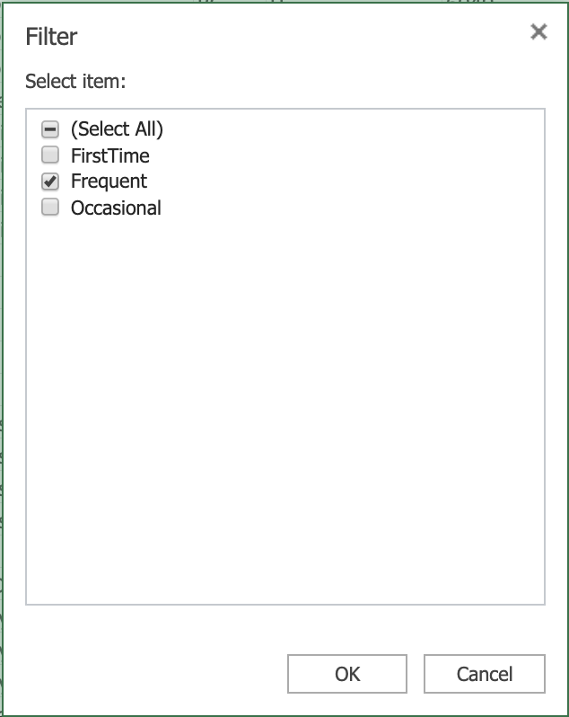

1. Click the **filter drop-down** in the column **AG**, and click **Clear Filter From “Purchase_Status”**.

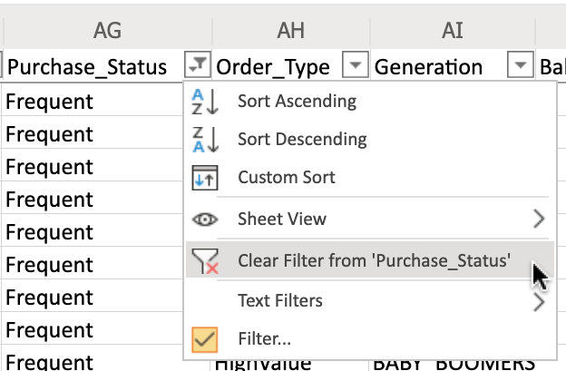

1. Click the **filter drop-down** in column **AE (T_Type)**, and select **Filter…**.
2. In the list, only select **Cancelled** and click **OK**.
3. Click the **filter drop-down** in column **AF (Purchase_Touchpoint)**, and select **Filter…**.
4. In the list, only select **Desktop** and click **OK**.
5. On the **Data** tab, click **Clear**.

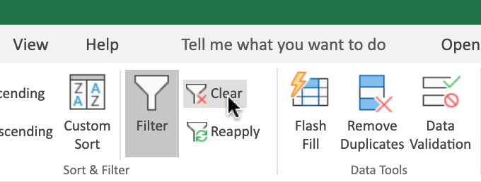

To use Custom Filters to filter data:

1. Click the **filter drop-down** in column **AD (Order_Value)**, then **Number Filters>Top 10…**.
2. Change the value from **10 to 50** and Click **OK**.
3. Click the **filter drop-down** in the column **AD**, and click **Clear Filter From “Order_Value”**.

## Task B: Sorting data

1. On the **Data** tab, click Custom Sort to open a dialog box like below.

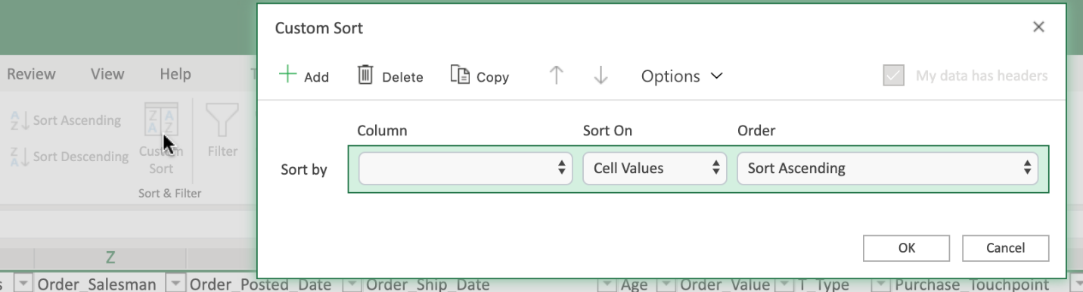

1. Click the **Column drop-down** of row **Sort By**, select **Order_Ship_Date**.
2. Click the **Order drop-down** of row **Sort By**, select **Sort Ascending**.
3. Click **Add**.
4. Click the **Column drop-down** of row **Then By**, select **Order_Value**.
5. Click the **Order drop-down** of row **Then By**, select **Sort Descending**.
6. Click **OK**.

# Exercise 2: Useful Functions for Data Analysis

In this exercise, you will learn how to use some of the most common functions a Data Analyst might use; namely IF, IFS, COUNTIF, and SUMIF.

## Task A: Use of IF to apply one condition

1. Select column **AF**, right-click, **Insert**.
2. In cell **AF1**, type **Complete?**.
3. In cell **AF2**, type **=IF(AE2=”Complete”,”Yes”,”No”)** and press Enter.
4. Double-click the **Fill Handle of AF2** to copy down the column.

## Task B: Use of Nested IF to apply multiple conditions

1. Select column **AE**, right-click, **Insert**.
2. In cell **AE1**, type **Order Size (IF)**.
3. In cell **AE2**, type **=IF(AD2>300,”Large”,IF(AD2>100,”Medium”,IF(AD2>0,”Small”)))** and press **Enter**.
4. Double-click the **Fill Handle of AE2** to copy down the column.

## Task C: Use of IFS to apply multiple conditions (alternative of Nested IF)

1. Select column **AE**, right-click, **Insert**.
2. In cell **AE1**, type **Order Size (IFS)**.
3. In cell **AE2**, type **=IFS(AD2>300,”Large”,AD2>100,”Medium”,AD2>0,”Small”)** and press **Enter**.
4. Double-click the **Fill Handle of AE2** to copy down the column.

## Task D: Use of COUNTIF to count the number of cells that meet a specified criterion

1. Select cell **BX2** and type **count VISA card**.
2. Select cell **BY2** and type **=COUNTIF(N2:N195,”VISA”)** and press **Enter**.

## Task E: Use of SUMIF function to sum the values within a specified range that meet a specified criterion

1. Select cell **BX3** and type **sum Large order**.
2. Select cell **BY3** and type **=SUMIF(AE2:AE195,”Large”, AD2:AD195)** and press **Enter**.
   * Formula: **=SUMIF(range, criteria, [sum range])**.

## Task F: Use of SUMIFS function to sum the values within a specified range that meet multiple specified criteria

1. Select cell **BX4** and type **sum Large order with Baby Gen**.
2. Select cell **BY4** and type **=SUMIFS(AD2:AD195, AE2:AE195,”Large”, AL2:AL195,”*BABY_BOOMERS*“)** and press **Enter**.
   * Formula: **=SUMIFS ([sum range], range1, criteria1, range2, criteria2, …)**.

# Exercise 3: Using the VLOOKUP and HLOOKUP Functions

In this exercise, you will learn how to use the VLOOKUP and HLOOKUP functions in Excel to reference data contained in both vertical and horizontal lookup tables.

## Task A: Use of VLOOKUP to look up data in a table organized vertically

1. Download the file [**indian_startup_funding_Lab6.xlsx**](https://cf-courses-data.s3.us.cloud-object-storage.appdomain.cloud/IBMDeveloperSkillsNetwork-DA0130EN-SkillsNetwork/Hands-on%20Labs/Lab%206%20-%20Filtering%20and%20Sorting%20Data%20using%20Functions%20for%20Data%20Analysis/indian_startup_funding_Lab6.xlsx). Upload and open it using Excel for the web.
2. In cell **K2,L2,M2,** type **VLOOKUP, Startup Name, Amount in USD** respectively.
3. Select and copy cells from **C9 to C15** and paste in cell **L3**.
4. In cell **M3**, type **=VLOOKUP(L3, C2:I113, 7, FALSE)** and press **Enter**.
   * Formula: **=VLOOKUP (value, table, col_index, [range_lookup])**.
5. Hover over the bottom-right corner of cell **M3**, and drag the Fill Handle down to the cell **M9**.
6. Select cells from **M3 to M9** and **select Number Format>Currency**.

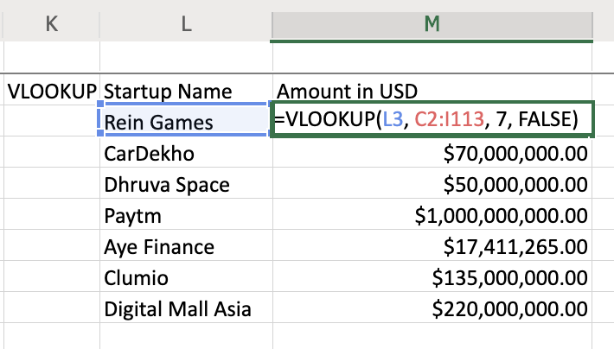

## Task B: Use of HLOOKUP to look up data in a table organized horizontally

1. Download the file [**Personal_Monthly_Expenditure_Lab6.xlsx**](https://cf-courses-data.s3.us.cloud-object-storage.appdomain.cloud/IBMDeveloperSkillsNetwork-DA0130EN-SkillsNetwork/Hands-on%20Labs/Lab%206%20-%20Filtering%20and%20Sorting%20Data%20using%20Functions%20for%20Data%20Analysis/Personal_Monthly_Expenditure_Lab6.xlsx). Upload and open it using Excel for the web.
2. In cell **J2,K2,L2,M2,** type **HLOOKUP, Month, Food & Dining, Health & Fitness** respectively.
3. Select and copy cells from **A10 to A12** and paste in cell **K3**.
4. In cell **L3**, type **=HLOOKUP(D1, A1:H14, 10, FALSE)** and press **Enter**.
   * Formula: **=HLOOKUP (value, table, row_index, [range_lookup])**.
5. Hover over the bottom-right corner of cell **L3**, and drag the Fill Handle down to the cell **L5**.
6. Select cells from **L3 to L5** and **select Number Format>Currency**.
7. In cell **M3**, type **=HLOOKUP(G1, A1:H14, 10, FALSE)** and press **Enter**.
8. Hover over the bottom-right corner of cell **M3**, and drag the Fill Handle down to the cell **M5**.
9. Select cells from **M3 to M5** and **select Number Format>Currency**.

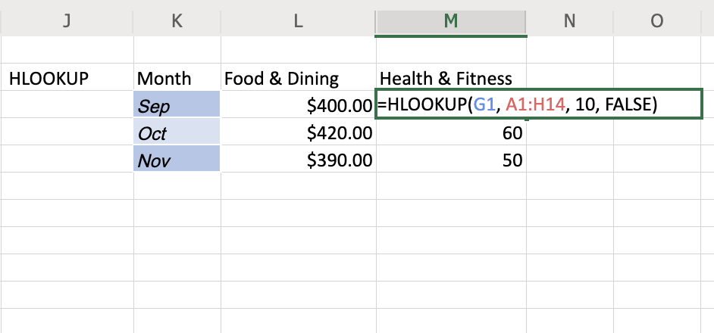

# Summary and Highlights

In this lesson, you have learned the following information:

Before shaping your data, you need to visualize the final output, and ask yourself the following questions:

* How big is the dataset?
* What type of filtering is required to find the necessary information?
* How should the data be sorted?
* What type of calculations are needed?

There are several advantages to formatting your data as a table:

* Automatic calculations even when filtering
* Column headings never disappear
* Banded rows to make reading easier
* Tables will automatically expand when adding new rows

The most basic way of shaping your data is to sort and filter it:

* Sorting data helps you to organize it by a specified criteria, such as numerically, alphabetically, or chronologically.
* Filtering our data makes it easier to control what data is displayed and what is hidden, based on filtered fields.

Excel Functions:

* Functions in Excel are arranged into multiple categories; including mathematical, statistical, logical, financial, and date and time-based.
* Common functions for a data analyst include IF, IFS, COUNTIF, SUMIF, VLOOKUP, HLOOKUP

### 1.

Question 1

If you have multiple filters set, how can you clear all of them at once?

1 / 1 point



You must clear each filter separately



Turn sorting off



Data tab > Sort & Filter group > Clear



Refresh the column

Correct

If you have multiple filters set, and you want to clear all of them at once, then on the Data tab, in the Sort & Filter group, press Clear

### 2.

Question 2

After enabling Filtering, where can you see and access the filter controls?

1 / 1 point



Each row has filter controls



Each column header now has a filter control



Only selected cells have filter controls



You must manually select data for filtering

Correct

After you enable filtering, each column header will have a filter control, and this is where you can see and access the filter controls

### 3.

Question 3

The IF function applies to one or two conditions, but what if you need to apply multiple conditions?

1 / 1 point



Use the IF-Then function



Use the nesting capabilities of the IF function



Use separate IF functions



Use the IFor function

Correct

if you need to apply multiple conditions, you can use the nesting capabilities of the IF function

### 4.

Question 4

When you use nested functions, what is required for each of the functions?

1 / 1 point



A set of parentheses for each function



Each function must be alphabetically ordered



Semi-colon between each function



=IF to begin each function

Correct

When you use nested functions, a set of parantheses are required for each of the functions

### 5.

Question 5

The difference between HLOOKUP, VLOOKUP, and XLOOKUP is how they look for data. How does each look for data?

0 / 1 point



HLOOKUP = by row

VLOOKUP = in all directions

XLOOKUP = by column



HLOOKUP = by row

VLOOKUP = by column

XLOOKUP = all directions



HLOOKUP = in all directions

VLOOKUP = by column

XLOOKUP = by row



HLOOKUP = by column

VLOOKUP = by row

XLOOKUP = in all directions

Incorrect

This is not how each function looks for data

### 1.

Question 1

Which of the following are valid sorting orders you can choose when adding sorting levels to your data? **Select all that apply.**

1 / 1 point



Youngest to Oldest



Oldest to Newest

Correct

This is a valid sorting order when adding sorting levels to your data. Depending on which data you are sorting, you can choose from A to Z, Z to A, Newest to Oldest, Oldest to Newest, Smallest to Largest, and Largest to Smallest



Smallest to Largest

Correct

This is a valid sorting order when adding sorting levels to your data. Depending on which data you are sorting, you can choose from A to Z, Z to A, Newest to Oldest, Oldest to Newest, Smallest to Largest, and Largest to Smallest



Z to A

Correct

This is a valid sorting order when adding sorting levels to your data. Depending on which data you are sorting, you can choose from A to Z, Z to A, Newest to Oldest, Oldest to Newest, Smallest to Largest, and Largest to Smallest

### 2.

Question 2

After filtering a column and getting the results, in which two ways can you return to showing all the data in a column? **Select two answers**.

1 / 1 point



clear the filter

Correct

Clearing the filter will enable you to return to showing all the data in the column



turn filtering off

Correct

Turning filtering off will enable you to return to showing all the data in the column



refresh the column



refresh the worksheet

### 3.

Question 3

What do custom filters provide that AutoFilters don't?

1 / 1 point



filter a column to see only above or below a certain value



display more data



set multiple filters at the same time



associate a formula with the filter control

Correct

Custom filters provide this capability, but AutoFilters don't

### 4.

Question 4

According to the video 'Useful Functions for Data Analysis', what is one of the most common functions a Data Analyst might use?

1 / 1 point



Average



Countif



Randbetween



Int

Correct

According to the video, this is one of the most common functions a Data Analyst might use

### 5.

Question 5

What does VLOOKUP stand for?

1 / 1 point



Variable Lookup



Vertical Lookup



Virtual Lookup



Volume Lookup

Correct

VLOOKUP does stand for Vertical Lookup

# Introduction to Creating Pivot Tables in Excel

Save note

Now that we’ve learned how to use the VLOOKUP and HLOOKUP functions, in this video we’ll

look at how to create and use Pivot Tables in Excel.

We’ll first look at how to format our data as a table, then how to create Pivot Tables

and use fields in a Pivot Table to analyze data, and lastly we’ll see how to perform

calculations in a Pivot Table.

Having a worksheet full of informational data is all very well, but to really get some use

out of it we need to analyze it from different perspectives to find answers to questions

related to the data.

Now, we’ve already used features such as filters and formulas to draw mathematical

and logical conclusions about our data but not all questions can be answered easily using filters and formulas alone.

In order to obtain usable and presentable insights into your data you need something

else… and that something else is Pivot Tables.

Pivot Tables provide a simple and quick way, in spreadsheets, to summarize and analyze

data, to observe trends and patterns in your data and to make comparisons of your data.

A Pivot Table is dynamic, so as you change and add data to the original dataset on which

the Pivot Table is based, so the analysis and summary information changes too.

A Data Analyst can use Pivot Tables to draw useful and relevant conclusions about, and

create insights into, an organization’s data in order to present those insights to

interested parties within the company.

Before you start to create a Pivot Table in Excel, it can be very helpful to first format

your data as a table.

The reason for this is not only to make it more organized and defined and to add table

styles to your data, but primarily it makes it a lot easier when adding records to the

dataset.

In the car sales worksheet, let’s first select any cell within the data, and then

on the Home tab, in the Styles group, choose ‘Format as Table’.

Then choose a style from the gallery…

note that Excel automatically knows the boundaries of our data range, but we can change this

if we need to.

And ensure you select ‘My table has headers’, if indeed it does.

After you click OK and the data has been formatted as a table, note the filter drop-downs at

the top of each column – these are automatically added when you format as a table.

If we now scroll down to the bottom of the table…

and start adding another row of data for another vehicle…

when you click Tab or Enter, note that it is automatically formatted and included as

part of our table.

OK, now let’s see how to create a basic Pivot Table, and how to use fields to arrange

data in a Pivot Table.

Just before we do that, there are a few things you should use as a checklist to ensure your

data is in a fit state to make a Pivot Table from, and these are:

Format your data as a table for best results

Ensure column headings are correct, and there is only one header row, as these column headings

become the field names in a Pivot Table

Remove any blank rows and columns, and try to eliminate blank cells also

Ensure value fields are formatted as numbers, and not text

Ensure date fields are formatted as dates, and not text

In the worksheet, we can just select any cell in the table.

Then, on the Insert tab, we click PivotTable.

Note that in the ‘Select a table or range’ box, the table name – Table1 – is already

entered for us.

If we hadn’t just formatted this data as a table, we would specify the cell range here

instead.

Under that, we need to decide whether we want to create the Pivot Table on a separate new

blank worksheet, or on this worksheet – a new worksheet is the default – and is the

most commonly used option.

So, a new blank worksheet opens, displaying some basic Pivot Table instructions in the

graphic on the left of the worksheet, and a ‘PivotTable Fields’ pane on the right.

You can rename the worksheet for the Pivot Table if you wish.

To build the Pivot Table report we need to add some fields from the top of the PivotTable

Fields pane, to one or more of the sections in the bottom part of the pane.

For example, if we want to find out the total sales for each model of car, let’s drag

the Manufacturer field to the Rows section of the report, …

and then we’ll drag the Model field there too.

But this isn’t really the way we want it to look, so we’ll drag the Manufacturer

field to appear at the top of the Rows section above the Model, which makes more sense with

our data.

Next, we’ll add the Price field to the Columns section, …

… but again that really isn’t the way we want to view the data, so we’ll drag

Price to the Values section instead, which makes a lot more sense and looks a lot better.

Next, we’ll add the Unit Sales field to Values too, so now we can see both the individual

price for each model and the number of unit sales of each model.

Let’s add the Vehicle-type field to Columns, but that doesn’t seem very useful, so let’s

remove that field, …

, which we can do in two ways.

Either by using the drop-down menu, …

( or, if we undo that, …

we can also do it by simply dragging the field out of the Columns section, either to the

left over the worksheet, or to the top over the fields list above.

Let’s now look at how to perform a simple calculation in a Pivot Table.

If we look in the ‘Sum of Price’ column in our Pivot Table, we can see that the figures

are formatted as General.

So first, let’s change the format for these figures to US currency.

This can be done by modifying the value field settings for the field in the relevant section

of the PivotTable Fields pane.

We’ll format the field as US dollars and show no decimal places.

Next, we’ll add a calculated field from the ‘PivotTable Analyze’ tab, using the

‘Fields, Items & Sets’ button.

We want this field to calculate the total sales for each model by multiplying the price

by the number of unit sales.

When we create and add this formula, it gets added to the PivotTable Fields pane, as a

field called Total Model Sales.

And we can change the format to make it US dollars again.

A new column called ‘Sum of Total Model Sales’ has now appeared in the Pivot Table

in our worksheet.

In row 5 we can see that there have been over 360 million dollars of sales of the Acura

Integra model, …

and in row 7 we can see that there has been over a billion dollars in sales of the Acura

TL model.

In this video, we learned how to format data as a table, how to create a Pivot Table and

use fields to analyze data in a Pivot Table, and how to perform calculations using Pivot

Table data.

In the next video, we’ll look at some other features of Pivot Tables.

# Viewpoints: Pivot Tables

Save note

TranscriptNotesDownloadsDiscuss

In this video we will listen to several data professionals discuss their experience using

pivot tables to analyze data.

What are your experiences using pivot tables to analyze data?

My experience using pivot tables in Excel is extensive.

I can use them all the time.

The thing to keep in mind is that you can sum, average, and count easily.

You can set it to group-by so people can choose what the parameters are at the top.

It's great if you've got a couple of thousand records all the way up to whatever Excel can

handle.

So, a pivot table is just a real simple way of manipulation without having to do any actual

querying or development language.

I once had a huge ecommerce sales data.

I need to analyze the KPI's including gross merchandise volume and take rate.

However, I can only generate limited insights if I stay at high level

With pivot tables I was able to group the data in terms of countries, type of stores,

type of products, which enabled me to view the data and analyze the key KPI's at different

levels of granularity.

I use pivot tables and we use pivot tables in our firm, especially during audits to assist

us and help us to kind of drill down on the data because what a pivot table does is, it

helps you to take a large set of data and whittle it down to something that's meaningful.

So, in the case of audits, a client might have, you know, $500,000 worth of maintenance

and repair bills that are made up of three-hundred invoices.

But we don't want to see every invoice for every dollar we want to see the high dollar

invoices, so we're going to use that pivot table to narrow it down to the invoices that

actually are going to have the highest level of impact on the financial statement.

Much like Excel, pivot tables are a great way to understand your data quickly and effectively.

Being able to just open up an Excel sheet, put it into a pivot table, drag and drop things

in to get a sense of what the numbers look like, what the values are, really can help

you get a good sense of the data in order to then start to build out something a little

bit more robust.

Being able to understand the fields, what they mean, what they look like.

These are all things that can help you at the start of a project, as you're looking

to do your analysis.

Pivot tables are incredibly useful to get a quick view of your data and to look at multiple

levels of your data in a very quick and clean way.

It's just very, very easy to create a pivot table on a set of raw data, aggregate it by

some level of interest, be it country, be it you know country the user is from, be it

the year the user joined, or anything else, be it something related to time.

It's really good for quickly seeing and understanding some of the more high-level summaries that

are hidden within your data.

# Pivot Table Features

Save note

Now that we’ve learned how to create and use Pivot Tables in Excel, in this video we’ll

look at some other features that we can use with Pivot Tables, including Recommended Pivot

Tables, Filters, Slicers, and Timelines.

Now that we’ve learned how to create and use Pivot Tables in Excel, in this video we’ll

look at some other features that we can use with Pivot Tables, including Recommended Pivot

Tables, Filters, Slicers, and Timelines.

First, let’s look at Recommended Pivot Tables, which isn’t exactly a feature as such; it’s

really more of a list of suggested different combinations of data that could be used when

creating a Pivot Table.

These recommendations are based on the data we select in the worksheet, and they are a

great way to get started creating Pivot Tables if you don’t have much experience with them

yet.

For example, in the vehicle toy sales worksheet, if we select column B, which contains data

about the quantity of items ordered, …

when we choose Recommended Pivot Tables from the Insert tab, then we are presented with

a list of potential data combinations related to the order quantity information.

(3)

However, if we select column F, which contains Order Size information, then the recommended

pivot table list changes to reflect that data.

(6)

And if we select column E, which contains sales information, then the pivot tables recommended

are related to sales data.

Let’s select the third one down, which is the sum of sales by territory; because that

sounds like something we could get some useful insight from, by presenting it in a pivot

table.

Note that a new worksheet is opened containing the recommended pivot table, and a new pane

opens on the right, called PivotTable Fields.

Let’s rename the worksheet to something more meaningful.

In the PivotTable Fields pane, you can see that some fields have already been added to

the Rows and Values areas.

Although it’s a recommended pivot table, we can still make it our own, by adding more

fields for example.

So, let’s add the Productline item to the Columns area using drag and drop.

Now we have columns for each of the product lines in our pivot table, such as motorcycles,

ships, and trains.

In the pivot table, we can manually expand any field we want to view its contents.

Here we can see that the order dates are located underneath the territory names in our pivot

table.

Note that this matches the order of the fields in the Rows area of the PivotTable Fields

pane.

We can manually collapse each of the fields too.

But we also have the option of expanding all the fields at once, …

and collapsing them all too.

The next feature we will delve into is pivot table filtering.

Pivot table filters work in much the same way as the standard filters we used earlier

in the course.

Note that we already have some in-built filtering in this pivot table.

For example, the Row Labels header is a filter, and we can filter on any of the listed territories,

such as Japan.

Just like standard filters, it’s very simple to clear a filter in a pivot table.

We also have a Column Labels filter, allowing us to filter on any of the productline items

in this pivot table; for example we could show data only for the trains product.

(7)

We also have the option of adding the Productline field as a standard filter instead of a column

heading, by dragging it to the Filters area in the PivotTable Fields pane.

And we can then use it as a standard filter, as we have done earlier in this course.

The filter also allows us to select multiple filter items.

But because it is now being used as a standard filter rather than a column header, we can’t

see the split of the information on these two product lines; we just see a combined

total.

When we had the filter as a column header, the information on each product line was presented

separately in each column.

Let’s display all the field totals again.

And we’ll drag the productline field back to the Columns area where it was previously,

so we can see the split of our different product lines in the pivot table.

The next pivot table feature we will look at are Slicers.

Slicers are essentially on-screen graphical filter objects that enable you to filter your

data using buttons.

Slicers make it easy to perform quick filtering of your pivot table data, and they also display

the current filter state, making it easier for you to know, and see, what data is currently

being shown, and which is being hidden, by the filter.

For example, if we remove the productline field from the pivot table by dragging it

out of the PivotTable Fields pane, ...

and then, from the PivotTable Analyze tab, we click Insert Slicer,...

and then choose the Territory field as our slicer,…

we can see that the slicer can be freely moved around anywhere on the worksheet, and it contains

buttons for each of the territory items, such as EMEA, North America, and Japan.

We can also select the Multi-Select button to filter on multiple territories if we wish.

We can click the Clear Filter button to clear all slicer filters.

Let’s add another slicer to our worksheet for the productline field.

However, be sure to select a cell in the pivot table first, because if you don’t, then

the insert slicer button won’t work.

Note that slicers can also be added from the Filters group on the Insert tab as well as

from the PivotTable Analyze tab.

We’ll select the Productline field this time for our slicer, and drag it near the

top of the worksheet.

As before, we can select only one slicer item, or we can turn on Multi-Select and choose

several items to filter on in the slicer.

Then let’s clear the slicer filters, …

and now let’s filter using both slicers.

Note that when you use multi-select filtering, when you select an item, you are in fact filtering

it out; that is, you are defining which items will NOT be displayed in the pivot table.

This is the opposite behavior to when you are selecting single items in a slicer.

So now we are displaying only ‘classic cars’, ‘trains’, and ‘trucks and buses’ products

for the EMEA and North America territories.

Now let’s clear those slicer filters, and put the productline field back in the Columns

area of the pivot table, so it’s ready for the next feature we will explore.

And let’s move these slicers out of the way, further down the worksheet.

The last useful feature for pivot tables we are going to look at, is Timelines.

A Timeline is another type of filter tool that enables you to filter specifically on

date-related data in your pivot table.

This is a much quicker and more effective way of dynamically filtering by date, rather

than having to create and adjust filters on your date columns.

We can add a Timeline for our pivot table either from the PivotTable Analyze tab, or

from the Insert tab.

Again, ensure you select any cell in the pivot table first.

We’ll select the Orderdate field as our Timeline filter.

Then we can drag it up the worksheet and enlarge it.

The default for this timeline is to display data by month, but you can also filter by

days, …

or by quarters.

You can select a single quarter; or you can select a range of quarters.

In this case, we’ll select twelve months between quarter 3 of 2003 and quarter 2 of

2004.

You use the Clear Filter button to clear a timeline filter.

You can also filter by years.

For example, here we have selected 2003 only.

And you can combine slicers and timelines as filters in a pivot table.

For example, here we can filter the slicers to display only data for trains, in the EMEA

and North America territories, and only in the year 2003.

And if we filter on the year 2004 instead, you’ll see that there is no data being displayed;

meaning that there were no sales of train products in 2004 in either the EMEA or the

North America territories.

(15)

Timelines and Slicers have their own tabs in the ribbon when you select them, and their

properties can be modified to change how they look and how they work.

For example, let’s change this Timeline to a light green shade, …

and let’s change this Slicer to a nice orange color.

And lastly, to remove a timeline or slicer, you can either select it and press the Delete

key, …

or right-click it and choose Cut.

In this video, we learned about some of the other features in Excel that we can use with

Pivot Tables, namely; Recommended Pivot Tables, Filters, Slicers, and Timelines.

# Hands-on Lab 7: Using Pivot Tables

**Estimated time needed:** 30 minutes

In this lab, first you will learn how to format data as a table, how to create a Pivot Table and use fields to arrange data in a Pivot Table, and how to perform calculations using Pivot Table data. Next, you will learn some other features that we can use with Pivot Tables, including Recommended Charts, Filters, Slicers, and Timelines.

# Software Used in this Lab

The instruction videos in this course use the full Excel Desktop version as this has all the available product features, but for the hands-on labs we will be using the free ‘Excel for the web’ version as this is available to everyone.

Although you can use the Excel Desktop software if you have access to this version, it is recommended that you use Excel for the web for the hands-on labs as the lab instructions specifically refer to this version, and there are some small differences in the interface and available features.

# Dataset Used in this Lab

The dataset used in this lab comes from the following source: <https://www.kaggle.com/sudalairajkumar/indian-startup-funding> under a [**CC0: Public Domain license**](https://creativecommons.org/publicdomain/zero/1.0/).  
Acknowledgement and thanks also goes to [https://trak.in](https://trak.in/) who were generous enough to share the data publicly for free.

We are using a modified subset of that dataset for the lab, so to follow the lab instructions successfully please use the dataset provided with the lab, rather than the dataset from the original source.

# Objectives

After completing this lab, you will be able to:

* Format data as a table
* Create a Pivot Table and use fields to arrange data in a Pivot Table
* Perform calculations using Pivot Table data
* Use the Recommended Charts feature (does not work with the ‘Basic’ Office for the web plan.)
* Use the Filters feature
* Use the Slicers feature
* Use the Timelines feature

# Exercise 1: Introduction to Creating Pivot Tables in Excel

In this exercise, you will learn how to format data as a table, how to create a Pivot Table and use fields to arrange data in a Pivot Table, and how to perform calculations using Pivot Table data.

## Task A: Format data as a table

1. Download the file [**indian_startup_funding_Lab7.xlsx**](https://cf-courses-data.s3.us.cloud-object-storage.appdomain.cloud/IBMDeveloperSkillsNetwork-DA0130EN-SkillsNetwork/Hands-on%20Labs/Lab%207%20-%20Using%20Pivot%20Tables/indian_startup_funding_Lab7.xlsx). Upload and open it using Excel for the web.
2. Select cell **A2**.
3. On the **Home** tab, in the **Tables** group, click **Format as Table**.
4. Select **Light Gray, Table Style Medium 15**.

## Task B: Create a pivot table and use fields to arrange data in a pivot table

1. Select cell **D4**
2. On the **Insert** tab, click **PivotTable**.
3. Click **OK**.

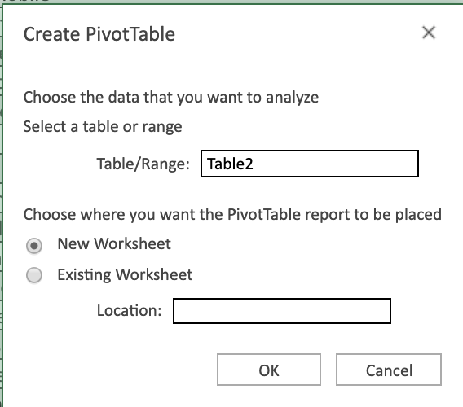

1. Double-click **Sheet1**, type **Pivot1** and click **OK**.
2. In the fields list, drag **Industry Vertical** to **Rows**.
3. In the fields list, drag **City Location** to **Rows** above **Industry Vertical**.
4. In the fields list, drag **Startup Name** to **Rows** below **Industry Vertical**.
5. In the fields list, drag **Amount in USD** to **Values**.
6. Use the drop down arrow for the **City Location** and Sort By Value in descending order (Largest to smallest) by the **Count of Amount in USD**.  
   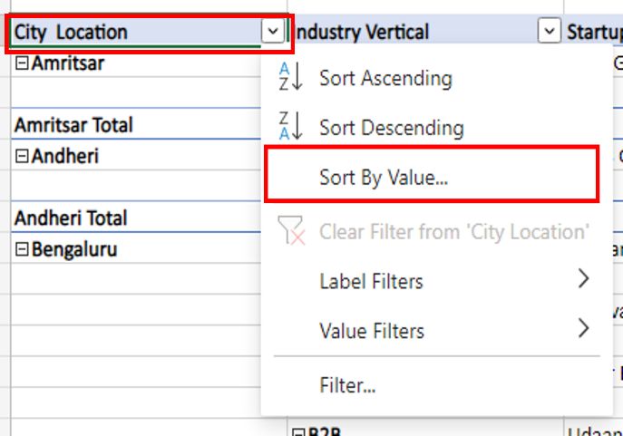

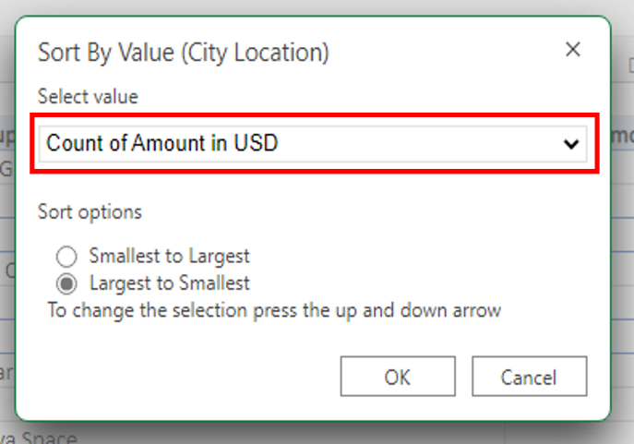

1. In the ribbon, select the **PivotTable** tab, click **Settings**, then in the **PivotTable Settings** pane, under **Layout**, select **Single column**.
2. Right-click on the row label Amritsar and select **Expand/Collapse** and **Collapse Entire Field**.

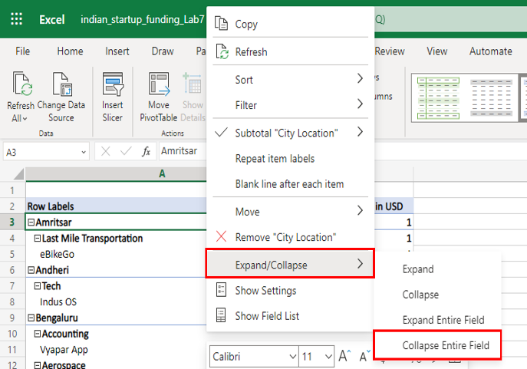

## Task C: Perform a simple calculation in a pivot table

1. In the **PivotTable Fields** pane, in the **Values** section, click the drop-down arrow next to **Count of Amount in USD**, and click **Value Field Settings**.
2. Select **Summarize value field by > Sum**.

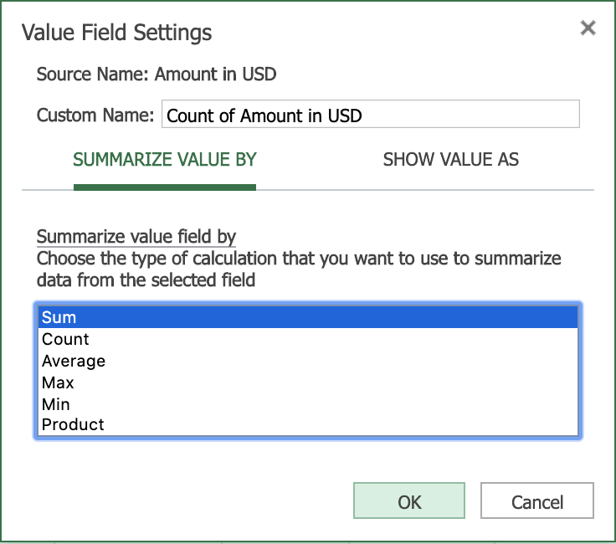

1. Click **OK**.
2. Select the column called **Sum of Amount in USD** and then on the **Home** tab, select **Accounting Number Format > $ English (United States)**.

# Exercise 2: Pivot Table Features

In this exercise, you will learn some other features that we can use with Pivot Tables, including Recommended Charts, Filters, Slicers, and Timelines.

**Note: The ‘Recommended Charts’ feature only works with ‘full’ Office for the web plans (those plans that come with an Office 365 subscription). Recommended Charts do not work with the ‘basic’ plan that comes with a Microsoft Account.**

## Task A: Use of the Recommended Charts feature (Optional: If you have a full Office for the web plan)

1. Switch to worksheet **indian-startup-funding**.
2. Select column **F (City Location)**.
3. On the **Insert** tab, select **Recommended Charts**.
4. Click **+ Insert PivotChart**.

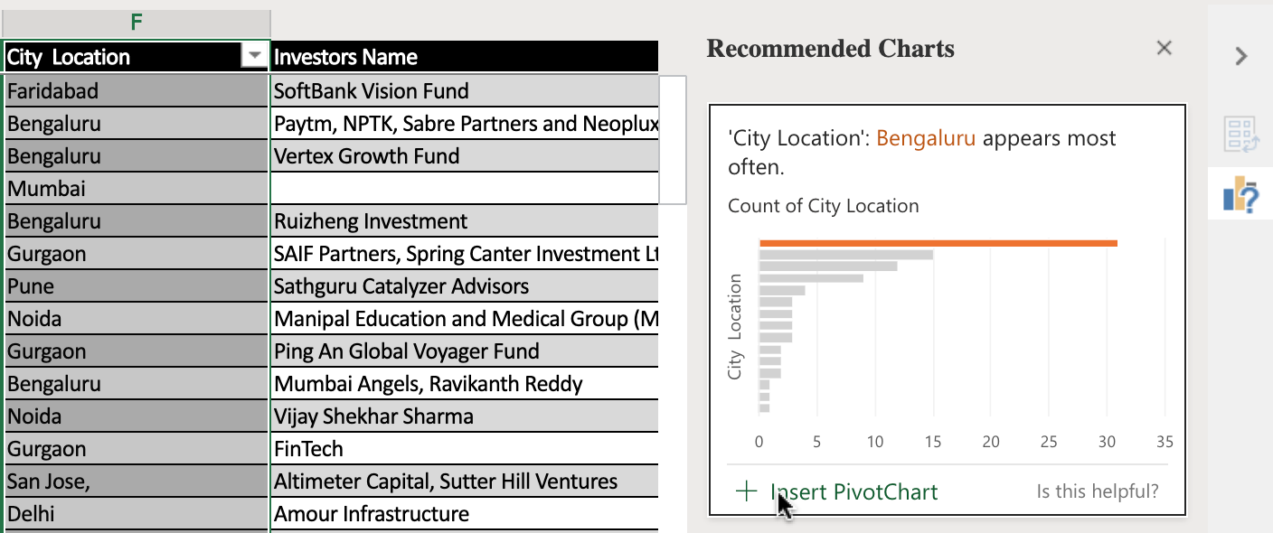

1. Switch to worksheet **indian-startup-funding** again.
2. Select column **C, D, E**.
3. On the **Insert** tab, select **Recommended Charts**.
4. Choose the recommended chart, and click **+ Insert PivotChart**.

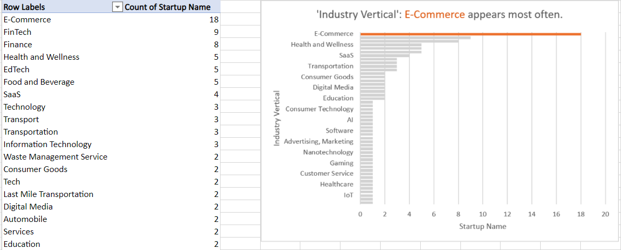

## Task B: Use of the Filters feature

1. Switch to worksheet **Pivot1**.
2. In the Pivot Table, click the **Row Labels** arrow.
3. Select **City Location**, then **Filter…**.
4. Just select **Burnsville**, **Delhi**, **New York**, then click **OK** to display the amounts for startups in these three cities only.
5. In the Pivot Table, click the **Row Labels** arrow.
6. Select **City Location**, then click **Clear Filter From ‘City Location’** to display the startups in all cities again.

## Task C: Use of the Slicers feature

1. Download the file [**indian_startup_funding_Lab7_with_slicers_timelines.xlsx**](https://cf-courses-data.s3.us.cloud-object-storage.appdomain.cloud/IBMDeveloperSkillsNetwork-DA0130EN-SkillsNetwork/Hands-on%20Labs/Lab%207%20-%20Using%20Pivot%20Tables/indian_startup_funding_Lab7_with_slicers_timelines.xlsx). Upload and open it using Excel for the web.
2. Switch to worksheet **Pivot1** if you are not there.
3. In the **City Location** slicer, select **Burnsville**, then **Delhi**, then **New York**.
4. To filter by multiple selection in the **City Location** slicer, with **New York** still selected, press **CTRL** and select **Burnsville**, and then **Delhi**.
5. To filter using more than one slicer, in the **Investors Name** slicer, select **Amour Infrastructure**, then press **CTRL** and select **Westbridge Capital**, and then **Breakthrough Energy Ventures**.
6. In the **City Location** slicer, click the **Clear Filter** button, then in the **Investors Name** slicer, click the **Clear Filter** button.

## Task D: Use of the Timelines feature

1. In the Date timeline, click **top right drop-down** and select **DAYS**, then scroll **left and right**.

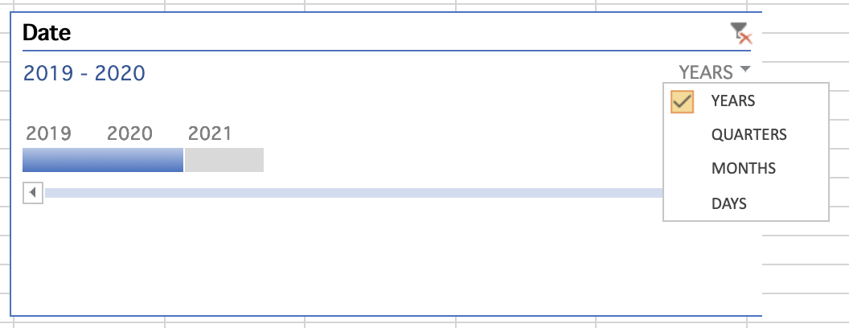

1. In the Date timeline, click **top right drop-down** and select **QUARTERS**.
2. In the Date Timeline, select **2019 Q1**, then drag **2019 Q1 to 2019 Q3**.
3. In the Date timeline, click the **Clear Filter** icon.
4. In the Date timeline, click **top right drop-down** and select **YEARS**, then select **2020** only.

### Congratulations! You have completed Lab 7, and you are ready for the next topic.

In this lesson, you have learned the following information:

Pivot Tables:

* To obtain usable and presentable insights into your data you need to use Pivot Tables.
* Pivot tables provide a simple and quick way to summarize and analyze data, to observe trends and patterns in your data and to make comparisons of your data.
* Pivot tables are dynamic, so as you change and add data to the original dataset on which the pivot table is based, the analysis and summary information changes too.
* A Data Analyst can use pivot tables to draw useful and relevant conclusions about, and create insights into, an organization’s data in order to present those insights to interested parties within the company.

Use this Pivot Table checklist to ensure your data is in a fit state to make a Pivot Table:

* Format your data as a table for best results.
* Ensure column headings are correct, and there is only one header row, as these column headings become the field names in a Pivot Table.
* Remove any blank rows and columns, and try to eliminate blank cells also.
* Ensure value fields are formatted as numbers, and not text, and ensure date fields are formatted as dates, and not text.

Arranging Pivot Tables with Filters and Recommended Tables:

* You use the Pivot Table Fields pane to add and arrange data fields in your pivot table.
* Recommended Pivot Tables are a list of suggested different combinations of data that could be used when creating a Pivot Table, based on the data selected in the worksheet.

Filters and Slicers:

* Slicers are on-screen graphical filter objects that enable you to filter your data using buttons, which makes it easier to perform quick filtering of your pivot table data.
* Timelines are another type of filter tool that enable you to filter specifically on date-related data in your pivot table. This is a much quicker and more effective way of dynamically filtering by date, rather than having to create and adjust filters on your date columns.

### 1.

Question 1

Before creating a pivot table, how should you format your data?

1 / 1 point



Cell size



Sort & filter



Conditional formatting



As a table

Correct

Before creating a pivot table, you should format your data as a table

### 2.

Question 2

How can you add more filters to the pivot table?

1 / 1 point



drag a field to the Filters area of the PivotTable Fields pane



first add filters to the original table data



use a function



use a formula

Correct

You can drag fields into the Filters area of the PivotTable Fields pane to add more filters to a pivot table

### 3.

Question 3

What are slicers?

1 / 1 point



on-screen graphical filter objects



split pivot tables



header filters



standard filters

Correct

Slicers are on-screen graphical filter objects

### 4.

Question 4

What do timelines provide in pivot tables?

1 / 1 point



sets the pivot table to an earlier view



previews views of different filters



lets you filter specifically on date-related data



provides details of all actions performed during a given period

Correct

Timelines in a pivot table enable you to filter specifically on date-related data

### .

Question 1

According to the video checklist, what should you remove before making a Pivot Table?

1 / 1 point



Value fields



Row labels



Blank rows, columns, and cells



Date fields

Correct

According to the video checklist, you should remove blank rows, columns, and cells before making a Pivot Table

### 2.

Question 2

What is automatically added after formatting data as a table?

1 / 1 point



Alternate light/dark rows



Column headers



Data bars



Filter drop-downs at top of columns

Correct

Filter drop-downs are automatically added at the top of each column after you format your data as a table

### 3.

Question 3

After creating a pivot table and selecting it, what pane appears to the right of the pivot table?

1 / 1 point



Additional pivot table examples



The PivotTable Metadata pane



The PivotTable Properties pane



The PivotTable Fields pane

Correct

The PivotTable Fields pane appears on the right of a pivot table after you create and select one

### 4.

Question 4

What do Timelines provide in pivot tables?

1 / 1 point



Provides details of all actions performed during a given period



Previews views of different filters



Sets the pivot table to an earlier view



Lets you filter specifically on date-related data

Correct

Timelines in a pivot table enable you to filter specifically on date-related data

### 5.

Question 5

What is one way to remove a slicer or timeline?

1 / 1 point



Right-click it and select cut



Remove all filters from pivot table



Create a new one



Press CTRL+Z

Correct

This is one way to remove a slicer or timeline



# Peer-Graded Assignment: Final Assignment – Part 1

**Estimated time needed:** 45 minutes

Great! You have now completed all four modules of this course. This week, you will complete the final assignment that will be graded by your peers. In this assignment, you will open a CSV file in Excel for the web, convert it to an Excel format, and then clean and prepare the data.

# Software Used in this Assignment

The instruction videos in this course use the full Excel Desktop version as this has all the available product features, but for the hands-on labs we will be using the free ‘Excel for the web’ version as this is available to everyone.

Although you can use the Excel Desktop software if you have access to this version, it is recommended that you use Excel for the web for the hands-on labs as the lab instructions specifically refer to this version, and there are some small differences in the interface and available features.

# Dataset Used in this Assignment

The dataset used in this lab comes from the following source: <https://data.montgomerycountymd.gov/Government/Fleet-Equipment-Inventory/93vc-wpdr> under a **Public Domain license**.

We are using a modified subset of that dataset for the lab, so to follow the lab instructions successfully please use the dataset provided with the lab, rather than the dataset from the original source.

## Assignment Scenario

In this final assigment, you will be following the scenario of a recently hired Junior Data Analyst in a local government office, who has been tasked with importing some data from another department which relates to inventory information about their fleet of vehicles. The data is in comma-separated value (CSV) format and the data also needs cleaning up before you can start to run any kind of analysis on it.

## Guidelines for the Submission

Download the file [Montgomery_Fleet_Equipment_Inventory_FA_PART_1_START.CSV](https://cf-courses-data.s3.us.cloud-object-storage.appdomain.cloud/IBMDeveloperSkillsNetwork-DA0130EN-SkillsNetwork/Hands-on%20Labs/Peer%20Graded%20Assignment%20-%20Part%201/Montgomery_Fleet_Equipment_Inventory_FA_PART_1_START.csv). Upload and open the file with Excel for the web and convert it to an .XLSX file. Then clean the data as detailed below.

Use the course videos from Module 3 and the lab ‘Hands-on Lab 5: Cleaning Data’ to help you complete these tasks.

Tasks to perform:

1. **Save the CSV file as an XLSX file:** Change the ‘Viewing’ in the ToolTip to ‘Editing’inorder to save the file as an XLSX file. The file is converted when you click ‘Convert’ in the prompt.

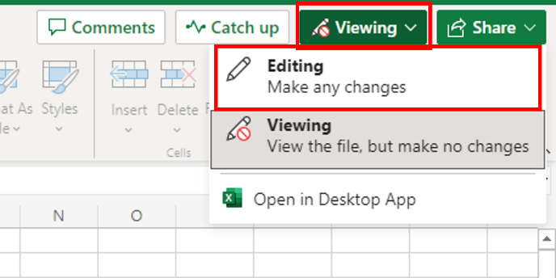 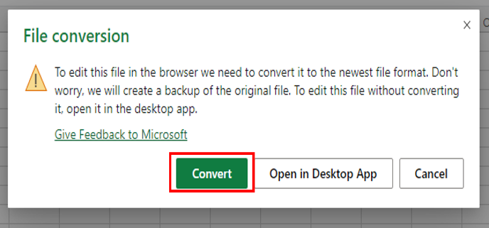

1. **Column widths:** Sort out the widths of all columns so that the data is clearly visible in all cells.
2. **Empty rows:** Use the Filter feature to look for blanks and remove all empty rows from the data.
3. **Duplicate records:** Use either the Conditional Formatting or Remove Duplicates feature to look for and remove any duplicated records from the data.
4. **Spelling:** The original source file data has not been checked for errors in the spelling. Check for spelling mistakes in the data and fix them.
5. **Whitespace:** Use the Find and Replace feature to remove all double-spaces from the data.
6. **Department names:** When the data was converted from its data source, the department names (see correct list below) didn’t import correctly and they are now split over two columns in the data. Use Flash Fill to reduce the department names to just one column, and then remove any unnecessary columns.

| **Department** | **Department** |
| --- | --- |
| Board of Elections | Economic Development |
| Circuit Court | Environmental Protection |
| Community Engagement Cluster | Finance |
| Community Use of Public Facilities | Fire and Rescue |
| Consumer Protection | General Services |
| Correction and Rehabilitation | Health and Human Services |
| County Executives Office |  |

1. **Download your workbook:** Use‘Save As’and select‘Download a copy’ to download your completed workbook as **Montgomery_Fleet_Equipment_Inventory_FA_PART_1_END.XLSX**.

**Note:** In Excel web version, files are auto saved.

## Grading Information

For your assignment to be graded in a subsequent step in this course, you will be required to upload the completed Excel workbook that you saved in Task 8.

The **main grading criteria** will be:

* Is the data saved correctly?
* Is the data formatted correctly?
* Has the data been cleaned correctly?

You **will not be judged** on:

* Your English language, including spelling or grammatical mistakes.